LANDSCOVE C OF E PRIMARY SCHOOL
RE & CW Lead Report for the School Ethos Group

SCHOOL ETHOS, SIAMS & RE

Wednesday 25th November 2020
How is the vision lived out in CW?
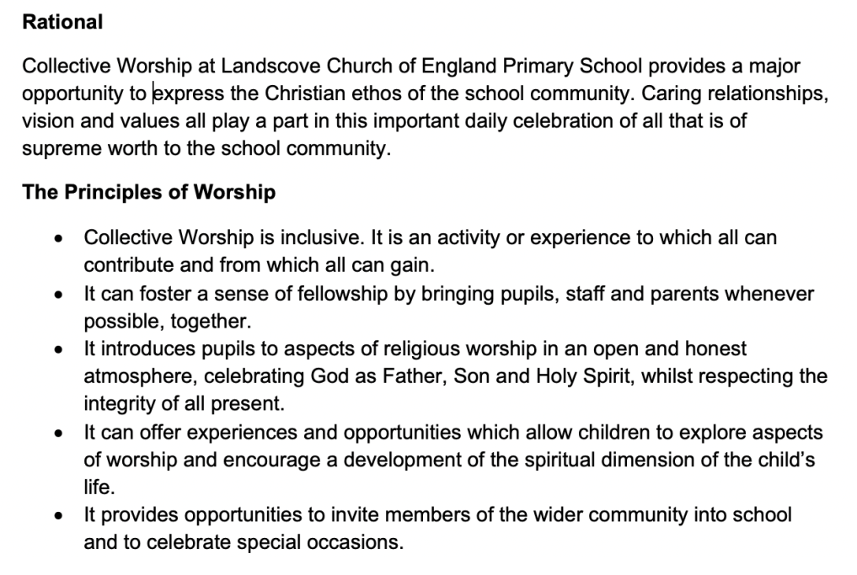

Inclusive – children invited to put their hands together if they would like to make it their prayer
Trinity symbol on display in reflective space
Spiritual – see below
Wider community – we are still achieving this, despite lockdown

Current provision for CW:
AN providing resources to support staff in delivering CW in bubbles. PowerPoint contains videos links, prayers/reflections, poignant images, bible stories etc.
Each class has a daily 15-minute CW slot.
Reflective space is updated, photographs taken and included in PowerPoint.
Imaginor journal purchased to support staff in developing spirituality.
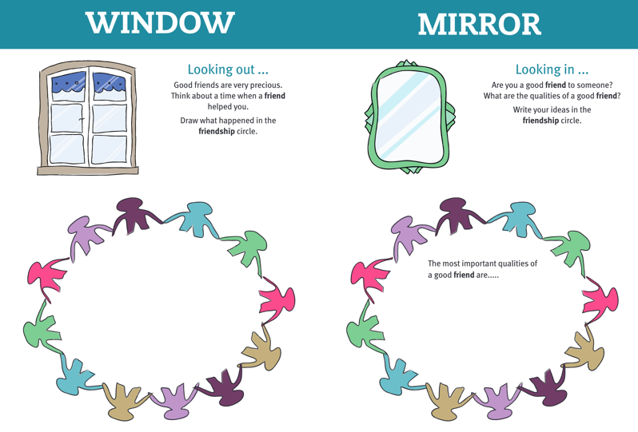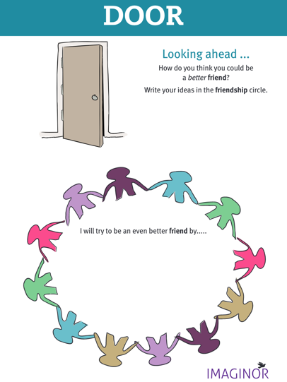
How does it make a difference?
Gives children the opportunity to talk through values and relate them to their school/home life as well as things that are happening in the world.
Promotes good discussions and tolerance of others (opinions).
Provides a safe environment in which children can raise and explore big questions.
Allows time during a busy day to stop and look at the world around us - share ‘ow’ and ‘wow’ moments.
Makes meaningful links with our PSHE curriculum.
What is the impact on pupils?
Develops an ability to:
Reflect on their ideas and behaviours, understand their place in the community and appreciate others.
Consider new ways of thinking/ideas or new ways to look at/approach situations.
Act as global citizens by understanding the difficulties in the world and take action
How do we know it’s working?
Children can:
Recall stories/discussions that we have had and apply them in different circumstances.
Be seen ‘living out’ the values that have been taught.
Speak confidently, expressing views and responding to those of others in a respectful manner.
Through the strength and presence of our ethos.

Evidence obtained through:
Discussions with staff
LEGs survey
Analysing children’s responses:
Verbal – during discussions
Written - class reflection journals
Creative – e.g., quality artwork produced for Remembrance. Vocabulary development in class 3

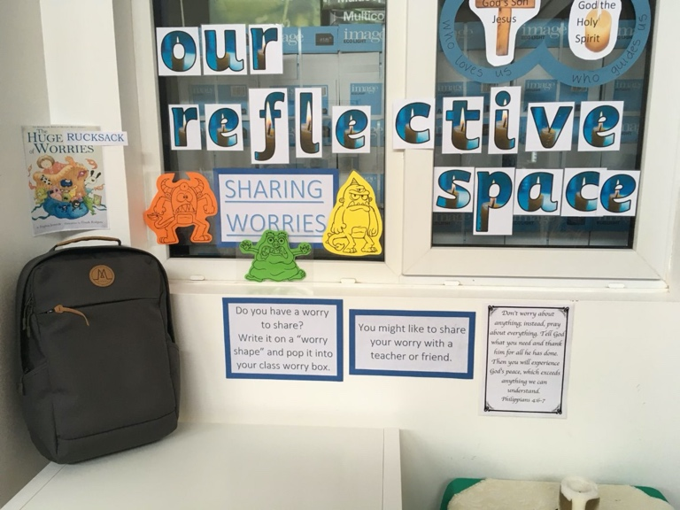
Reflective Space

Linked to the ‘Here We Are’ two-week unit
This formed part of our recovery curriculum.

21.10.20 AN attended online CPD – Making the most of RE – Introducing the new Devon and Torbay Agreed Syllabus
Changed reflective space to mark Remembrance
23.10.20 Landscove’s Harvest 2020 Video launched – can committee members please provide feedback?
AN delivered three boxes of donations to Buckfastleigh food bank.
£80 raised for Send a Cow charity.
26.10.20 Staff provided with resources for Inter Faith week
6.11.20 AN, Christine Pascoe and two year four children delivered pots to local residents
9.11.20 AN liaised with Helen Sands (Open the Book). Class three to act out bible story in outdoor classroom
9.11.20 AN and JR made a list of jobs required to clear our spiritual garden
11.11.20 Remembrance Day - Classes observed a two-minute silence. All children were given the opportunity to respond creatively
AN attended online course – Bringing Sacred texts to life
18.11.20 Staff meeting to discuss Landscove Nativity 2020
18.11.20 Landscove Ethos Group 2020 (LEGs) formed. Two children from years 2, 3, 4, Five children from years 5 & 6
23.11.20 AN met with LSEG – members completed a CW survey

Staff Training
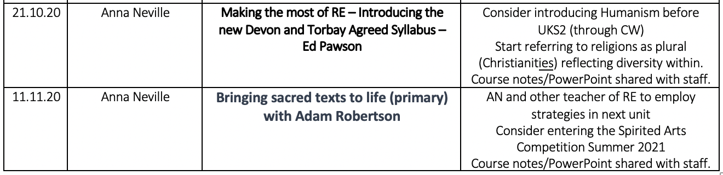

LANDSCOVE C OF E PRIMARY SCHOOL
Academy Head Report for the School Ethos Group

PUPIL NUMBERS

R 14 -1 deferred entry
Y1 13
Y2 15
Y3 11
Y4 15
Y5 13
Y6 11
Total 92

CLASS ORGANISATION
- Class 1 : R (0.4 Lucy Field, 0.6 Jo Woods)
- Class 2: Y1 & Y2 (0.8 Jenny Foster, 0.2 Amanda Richardson)
- Class 3: Y3 & Y4 (0.5 Anna Neville, 0.5 Anne Smart)
- Class 4: Y5 & Y6 (Karen Barlow FT)

Staffing updates
Jill currently Acting Executive Head for Landscove and Broadhempston
Mostly spending ½ day at each school, which is working well
Senior teachers are in place at Landscove, with clear roles and responsibilities for when I’m not in.
Jo Woods leads on all curriculum issues.
Karen Barlow leads on daily operational issues.
Both senior teachers liaise on any major decisions and are able to contact me as necessary.

STRAEGIC IMPROVEMENT PLAN & SCHOOL SELF EVALUATION:
Our SIP is well underway.
The recovery and bounce back curriculum is in place and gaps in learning are being addressed. KP1
The biggest development we are concentrating on this half term is to get blended learning in place. All children (except EYFS who use Tapestry)are now accessing TEAMS and are beginning to use this with more confidence. Staff are putting considerable time to accessing webinars KP5
Staff have also had INSET on Talk4Writing linking to
In addition Jo Woods has joined the Oracy project: The Plymouth Oracy Project was designed to develop theoretical and pedagogical understanding of dialogic talk for learning amongst school staff, with a particular focus on improving the oracy development and educational outcomes of pupils falling into the ‘disadvantaged’ category. KP2 &KP3

SCH SCHOOL COUNCIL & PLAY LEADERS
Miss Foster and the school council representatives met on Wednesday 18th November for their first meeting. They started off with an icebreaker activity to get to know each other and then each class' reps had the opportunity to share their suggestion pack ideas so far. The suggestion packs are used so that children who are not on the school council can still have a 'voice'. A common suggestion across the school was to review the school dinner menu so the reps were challenged with visiting each class to receive responses and complete a survey/questionnaire. The results will be collected in and fed back to Linda in the kitchen. Miss Foster was very impressed with the commitment, maturity and responsibility shown by the new reps.

OTHER INFORMATION – VISITORS - COURSES ETC
Staff training this term has been on the following
- Early career training programme
- Blended learning
- Use of TEAMS
- PE – Dance: remote CPD by MT
All staff have also joined their Trust Curriculum Hubs:
- Lucy attends EYFS & PSHE and is our mental health Champion
- Jo attends English & ITT
- Jenny attends Music
- Anna attends RE, SIAMS & Art
- Anne attends PE, Science & DT
- Karen attends maths, computing & MFL
- Jill attends Art Hub meeting as the Head attached to this group. I also attend SEND hub meetings and weekly Academy heads meetings.
- County Educational psychologists have visited this term.
- Speech & Language therapists complete S&L work via TEAMS
- Trust therapeutic worker who runs IIH courses attends school each week to meet with a pupil

HEALTH & SAEFTY/ SAFEGUARDING/ BEHAVIOUR
- Regular COVID updates and guidelines are scrutinised by Trust leaders, including Heads and Risk assessments are updated as required.
- Jill completed Level 3 safeguarding update training 24.11.20
- County safeguarding audit will be completed before the end of term with our local board link governor.

Anna Neville & Jill Ryder

