LANDSCOVE C OF E PRIMARY SCHOOL
RE & CW Lead Report for the School Ethos Group

May 2021

SCHOOL ETHOS, SIAMS & RE
12.5.21 Big Brekkie Fundraiser for Christian Aid raised £53.46
23.5.21 AN attended RE Hub Meeting
24.5.21 Class 2 taking part in Royal Mail Heroes Stamp Design Competition

Collective Worship
- Chris Grimshaw from Open the Book is now providing weekly recordings.
- CW continues in our bubbles. A live Celebration Assembly takes place every Friday via Teams, during which the courtesy cup is awarded.
- The values of Perseverance and Service have been explored this half term. Linking with the church calendar, we have also focused on Ascension Day and Pentecost. Children found shadow puppet and Lego dramatisations captivating.

Resources
- New RE resources purchased. Muslim doll, Qur’an with rack and cover.

Spiritual Garden Update
- Area now cleared and rubbish disposed of.
- Old water feature dismantled.
- Two parents to repair cracks and paint back of classroom wall and pond area. Green Masonry paint donated by Andy Bevel from S&S decorators.
- Andy Tranter has measurements for boards to mount mosaics created during arts week 2019.
- Erect a six-foot gate alongside the schoolhouse. FOLS have hopefully secured a donation of timber.
- Remove large, raised bed. Slab area. Materials required. Would be lovely to have seating here (benches/picnic tables).
- Remove shrub by lower steps. Create a bug hotel and small rockery.
- Children to design mosaics showing our six core Christian values. Jenny FF will create these and our keys over the summer. Ground requires preparation.
- Further develop seating area. More logs/planks of wood.
- Reinstate pond – solar panel and pump?
- Two parents lined up for digging/clearing.

Future plans
Grand opening. Invite press.
Each class will have responsibility for a raised bed. Grow a pizza/flowers for Mothering Friday.
Host a tea party to say thank you to all volunteers.
Community coffee mornings.
Ethos Group to help manage access during playtimes. A ‘key’ system.

Monitoring Focus – Dignity and Respect

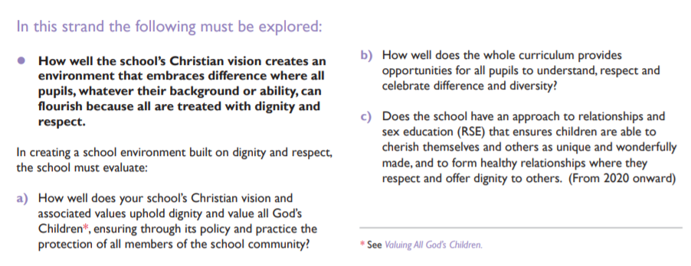

Important Documentation - Valuing All God’s Children
https://www.churchofengland.org/sites/default/files/2019-07/Valuing%20All%20God%27s%20Children%20July%202019_0.pdf

Please have a read of this and ask questions/seek further information etc

LANDSCOVE C OF E PRIMARY SCHOOL
Academy Head Report for the School Ethos Group

PUPIL NUMBERS

R 14
Y1 13
Y2 14
Y3 10
Y4 11
Y5 12
Y6 10
Total 84

CLASS ORGANISATION
- Class 1 : R (0.4 Lucy Field, 0.6 Jo Woods)
- Class 2: Y1 & Y2 (0.9 Jenny Foster, 0.1 Amanda Richardson)
- Class 3: Y3 & Y4 (0.5 Anna Neville, 0.5 Anne Smart)
- Class 4: Y5 & Y6 (Karen Barlow FT, Amanda Richardson 0.1)

STAFFING UPDATES
- I’m pleased to let you know that Mrs Richardson (Amanda Berry) is pregnant with baby number two. As a Trust we are supporting her to work differently within C19 guidelines, and she will be delivering lessons remotely on Fridays. HLTAs will be supporting in class. We wish her lots of luck!
- Annie Smith has joined the team, working in Class 1 as a 1-1 TA. She has become an instant Landscovian!
- I am sad to announce that Mrs Lucy Field will be leaving us at the end of the summer term. She is seeking new adventures and challenges. She will be much missed. The recruitment process is well under way.

SCHOOL IMPROVEMENT PLAN & SCHOOL SELF EVALUATION:
- I have been beginning to sign off key areas our school improvement plan and will discuss the outcomes so far with our link governor this week. Our new improvement priorities are underway – although not quite finalised. I will share these with you at the next LEG meeting.

OTHER INFORMATION – VISITORS - COURSES ETC
- Across Spring 2, and the beginning of the summer term, Landscove and Broadhempston have held joint staff meetings and Inset programmes which has enabled a sharing of expertise and workload!
- 2 TAs have completed HLTA training - working with Lizzie Lethbridge (EIT) and other HLTAs across our Trust
- The Trust Inclusion hub continue to offer therapeutic support to some of our families
- Class 4 have been on 2 Dartmoor adventure days (even the rain did not stop the fun!)
- Class 3 will be visiting Riverford farm – having been offered the opportunity by former pupil Will Watson.

HEALTH & SAEFTY/ SAFEGUARDING/ BEHAVIOUR
- Covid19: We continue to take advice from the Dfe and Public health England alongside the lead for education in Devon. We have daily updates that enable us to keep up with developments and what is being asked of us. Our risk assessment for school is a live document and responsive to the latest advice. Heads meet weekly with our CEO and Trust wide decisions are made with regards to RAs, protocols and procedures.
- PSHE, wellbeing and re-establishing learning behaviours has continued to be a key focus as we returned after Easter.

Anna Neville & Jill Ryder

