Learning to read at Landscove

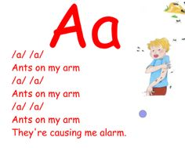
Initially, for the children to learn their sounds we use a programme called Jolly Phonics. Jolly Phonics represents each sound with an action helping children to remember both more easily.
Jolly Phonics website - www.jollylearning.co.uk

At this stage, the name for the letter, as in abc, is not as important as the sound it makes, and the way we say the sound is quite precise, so f is ‘ffff’ rather than ‘fuh’ and m is ‘mmm’ instead of ‘muh’!

We also use a scheme called Letters and Sounds which outlines the teaching sequence of phonics from Phase 1 to Phase 6
We’ll be romping through the alphabet sounds in our daily phonics sessions, you can see on the sheet – (which we have stuck into the front of your child’s reading record) those sounds that have been covered in class, as they will be highlighted. Please reinforce these at home too and ask your child to show you the action to go with the sound. Notice, they aren’t taught in alphabetical order!
Once children begin learning sounds, these are used quickly to read and spell words. Children can then see the purpose of learning sounds. For this reason, the first six letters that are taught are:
‘s’, ‘a’, ‘t’, ‘p’, ‘i’, ‘n’.
These can immediately be used to make a number of words such as ‘sat’, ‘pin’, ‘pat’, ‘tap’, ‘nap’ www.phonicsplay.co.uk

Blending - for reading
To learn to read well children must be able to blend sounds smoothly together. E.g. they will learn to blend the sounds s-a-t to make the word sat.

Segmenting - for spelling
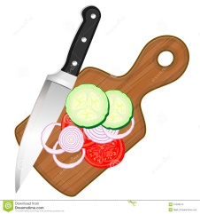
Segmenting is a skill used in spelling. In order to spell the word cat, it is necessary to segment the word into its constituent sounds: c-a-t. Children often understand segmenting as ‘chopping’ a word.

Key words:
Tricky words are those words which you simply can’t sound out, because they don’t sound as they look, ‘the’, for example, and ‘was’; for these words we teach the chn. to look at the pattern and shape of the word, saying it, taking a picture of it in their visual memory.
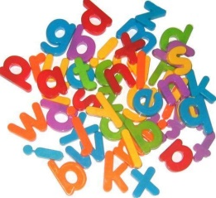
These words are joined by other words that can be sounded out, eg. ‘it’, ‘on’, ‘mum’…. Together, these make up a bank of sight words/key words/high frequency words that the chn. need to learn, so when they are reading they are beginning to recognise them.

We’ll be sending home a folder with six of these key words for your child to learn, plus lots of examples of games to play with your child, because if you turn it into a game, then it’s fun and not a chore!
Tricky words are preceded by a stop sign (of a hand) as a visual reminder not to try and sound out that word.

Reading books:
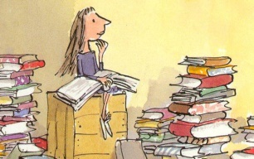
Children at this stage need to enjoy getting to know their book: Let them hold it and turn the pages – give them ownership of the book! They will invariably turn to the last page to have a look at what happens, but get them interested by…..
- Looking at the cover, guessing what it might be about.
- Really looking at the pictures, and using these for clues as to what is happening and matching to the words.
- Encourage using their increasing knowledge of sounds to look at initial letters to guess a new word.
- Can they recognise the odd key word eg and/ like/ the.
- Are they pointing to the words as they are said.
- Ask some questions about why something happens in the story, what do they think might happen next?
Wow – that’s a lot isn’t it? They will be relying a lot on memory at this stage to ‘read’ the book. So in order to get confident with all this, it’s important that they share the book at home a lot more than just once, so for this reason we don’t change books on a daily basis.
Encourage lots of pointing to each word… as they point to the words and say them, they will begin to recognise words and make connections between what they say and what the word looks like.
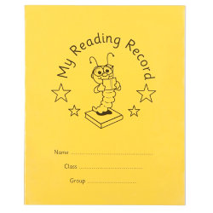
We really will appreciate your support with reading, so please use the reading record to put your initials or a little comment, this lets us know when you’ve shared the book at home, and then we can see that your child is ready for a new book. Don’t forget to use this record for any messages from home and sometimes we will use it to get a message to you. (Top tips for happy reading at home can be found on the inside back cover!)
Learning to read is hugely individual and should be very exciting, so please, if you have any concerns, do come and have a chat with us.

