**Final event:**

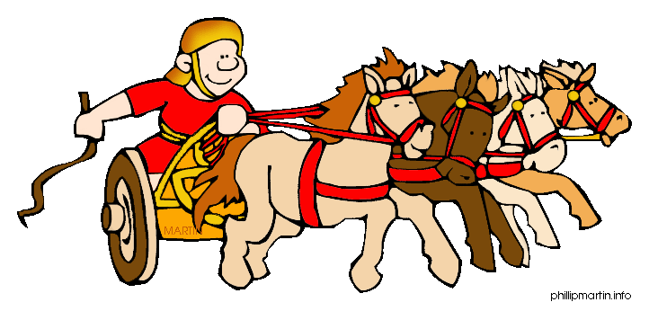

**Roman Day with a Roman soldier**

**Special event – Art Week**

**FaB Day**

**Harvest Festival**

**Healthy week**

MFL: Introductions

FaB: People of God

MUSIC – learning to play the trombone!

COMPUTING – SCRATCH programming

PHSE – healthy lifestyles

Maths – number & place value

**History:** Who was Boudicca?

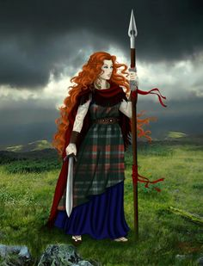

Who were the Roman Gods and Goddesses? Create Top Trump cards

**ENGLISH: Invent**

**Winter’s Child –writing our own version of Winter’s Child using our new knowledge.**

**ENGLISH: Innovate**

**Winter’s Child –creating a class story based on Winter’s Child**

**ENGLISH: Immersion Explanation text**

**Winter’s Child– Learning and remembering, boxing up, book talk, writer talk and sentence level work.**

**History:** When were the Roman invasions of Britain?

Why did they invade?

**DISCRETE**

**MATHS linked to Topic: Roman numerals**

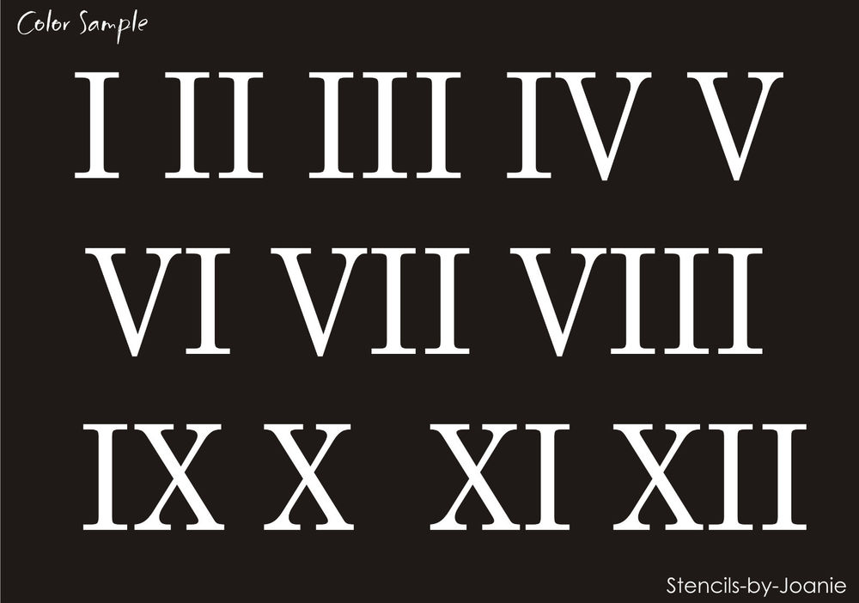

ART – Making Roman soldier shields 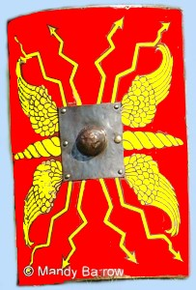

**History -How did Roman invasion affect Britain?**

**We will investigate:**

**-Roman Roads**

**-Hadrian’s Wall**

**-Roman Baths** 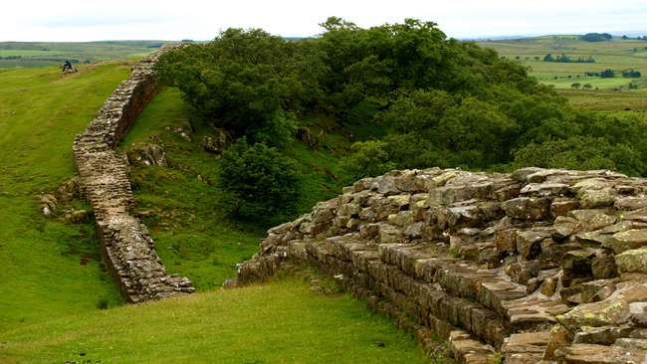

**GEOGRAPHY: Where was the Roman Empire? Comparing then and now using Atlas**

Mapping Roman Roads.

**HOOK: Horrible Histories – Roman Invasion HHTV News Report.**

**Elicitation – What do you know?**

***The Roman Empire***

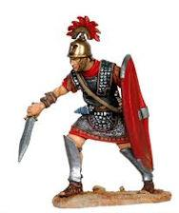

***and its impact on Britain***

Remembering & Understanding

Applying & Analysing

Evaluating & Creating

T

**PE: **



TAG RUGBY & TRI-GOLF – 2 new

sports to learn and enjoy…



WWL

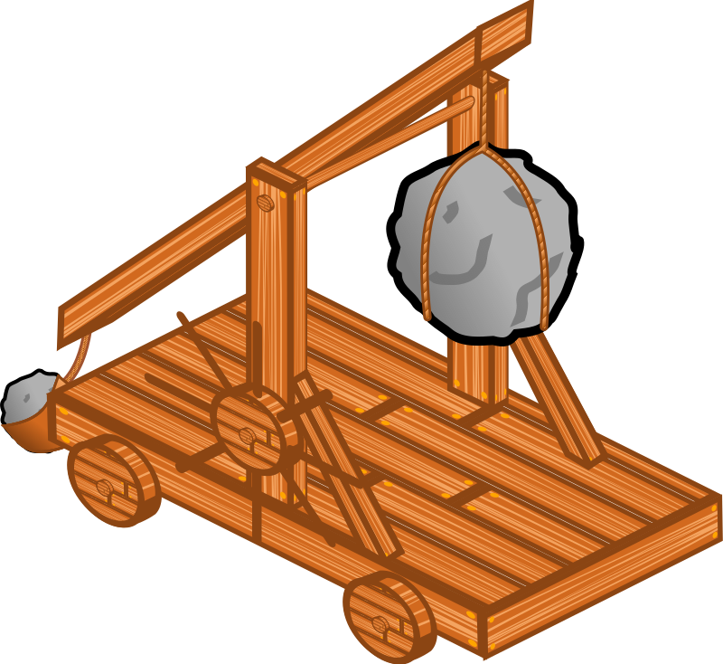

Links with our science and history topics – forces and the romans

**Science: Forces and Magnets –** investigations into how forces and magnetism affect our lifestyles

