Landscove C of E Primary School
Landscove, Nr Ashburton, Devon. TQ13 7LY
Tel: 01803 762656 Email: adminlandscove@thelink.academy

SCHOOL RETURN & NEWSLETTER Wednesday 3rd March 2021

Dear Parents and Carers,

Yippee!!! The staff are delighted that we will be able to welcome all children back to school on Monday 8th March. Our main priorities will be to reintegrate children back into the routines of school life, re-establish relationships and get back to some kind of normal! I can’t wait!

MENTAL HEALTH AND WELLBEING - COVID RECOVERY
The return to school will ‘look’ different for different children. Some will be excited; others will be worried or anxious and for some it will be a mixture of the two! Here are a few ‘top tips’ to help ease the transition.

1) Preparation-Over the coming days chat with your child about starting school in an ‘age appropriate ‘way. This is especially important if you think they are feeling ‘wobbly’. Talk through what will happen at drop off & who will greet them at school, mention things they like at school & remind them of different activities / lessons they will be doing. Share with them the ‘Recovery Curriculum’ topic planners get them excited about the learning coming up in the next few weeks! Let them help you get their uniform & school equipment ready. If you have particular concerns please make class teachers aware ahead of Monday.

2) Routine – Try to establish a good ‘back to school’ routine. For the most part children find routines reassuring. Knowing what to expect, helps to manage uncertainty & feelings of anxiety. Think about the mornings & evenings and put a consistent routine in place.

3) Sleep- Some children’s bedtimes may have gone a bit ‘haywire’ during Lockdown. Now is the time to get a good bedtime re-established. The children WILL be tired when they start back fulltime, as they will be using a lot of ‘brain power’, but also emotional energy! You may find they need more sleep than usual!

4) Chat - Build time to talk through feelings and emotions. Rather than saying ‘what did you do today?’ Think about rewording questions: ‘how are you finding being back at school? ‘What made you happy today?’ ‘What did you enjoy? ‘What did you find tricky or challenging today?’ ‘Tell me the best thing about your day’.

5) Gratitude -Encourage your child to pick out and share positives from each day. When they go to bed can they tell you three things they are grateful for? This helps with our general wellbeing and feelings of ‘contentedness’. 😊
Mrs Lucy Field

OUR CURRICULUM ON OUR RETURN…
When we return it will be at the beginning of the national science week and so we aim to welcome the children back to a creative, thematic approach based on science, design technology, and PSHE/wellbeing. Of course, English and maths are woven into some creative and motivating learning experiences that the staff have been working on since the announcement of our return.
Do take a look on our school website; recovery curriculum topic webs can be found on individual Class pages. I am assured these will be published by the end of the week, if they’re not already there. I will be updating the school Risk Assessment, which once completed, will be found on the COVID 19 tab on the website and includes all the measures we are taking to minimize infection risks.

COVID GUIDANCE
The majority of information in the latest Government Operational Guidance is the same as it was in December, so we will be returning to the routines previously established.

This will mean that we are able to run breakfast and after school clubs in a normal fashion as well as running sports clubs. Mrs Smart is currently arranging for Mr Tanner and 2 other providers to get these clubs up and running as soon as possible. More details will follow once these are in place. Breakfast club will run from 7:45-8:45 and after school care will be running from 3:30-5:30. A separate risk assessment will cover these activities.
Peripatetic music teachers will be invited back into school and will be required to take twice weekly lateral flow tests. A separate risk assessment will cover these activities.

Due to the size of school, the number of siblings across year groups and the necessity for staff to cross bubbles to support and to use the loo(!) we will be running Landscove as one Bubble, although operationally EYFS will, for the most part, be in their own Bubble. This is possible as Class 1 have their own playground, toilets and entrance. Classes 3&4 will also be operating as a bubble in terms of playground use and lunch service.

Staggered start and end to each day:
• C3 & C4 children to arrive at 8:45, enter school via pathway to playground. To be met by class teacher at the school gate by the road and directed to go straight to class and wash hands, apply sanitizer and sit at own desk (monitored by class TA). Parents will be required to queue carpark side, on the social distance lines provided when dropping children to school. Pick up will be from the same point at 3:15.
• C2 children to arrive at 9:00, enter school via pathway to playground. To be met by class teacher at the school gate by the road and directed to go straight to class and wash hands, apply sanitizer and sit at own desk (monitored by class TA). Parents will be required to queue carpark side, on the social distance lines provided when dropping
children to school. Pick up will be from the same point at 3:30
• EYFS children to arrive at 9:00. Pupils to enter school via EYFS playground. To be met by class teacher at the school gate by the road and directed to go to wash hands, apply sanitizer and sit at own table (monitored by class TA). Parents will be required to queue roadside, on the social distance lines provided when dropping children to
school. Pick up will be from the same point at 3:30
We will be reminding all the children of the importance of good hand and respiratory hygiene and staff will continue to routinely disinfect surfaces and tables throughout the day. We will also be ensuring that areas used by the children are well ventilated.
The guidance explicitly states that school uniform does not need to be cleaned more often than usual or using different methods. We will still be asking children to come in in PE kit on the days that they have PE.
We will be actively supporting the children as they adjust to daily school routine again, re-establish relationships and enjoy those all-important face to face friendships.

Please don’t forget to order your child’s school dinners which you will find on Parent Pay – please order 48hours in advance. Breakfast and after school care can also be booked via Parent Pay.

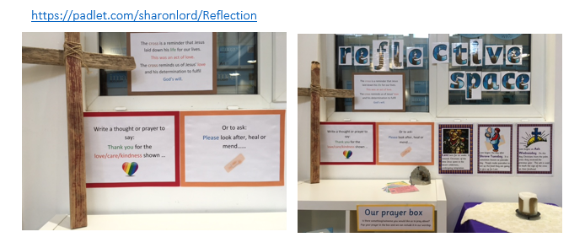
VALUES
Next week the children will have the opportunity to add their own ‘hearts’ or ‘plasters’ to our reflective space in school. If you would like to share your own thoughts, prayers, or reflections, please follow this link to our Padlet Reflective Board.

For their remote learning in FaB this week, Class three were asked to share their existing knowledge of Holy Week and raise questions regarding any aspects they find puzzling or would like to learn more about. Their responses showed deep thinking and careful reflection. We are looking forward to discovering the answers together in class.
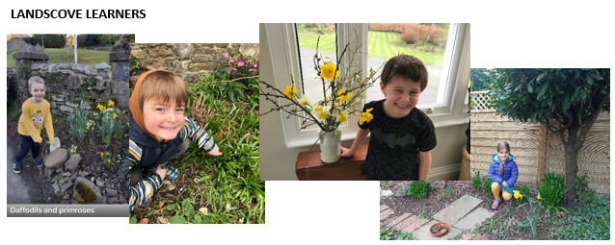

Some fabulous learning- well done!

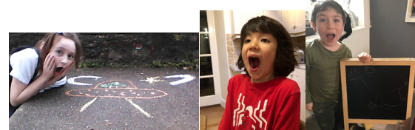

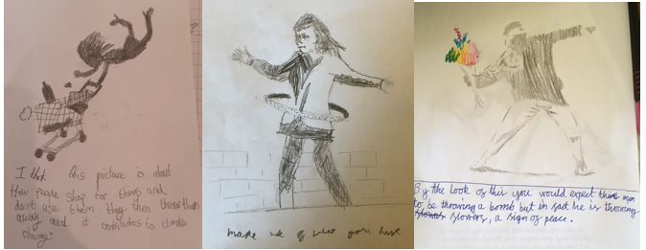

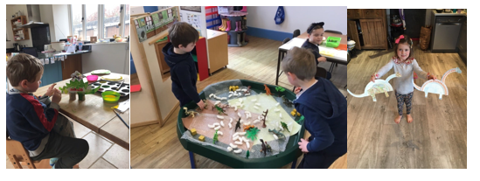

I am so glad that everyone is going to be back next week and hopefully it will be the last time we have to lockdown – fingers crossed! I look forward to welcoming everyone back and cannot wait to hear the buzz of children’s voices and laughter fill the building.
Let’s hope for a sunny and restful weekend to get us totally ready for a fun packed few weeks before Easter.

Link Academy Trust – Registered Office Address
Landscove School, Landscove, Ashburton, Newton Abbot, Devon.TQ13 7LY
Tel:- 01803 762113 Email:- admin@thelink.academy

