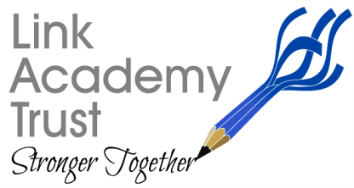
LINK ACADEMY TRUST
L a n d s c o v e S c h o o l H o u s e
L a n d s c o v e , Nr A s h b u r t o n
Devon. T Q 1 3 7 L Y
T e l : 0 1 8 0 3 7 6 2 1 1 3

Wednesday 1st December 2021

Dear Parents and carers,
Link Academy Covid Update

As you will be aware across the Southwest region, and most particularly in Devon, we are seeing a significant increase in positive Covid cases which, in turn, is having an impact on both our pupils and staff attendance in some of our primary schools. I am sure you are also as concerned as we are about the new Covid variant Omicron as England's deputy Chief Medical Officer Jonathan Van-Tam has said that this variant is of increased concern.

As we progress towards the end of the Autumn Term, and break for the festive holidays, I want to reassure you that we will do all we can to minimise the spread of infection while keeping our schools open and ensuring, as far as possible, that all our families are safe to enjoy the Christmas period.

We have decided that each school will continue with their established system of controls and, where we can, we will strengthen these by reducing mixing where this does not affect learning, however we will not resort to the ‘bubble’ arrangements as before, unless directed by government.

To this end we will also continue to ask parents to wear face coverings when gathering to collect and drop off children. Staff for their part will continue with their weekly LFD testing regime.

As an additional means of preventing the spread of infection, all Christmas performances will be reviewed in line with each schools’ facilities. Christmas Fayres, nativity plays, carol services etc will go ahead where possible but we ask your patience if we feel the numbers attending need to be restricted. In some cases, we might need to move the venue, perform outside or in extreme situations put the performance online or even postpone to a later date. Each school will be making their own arrangements to ensure that our children still enjoy these experiences while remaining as safe as possible to enjoy the whole Christmas holiday, it is essential that we take sensible steps now.

I want to thank you all for your continued support and understanding. I would also like to take this opportunity to wish you and your families a safe and festive break and thank you for all your support during the past year with all its ups and downs!

Kind regards,
Nicky

