LANDSCOVE C OF E PRIMARY SCHOOL
RE & CW Lead Report for the School Ethos Group

June 2020

SCHOOL ETHOS, SIAMS & RE
- 25.2.20 Sharon met with Anna to look at key areas of RE & CW development / leadership
- 5.3.20 Jill drafted our Ethos Group terms of reference to discuss at previous meeting. This has since been worked on by Sharon Lord before coming to you. (10th June 2020)
- 10.3.20 Rev Tom met with Anna to look at how he could support teaching and learning in RE
- 11.3.20 Jill attended the Diocese School Leaders Conference - Roots & Wings: Flourishing for all. It was very interesting and confirmed the central importance of our vision for our school being understood by all and being ‘lived out’ by the whole community ~ which I think it is! A key document: Called, Connected & Committed looks at leadership practices and how these shape a school. Of particular interest are the following:

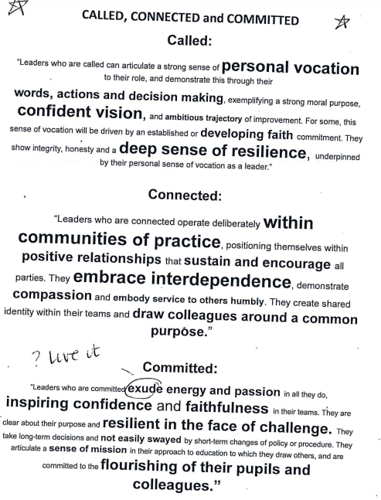
- These characteristics underpin a sustained, clear vision.

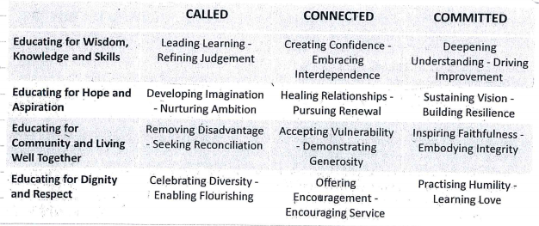
What are our strengths and what does it look like? This is something I intend to look at with staff.

- I also completed workshops on celebrating diversity~ acting locally and thinking globally as well as being ‘scandalously inclusive’ ~ the idea being we lead, think, & learn better because of diversity and inclusion. Retention of early career teachers was also the key theme of another workshop (currently 40% of new teachers leave the profession by Y5. It is evident that many new teachers are not ‘school ready’.) Coaching and collaboration are the buzz words of this workshop and I will look at our Trust programme to see where we might be able to add this in.
- Anna has completed a book scrutiny of RE across all classes. It was really encouraging seeing how well staff have embraced the new RE syllabus teaching materials and children’s books/class scrapbooks reflected a diversity of engaging activities, a clear balance between Christianity, religions and beliefs ~ a very positive result for our first year of using this material. Feedback from our Ethos group indicate that they are very positive about the changes and enjoy finding out about religions and beliefs (particularly those they know little about / have little experience of.)
- 16&17.3.20 Classes 2 and 3 visited Buckfast Abbey for an extra ordinary Easter egg hunt.
- Anna has used some of our lockdown time to sort through our RE resources and review our collective worship rolling programme
- Collective worship has been maintained but in classes. Anna has provided staff with CW material for daily acts of worship.
- 30/6/20 - Anna took part in CDP (via zoom)Primary RE Updates. Focused on knowledge organisers and making learning stick.

LANDSCOVE C OF E PRIMARY SCHOOL
Academy Head Report for the School Ethos Group

June 2020

PUPIL NUMBERS

R 15
Y1 15
Y2 10
Y3 16
Y4 10
Y5 11
Y6 13
Total 90

CLASS ORGANISATION
- Class 1 : R 15 (0.4 Lucy Field, 0.6 Jo Woods)
- Class 2: Y1 & Y2 26 (0.8 Jenny Foster, 0.2 Jill Ryder)
- Class 3: Y3 & Y4 28 (0.5 Anna Neville, 0.5 Anne Smart)
- Class 4: Y5 & Y6 23 (Karen Barlow FT)

STAFFING UPDATES
- I’m pleased to let you know that Mrs Richardson (Amanda Berry) will be joining us once more in September, but just for one day a week. She will teach in class 2 on a Friday.
- Miss Jenny Foster has now become a permanent member of team Landscove.

SCHOOL IMPROVEMENT PLAN & SCHOOL SELF EVALUATION:
- I have been signing off our school improvement plan and will discuss the final outcomes with our chair of governors in the next week. Our new improvement priorities are underway

OTHER INFORMATION – VISITORS - COURSES ETC
- Across Spring 2, half term Landscove and Broadhempston have held joint staff meetings and Inset programmes which has enabled a sharing of expertise and workload!
- 2 TAs have accessed further HLTA training and are working with other HLTAs across our Trust
- 11.2.20 Jill attended DAPH conference~ this updates Heads with all that is about to change/become statutory etc
- 11.2.20: Karen attended the Jurassic Maths Hub looking at the development of Maths Mastery.
- 25&27.2.20 parent consultation evening
- 27.2.20 EP consultation with staff
- 27.2.20 Class 4 attended a Fair trade conference ~ lots of positive feedback from the children about this
- 9-13.3.20 Science week~ fun activities ranging from animal encounters to making seed bombs. Thanks to FOLS for their financial support.
- 12.3.20 an afternoon of science and sports relief with parents~ great fun!
- 20.3.20 school closed due to national lockdown

HEALTH & SAEFTY/ SAFEGUARDING/ BEHAVIOUR
- Covid19: We take advice from the Dfe and Public health England alongside the lead for education in Devon. We have daily updates that enable us to keep up with developments and what is being asked of us. Our risk assessment for school is a live document and responsive to the latest advice.
- New cleaners have been employed. Over the February half term Shaun and his staff deep cleaned the school ~ it smelt & looked wonderfully clean when we came back! This high level of service has continued to be delivered
- Landscove had a 4-hour safeguarding audit on 25th February 2020. This was completed by a County Safeguarding lead and the Trust Safeguarding lead also attended. The only target we were given was a typo in our policy!

LOCKDOWN UPDATES
- Well you could say we’ve been living through odd and challenging times. Much of my time recently has been spent ensuring I can keep children, staff and parents safe and secure in school. Risk assessments are becoming quite a strength for me!
- Landscove has acted as a Hub school for Broadhempston families as well as our own families. Staff from both schools have worked with Jill to ensure a tight timetable of support staff and teachers, enabling key workers and vulnerable children access to educare.
- Since the 1st June teachers have taught full time as well as provide home learning, keeping weekly telephone contact with our vulnerable families and those who need a bit of additional support, alongside supporting their own children and families at this time.
- Matt Matthews, our Trust business manager, put together a workforce~ me, Ellie & Linda, who pack fortnightly food boxes, for those families across our Trust who could do with this support. On average, we pack 40 boxes, which the Heads then deliver on Thursday & Friday.
- I have been able to offer support to a family & SDCC as an outreach for a Y7 pupil.
- You will have no doubt heard that we are having a socially distanced Y6 leavers picnic on Friday 3rd July. Not our usual end of year service, but we aim to say goodbye in a sort of time honoured tradition.
- We are currently working a successful ‘Bubble’ structure to our days at school. This has been a positive experience for all and we will be welcoming back different year groups over the coming weeks left this year.
- The Trust put out a survey to see how home learning had been received. There were many varying comments.

52 families responded
Are you finding the amount of work set: |  | Is the level of challenge for your child |  | 3.Are you finding trying to teach your child: |  | Average time spent learning.
Too little | 5/52 | Too easy | 6/52 | Enjoyable | 3/52 | 1hr | 24/52
Right amount | 40/52 | Just right | 43/52 | Stressful | 10/52 | 2hrs | 22/52
Too much | 7/52 | Too hard | 3/52 | Sometimes enjoyable/stressful | 39/52 | 3 or 4 hrs | 6/52
Engagement:
85% of our pupils engage with home learning (some of our children are doing their own thing) ~ daily/3+ weekly work has been uploaded and shared with staff
5% engage with 1 or 2 items per week/own learning
10% of our children have not engaged with home learning at all
As a result of our survey:
- The Trust are looking to develop the use of TEAMS as an online learning platform for the children
- Staff will be running a KS1&2 themed fortnight to enable families to work from the same starting point. Teaching clips will be uploaded alongside project tasks. A timetable/checklist will accompany this.
- I will be working across the summer with Heads from the Trust to ensure we are ready for September, in whatever form it takes! We will have weekly meetings to stay up-to-date and prepare for the autumn term.

I can honestly say I have never been in school when it felt quite so unusual!

Jill Ryder & Anna Neville

