

Landscove C of E Primary School
Landscove, Nr Ashburton, Devon. TQ13 7LY
Tel: 01803 762656 Email: adminlandscove@thelink.academy

NEWSLETTER Thursday 23rd April 2026
Dear Parents,
Welcome back! I hope you all had a lovely break, and everyone is well rested for the start of another busy term!

DATES FOR YOUR DIARY
28.4.26 | Y3/4 football @ KEVICC with Mr Tanner
29.4.26 | Class 4 visit to London – Westminster Abbey & the Houses of Parliament
01.5.26 | May Day event @ Woolston Green 2pm
11-14.5.26 | KS2 SATS
18.5.26 | Y5/6 football @ Stoke Gabriel with Mr Tanner
22.5.26 | Class 1 Forest School Day
22.5.26 | Break up for half term
COMING UP – ADVANCED NOTICE
15.6.26 | SPORTS DAY WITH MR TANNER a.m. for children only.  1:30 parents invited to join us for our traditional sports day
No doubt there will be a few other things to add to this list as the weeks go by but this gives you a good idea of what’s ahead for this half term.

SONG MACHINE GOES TO LONDON! What a fabulous day for Song Machine! A London adventure for making memories... A West end musical - Matilda-, seeing the sights and enjoying the buzz of the city. Huge thanks to Jas Searle, Amanda Grant and Becky Drew for supporting the day and all the fun!
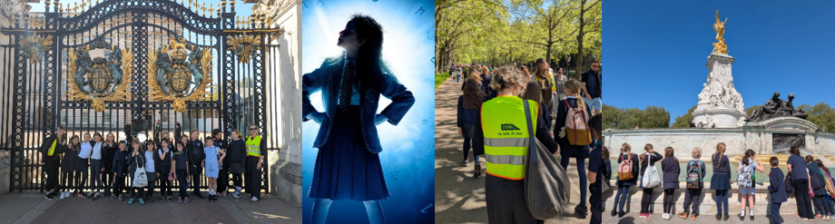

MAYDAY: School May Day event at Woolston Green on Friday 1st May Another traditional Landscove event where the children perform a number of country and Maypole dances as well as singing a few seasonal songs. We are (weather permitting) aiming to be on the village green for a 2:00 start, giving us plenty of time to complete everything before returning to school by 3:30. The BBC weather is predicting a cloudy day with a bit of a cool breeze so I would suggest that the children bring a warm outer layer with them to put on and off as required during the event. You are, of course, cordially invited to join us. You can park down around the Green or leave your car at school and enjoy a stroll down and up the pathway that runs along the edge of the farm land. I hope to see lots of you there.
Huge thanks to the band of parents who are supporting us to do this on the Green!

STAFFING UPDATE
Mrs Barons will be stepping in alongside Mrs Neville to teach in class 4 from June 15th. She will continue to work in Reception for her usual 2 days but is looking forward to stepping back into KS2 – we really will be making the most of having her here practically full time! Miss Hart has decided to step away from teaching and has secured a position with the environment agency. We wish her every success in her new career and hope she pops back to see us when she can!
FOLS Update

A big 'hello' from FOLS, where we are busy thinking about the school community events and fundraisers we will run for the remainder of this academic year. As always, please contact fols@outlook.com if you have an idea for a school community or fundraising event-we would love to hear from you.

This Friday 24th April-Second Hand Uniform Sale and Ice Lollies-3.15-3.45pm
Come and grab a bargain-all items either £1 or 50p (cash or bank transfers to FOLS account). Thank you to our second hand uniform coordinators and the Landscove Eco Group for setting this up.

At the same time we will be selling ice lollies for £1 each, seeing as the sun his finally making an appearance this year.

May Day Refreshments-1st May
Maypole dancing we will be serving refreshments-drinks, cakes and maybe ice lollies if the weather is looking good. Please bring cash. Email fols@outlook.com if you can help on the day or make some cakes for our cake stall.

Looking Ahead-Help Please!
Recruiting for the following positions 🙂

Sports Day-15th June-refreshment tent coordinator (plus small team of helpers). Please speak to one of the FOLS team or email fols@outlook.com

Summer Fair-3rd July. Shout out for someone/a couple of people to lead this event (or an alternative summer fundraiser idea) and rally a team of coordinators. This is usually a big one for us and we would love to continue to run an event. Please speak to one of the FOLS team or email fols@outlook.com

Ice Lolly Fridays-most Fridays after May half term
We will shortly be putting up a Ice Lolly Friday sign up sheet outside the school office-please add your names
In the past we have also run alternatives such as a fruit kebab shop. Always open to ideas and volunteers so please have a think about how you can get involved. Please speak to one of the FOLS team or email fols@outlook.com if you would like to know more or have an idea.
Kind regards, Becky Drew.

KS2 SATs
Just a reminder to the parents of children in Year 6 that the annual SATs tests are being held during the Week beginning 11th May. I’m sure that all the children will be fine and do their best, in the traditional Landscove way, but I can assure them that it won’t be anywhere nearly as bad as they might think it is going to be!
KS1 also do SATS but we keep this low key and have quiz days! All children across the school have some form of formal assessment in the summer term, but rather than have a high profile we prefer to do this the ‘Landscove way’ and keep it as low key as possible.

A message from Julia at Theatre Train
It was lovely to pop in for an assembly on Wednesday 22nd April! The children had a flyer to take home, and I wanted to add that we are now also open to children in Reception. Do feel free to ring or text me on 07752 726028, or to visit www.theatretrain.co.uk/torbay to find out more about us. We are planning to share a little performance at the end of the school year.
Thank you, Julia.

Attendance:
(Our school target is 96.8%)

Whole school | 95.0%
Class 1 | 94.6%
Class 2 | 95.3%
Class 3 | 96.3%
Class 4 | 93.5%
Well done to Class 3!
SAFEGUARDING & ATTENDANCE
Please follow this link to see all the online safety updates that have been posted on our website.
https://sway.cloud.microsoft/pKuNZwodRrzKLNYd?ref=Link
If you are concerned about a child’s wellbeing, please contact the school or in non-school hours contact FRONTDOOR on 0345 155 1071. Our designated safeguarding officer is Mrs. Ryder, and the deputy safeguarding officer is Mr. Ansermoz.
That’s all for now, have a lovely weekend!


