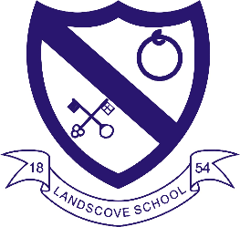
LANDSCOVE C OF E PRIMARY SCHOOL
RE & CW Lead Report for the School Ethos Group 19th Sept 2024

We started the year with a training session on our Non Pupil Day from the Food for thought group – the school garden got our attention for an afternoon!
As we are at the beginning of term we have just gathered our Ethos group together ~ the following are the minutes from the first meeting of the year
Thursday 12th September 2024:
Agenda
1. Welcome our new members
2. Update on Global Neighbours Silver Award – Fair Trade
3. Plans for Harvest
4. Requests
Minutes/Actions
1. Mrs Neville welcomed our new Y2 members, Joa and Cillian, and thanked existing members for agreeing to remain part of our group.
2. Following a phone conversation with Alison Brown, the Global Neighbours Schools Programme Officer, during the holidays, Mrs Neville was able to provide an update of the aspects we need to focus on in order to get our Silver Award. All group members were keen to become part of a Fair Trade Group and work towards a Fair Active Award.
Mrs Neville to arrange a meeting with Linda from the kitchen to find out which Fair Trade products are already used.
Ethos Group to lead CW on 26.9.24
Recruit a volunteer from our adult Ethos Group
3. All group members were in favour of collecting donations for Buckfastleigh Food Bank.
4. Further visits to St Andrew’s House
Miss Capaldi and Mrs Grant plan on taking the Song Machine. Mrs Neville to set a date for this.

Coming up this half term:
- 4.10.24 Harvest festival @ St Matthew’s
- 9.10.24 Sharon Lord & Anna to lead training on new RE syllabus
- 23.10.24 Hindu Speaker for KS2

LANDSCOVE C OF E PRIMARY SCHOOL
Academy Head Report for the School Ethos Group

PUPIL NUMBERS

R 14
Y1 7
Y2 13
Y3 16
Y4 15
Y5 12
Y6 12
Total 89

CLASS ORGANISATION
Class 1: R (Rebecca Barons & Jo Woods)
Class 2: Y1 & Y2 (FT Jasmine Capaldi)
Class 3: Y3 & Y4 (Luke Ansermoz FT)
Class 4: Y5 & Y6 ( Anna Neville & Jo Lunt)
SCHOOL IMPROVEMENT PLAN & SCHOOL SELF EVALUATION:
Key priorities are as follows:
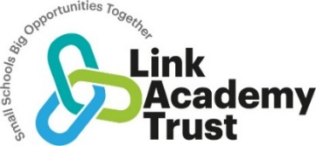
Landscove Academy Strategic Improvement Priorities

Key Improvement Priorities 2024-2025
Landscove will use the keys to unlock the very best of us!
Key Priority 1: RELATIONAL APPROACH (Trust priority)  To embed the relational approach in “every person, every interaction, every moment”. To continue to ensure that staff (including new staff), children and stakeholders understand and are confident with our relational approach. Begin to involve children in the leading of the approach – behaviour champions. | 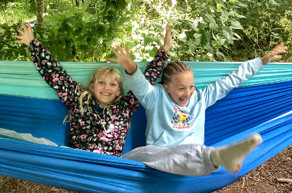  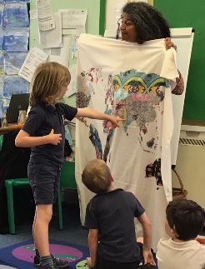
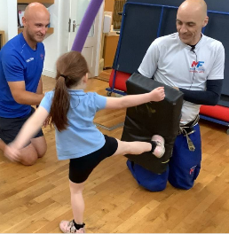  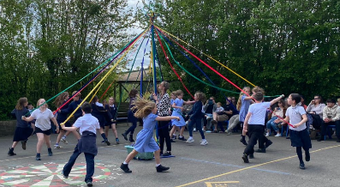 | Key Priority 2: WRITING (Trust priority)  To improve the outcomes in writing across the school. This will include developing pupils’ ability to monitor, direct and review their own learning through a range of focus areas, including Bookwrites teaching sequences best practice, handwriting, spelling and sentence structure.
Key Priority 3: FEEDBACK & ASSESSMENT  Use feedback and assessment within lessons to track and ensure children know more and remember more. Have a consistent approach to foundation subject assessment to enable subject leaders across the school ensure children know more and remember more. | 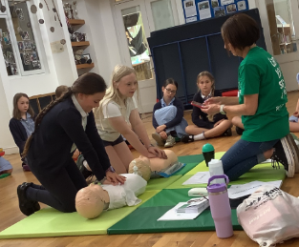  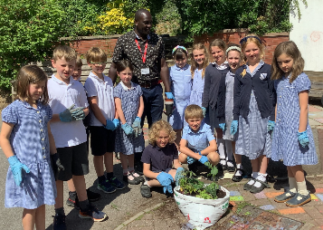
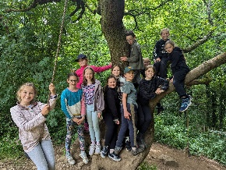  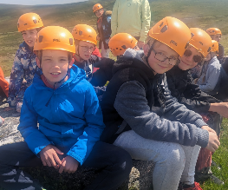 | Key Priority 4: SEND:  For all staff to review OAIP and to further develop adaptive teaching strategies to provide all pupils the opportunity to experience success in all lessons they meet in school. Children with additional need will, where possible, keep up to catch up.
Key Priority 5: LIFE IN MODERN BRITAIN  To continue developing children’s understanding of life in modern Britain alongside building on our global citizenship projects across the year. | 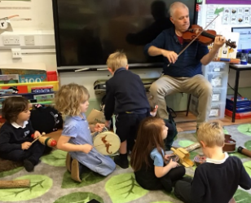  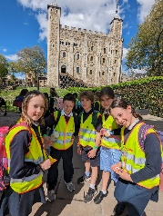

We are a school that is built on success stories; some big, some small, some public but most private. The message is simply that we want all the children to feel the warm glow of success and be motivated individuals who are constantly striving to unlock their potential to do exceptional things.

OTHER INFORMATION – VISITORS - COURSES ETC
- 3.9.24 NPD1 Trust wide training day · Visiting author to inspire staff and Devon Literacy Team training on improving writing outcomes.
- 9-11.9.24 Parents meetings held for new classes
- 9-13.9.24 Reception baseline has been completed.
- 10.9.24 TA intervention training with Rosina @ LC (Landscove and Broadhempston staff.)
- 11.9.24 Jo Woods – Phonics training for TAs .
- 14.9.24 Sarah Clarke Director of School Improvement visited Jill to look at data outcomes for 2023/2024 & look at targets Jill set for 24/25. We also discussed Interventions for those children not at ARE.
- 17.9.24 Trust wide cross-country event.

Coming up this half term:
- 23.9.24 Jill & Rosina to attend a PARM (planning & review meeting) With Becky Humphreys, Inclusion lead.
- 23.9.24 Jill to meet Lucy – Governor focussed visit
- 23.9.24/2.10.24 Trust training OAIP (Ordinarily available inclusive provision)
- 26.9.24 Jill to meet Director of inclusion to review inclusion at Landscove
- 4.10.24 Harvest festival @ St Matthew’s
- 9 &16.10.24 KS2 art workshops with Courtney Arnold
- 9.10.24 Sharon Lord & Anna to lead training on new RE syllabus
- 10.10.24 Y6 Junior Life Skills event
- 14-18.10.24 We Are Authors Week. Simon James workshops 15.10.24.
- 23.10.24 Hindu Speaker for KS2

HEALTH & SAFETY/ SAFEGUARDING/ BEHAVIOUR
- 4.9.24 All staff have completed L2 safeguarding training.
- All staff have completed a variety of mandatory compliance training: All areas have to be met & signed.
Annual training:  -Level 2 safeguarding (for staff and regular volunteers)  -Prevent (online Prevent duty training, for staff and regular volunteers)  -GDPR PowerPoint (staff only)  -Basic Health and Safety | Compliance checks:  -KCSIE updates, read and understood  - DBS – nothing has changed  Policies:  Safeguarding policy - read & understood.  Code of Conduct policy - read & understood.  Public Interest Disclosure policy - read & understood.

Safeguarding training this half term is based on: Keeping Children safe in Education (KCSIE), Domestic Abuse and Operation Encompass.
Anna Neville & Jill Ryder

