
LANDSCOVE C OF E PRIMARY SCHOOL
RE & CW Lead Report for the School Ethos Group 7th March 2025

- 24.2.25 Angela Redmond, Food for Thought gardener, spent the morning in school helping to prepare the garden for planting.
- 26.2.25 Reverend Gina Q&A session in Class 4 to end our Science and Religion: Conflicting or
- Complementary unit.
- All classes have explored the Ugandan Artefacts Box. We will be preparing an artefacts bag for Sue to take out with her in April.
- Fair Trade Ethos Group met with Business Manager, Mr Matthews. He has agreed in principle for the kitchen to make a Fair Trade swap. Linda liaising with supplier.

Upcoming Events
- 20.3.25 Sue Errington, Food for Thought Coordinator, working with Ethos Group then delivering CW. Focus on what like is like for children in our link school.
- 28.3.25 Mothering Friday Service in St. Matthew’s
- 2.4.25 Derek Holloway visit for Global Neighbours Silver Award Assessment
- Ethos members now deliver prayer box to classes – this helps ensure all children get the time and opportunity to respond to the Reflective Space and elements of CW.
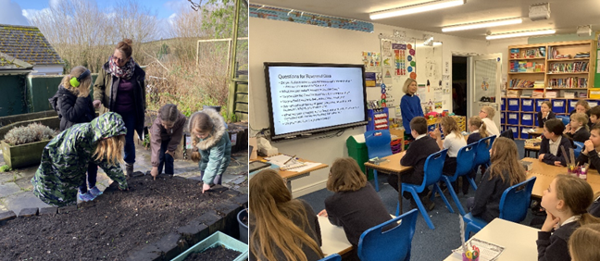
FaB – children reflecting on learning and articulating their worldview
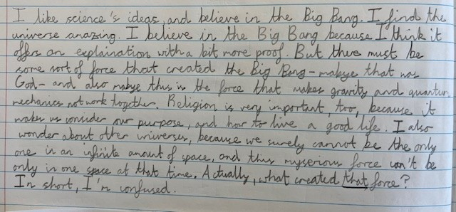

LANDSCOVE C OF E PRIMARY SCHOOL
Academy Head Report for the School Ethos Group

R | 14
Y1 | 5
Y2 | 14
Y3 | 15
Y4 | 15
Y5 | 12
Y6 | 12
Total | 87
PUPIL NUMBERS CLASS ORGANISATION
Class 1 | R | Rebecca Barons & Jo Woods
Class 2 | Y1&2 | Jasmine Capaldi
Class 3 | Y3&4 | Luke Ansermoz
Class 4 | Y5&6 | Anna Neville & Emily Hart

- We have 3 pupils who have applied for in year admission – these are moving forward.
- Numbers for next year look to be around 12. Confirmation due.
SCHOOL IMPROVEMENT PLAN & SCHOOL SELF EVALUATION:
Staff meetings this half term have/will cover:
- Writing – next steps to further develop
- Writing moderation with Harbertonford and Broadhempston
- Maths – lesson drop ins and books looks – feedback and next steps
- Review feedback policy and marking codes
- Sustainability planning
- Computing, geography & DT book looks
- PSHE/RSE updates
- Provision mapping and interventions – review and reset
I have updated the ASIP during half term and the SEF is also ready for an inspection should it be required. We are now in the Ofsted window and could get the call at any time
OTHER INFORMATION – VISITORS - COURSES ETC
- An ex-pupil has begun weekly visits as a work experience opportunity. She is currently looking at University applications and wanted to confirm her desire to teach. JR has completed all risk assessments and induction paperwork to support her to do this at Landscove.
- Jo Woods has held training across the term for TAs- Early reading
- Jo has observed English lessons across the school and offered feedback & even better ifs to all staff.
- 24.1.25 Class 3 educational visit to Eden Project
- 29.1.24 Class 2 educational visit to Occombe farm
- Week beginning 3.2.25 all staff have met Jill for pupil progress updates – analysing data and target setting
- February half term – as a direct result of JR completing a carbon audit for the school and meeting with Will Ewens from Lets’ go zero we have had all lights in school changed to LEDs – free of charge! A grant accessed through LGZ enabled this to go ahead.
- Early Career teacher meetings continue – one every half as well as meetings within the Trust and school – lots of support for continuous professional development.
Coming up
- 5.3.25 Jill to meet with national leader Will Ewen from Let’s go zero to discuss our sustainability plan and next steps. Matt Matthew, deputy CEO also attending.
- 14.3.25 C1 educational visit to Buckfast Abbey - Easter
- 28.3.25 Mothering Friday Service in St. Matthew’s
- 4.4.25 Easter Service St Matthews for the children

HEALTH & SAFETY/ SAFEGUARDING/ BEHAVIOUR
Safeguarding training this half term is based on:
- Protected characteristics,
- Ramadan
- Disguised compliance
- One chance rule
- We have a Trust safeguarding visit which will ‘test’ our safeguarding procedures on 11.3.25

Anna Neville & Jill Ryder

