
LANDSCOVE C OF E PRIMARY SCHOOL: School Ethos Group
CHRISTIAN DISTINCTIVENESS LEAD REPORT

Ethos Workshop at Buckfast Abbey
Tom and Beth to report.

Collective worship for the coming half term
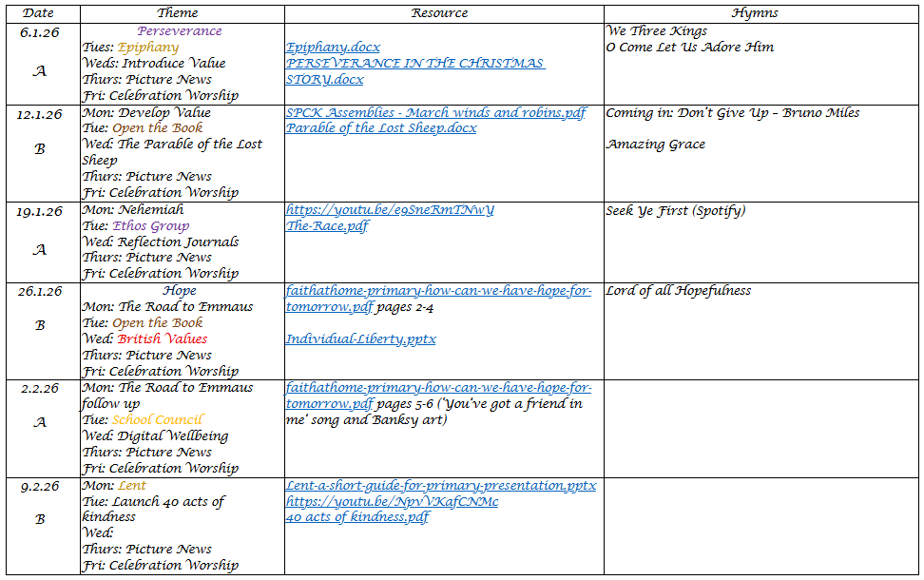
Class Reflection Journals
AN to share with group. Discuss how spirituality links to all areas of the curriculum. Planned and incidental.

Upcoming Events
Whole School vision, values and spirituality day. Are any members of our group able to support with this? Date TBC
Whole School vision, values and spirituality day. Are any members of our group able to support with this? Date TBC

- 4th March 26 Class 4 visit to Plymouth Synagogue
- 12th March 26 - Mothering Friday
- 25th March 26 - Class 3 visit to Exeter Mosque
- 1st April 26 - Easter Service

Parent Collective worship survey 16 responses 1=6.25%
Question | Responses | Comments/actions
What do you know about collective worship (assembly) in our school? Do you think it plays an important part in school life? | 1/16 negative My children do not enjoy it and for me I would rather it wasn’t a part of school life  Most linked to daily act, coming together, tradition, values play impt role | Ensure we put link to Xian distinctiveness page and a list of contents in our Welcome pack.  Make more of Xian Dist. In welcome meetings with new parents.
Does the school website tell you about collective worship? | 62% Yes  38% no | Have already put information into newsletter with links to the website CW area
Does your child enjoy collective worship and talk about it? | 38% Yes  38% sometimes  25% No | Survey children re CW. Guage what they enjoy the most.
Have you attended collective worship at school or Church? Do you feel it was appropriate for the children? | 27% Yes  13% maybe  60% No | Really interesting to note that parents have not considered all the times we come together as a community in church as CW.
Are festivals of the Christian year celebrated well in worship, and in such a way that all can learn and join in? (Harvest, Christmas, Easter) | 87% Yes  13% maybe | Make links between this & CW for parents
Are children from different backgrounds able to take part in collective worship in appropriate ways? Do children show respect for the belief of others? | It is taught about in school and there have been assemblies around that - there was one led by a Muslim woman who led a prayer  The range of backgrounds is probably narrow, but the children show respect, most of the time.  Most comments similar
Has collective worship helped your children know more about how and why Christians, and others, value times of prayer, stillness or reflection? | 56% Yes  38% maybe  6% No | CW survey for chn – I think they will offer a different perspective.
Can you tell us how a theme in collective worship has made your child think / do something differently? | He likes it when they focus on specific values and read the biblical story and then he'll point out when he thinks he's showing that value  Eco & out of the book mentioned as getting chn to think and ask questions  Have discussed spirituality and justice most recently  Most comments similar
As parents can you tell us what our vision and motto means to you? ( Matthew 7:7 "ask, and it will be given to you; seek, and you will find; knock and it will be opened to you." Landscove will use the keys to unlock the very best of us! | To me it means providing opportunities for children to experience success and supporting them with this (ask, seek, knock). Most comments are similar to this.  1 comment not so positive: I feel a school vision should come from those who are the school instead of a faith or belief – don’t like it . | Put vision and explanation in newsletter  Link to Xian Dist pages

ACADEMY HEAD REPORT FOR THE SCHOOL ETHOS GROUP
R | 11
Y1 | 15
Y2 | 6
Y3 | 15
Y4 | 16
Y5 | 15
Y6 | 12
Total | 90
PUPIL NUMBERS CLASS ORGANISATION
Class 1 | R | Rebecca Barons & Jo Woods
Class 2 | Y1&2 | Jasmine Capaldi
Class 3 | Y3&4 | Luke Ansermoz
Class 4 | Y5&6 | Anna Neville & Emily Hart

SCHOOL IMPROVEMENT PLAN & SCHOOL SELF EVALUATION:
Staff meetings this half term will be on the following and are directly linked to our ASIP or day to day running.
- OAIP SEND & inclusion- Ofsted toolkit
- MFL evidence check, English editing and proof reading
- Science week planning
- Art book look, Science rolling programme update
- SIAMS – area TBC Anna & Jill
- CAP review and actions, collate evidence
SEF & Ongoing SIAMS SEF are up to date
OTHER INFORMATION – VISITORS – COURSES
- 17/11/25 Governor monitoring visit
- Jas completed Funfit training (co-ordination intervention)
- 28/11/25 Y5&6 Link Fit Games with Mr Tanner
- Playground renovations – it looks great!
- 5/12/25 Christmas fair
- Christmas performances – all fabulous, well attended and heart warming
- 15/12/25 Santa run with Mr Tanner had to be cancelled due to weather. Cat & Matt are planning another run
- 17/12/25 Christmas lunch
- 17.1.25 Community crafting – linked to request from Rev Gina to create a display in church for the community carol service and Christmas period
- 18.12.25 Mr Phil – children’s entertainer – a great success and well loved by the children
- 5.1.26 NPD – staff training day
- 8.1.26 Ethos Group to Buckfast Abbey

COMING UP
- 20.1.26 Gemma Marels attendance & inclusion visiting
- 22.1.26 C2 Forest School Day
- 27.1.26 Trust Maths Hub meeting
- 2.2.26 English workbook scrutiny and reading drop ins – Jo Woods
- 3.2.26 Jill & Karen PSHE new rolling programme & update policy RSE
- 3.2.26 DSL Forum meeting – Jill attending
- 4.2.26 Jo attending KS2 Reading Fluency CPD
- 5.2.26 C1 Forest School Day
- 9.2.26 Children’s mental health week
- 12.2.26 C2 to Bygones
- 13.2.26 break up for half term

HEALTH & SAFETY/ SAFEGUARDING/ BEHAVIOUR
- Safeguarding training plan will be updated once all audits are completed.
- Our County safeguarding audit is due to be completed by February 13th. The Trust supports the completion of this document.

Anna Neville & Jill Ryder

