
LANDSCOVE C OF E PRIMARY SCHOOL: School Ethos Group
CHRISTIAN DISTINCTIVENESS LEAD REPORT
19th June 2026
9.6.25 Angela from Food for Thought project visited Class 3. The children learnt about: fruits, vegetables and their plant families the importance of nitrates in the soil the best ways to harvest our broad beans
17.6.25 AN led staff CPD on SIAMS development points
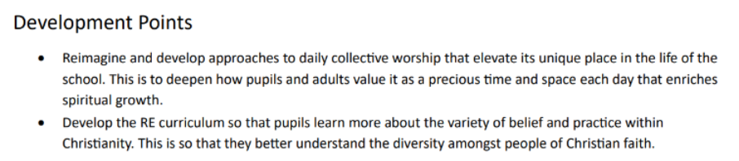
SIAMS development points
1.7.25 AN to attend RE Hub Leads meeting at Exeter Deanery

ACADEMY HEAD REPORT FOR THE SCHOOL ETHOS GROUP
R | 11
Y1 | 15
Y2 | 7
Y3 | 15
Y4 | 16
Y5 | 15
Y6 | 13
Total | 92
PUPIL NUMBERS CLASS ORGANISATION
Class 1 | R | Rebecca Barons & Jo Woods
Class 2 | Y1&2 | Jasmine Capaldi
Class 3 | Y3&4 | Luke Ansermoz
Class 4 | Y5&6 | Anna Neville & Emily Hart

SCHOOL IMPROVEMENT PLAN & SCHOOL SELF EVALUATION:
Staff meetings this half term will be on the following and are directly linked to our ASIP or day to day running.
- Assessment and curriculum coverage – linked to National curriculum, not scheme.
- Guided reading
- Science
- Trust NPD training on Writing developments
- RE/CW – taking SIAMS targets into coming year
- Maths – observation and feedback.
Staffing update – Please hold this as confidential until it goes in the newsletter this Thursday. Thank you!
- Mr George Ball joins us as HLTA – maternity cover for Tasha Lissaman
- Mr A will be joining Class 2 in the coming year, as part of a valuable professional development opportunity. Mrs Searle will be moving to Class 3 where we know her enthusiasm and expertise will make a wonderful impact on the children’s learning. We are delighted to support them both in this next step of their careers.

OTHER INFORMATION – VISITORS – COURSES
- 29.4.26 C4 trip to London – Westminster Abbey & Houses of Parliament tour.
- 30.4.26 Head teacher interviews for Landscove
- 1.5.26 May Day event – on the village green
- 4.5.26 BANK HOLIDAY
- 5.5.26 Jill to attend Trust leadership development day
- 11-14.5.26 KS2 SATS
- 18.5.26 Year 5 & 6 Football tournament @ Stoke Gabriel
- Week beg 8th June Y1 Phonics screening & MTC
- 9-12.6.26 Y5/6 residential @ the Dartmoor Centre
- 15.6.26 Landscove Sports day with Mr Tanner
- Week beg 15.6.26 KS1 SATS
Coming up:
- 18.6.26 Classes 1&2 visit to Wembury
- 29.6.26 Mrs Last in school for the day
- 2/3/6/7/8.6.26 Class 4 swimming lessons
- 3.7.26 FOLS Summer Fair ~ Mrs Last joining us today
- 9.7.26 KS2 Production – The Wizard of Oz, Landscove Village Hall 2pm
- for parents and families of Class 3
- 10.7.26KS2 Production – The Wizard of Oz, Landscove Village Hall 2pm
- for parents and families of Class 4
- 13/14.7.26Class 3 residential
- 13/14/15.7.26 Y6 Bikeability
- 20.7.26 Kip running music workshops for C1, C2 & C3
- 21.7.26 Year 6 leavers service,10am St Matthew’s, refreshments at school afterwards

HEALTH & SAFETY/ SAFEGUARDING/ BEHAVIOUR
Work during the last term looked at:
- SG this half term has been /will be linked to INCEL & RSE
- We are about to send out our draft RHSE policy and parent letter as a means of consultation – parents can feedback by 26th June should they wish to.
- Finalising actions on S175 action plan – ready to RAG rate for the end of the academic year.

Anna Neville & Jill Ryder

