
Landscove Academy Strategic Improvement Priorities

Improvement Priorities 2026-2027
Landscove will use the keys to unlock the very best of us!

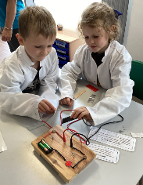
Priority 1:
To ensure that assessment and feedback are used consistently to aid high-quality teaching and learning for all pupils. (English and Maths priority)

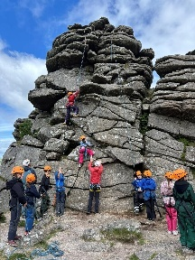
Priority 2:
To ensure consistently high-quality inclusive teaching and learning in every classroom, underpinned by evidence-informed, adaptive practice, with a sharp focus on securing key knowledge and skills for all pupils.

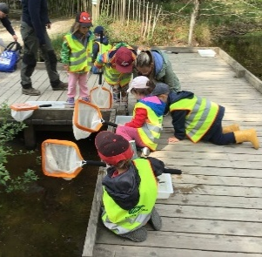

Priority 3:
To sustain and strengthen the implementation of the White Rose Maths curriculum through consistent, high-quality teaching, responsive assessment and adaptive practice, ensuring all pupils develop fluency, reasoning and problem-solving skills and make strong progress from their individual starting points.


Priority 4:
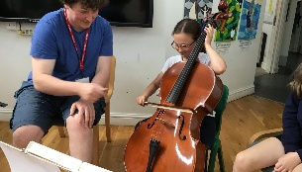
Reimagine and develop approaches to daily collective worship that elevate its unique place in the life of the school. This is to deepen how pupils and adults value it as a precious time and space each day that enriches spiritual growth.


Priority 5:

Develop the RE curriculum so that pupils learn more about the variety of belief and practice within Christianity. This is so that they better understand the diversity amongst people of Christian faith.
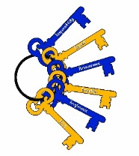
Matthew 7:7 “Ask, and it will be given to you; seek, and you will find; knock, and it will be opened to you.”
We are a school that is built on success stories; some big, some small, some public but most private. The message is simply that we want all the children to feel the warm glow of success and be motivated individuals who are constantly striving to unlock their potential to do exceptional things.

