Landscove C of E Primary Ethos Group
Terms of Reference
Landscove will use the keys to unlock the very best of us. Matthew 7:7.”Ask, and it will be given to you; seek, and you will find; knock, and it will be open to you.”


The group supports the Christian distinctiveness of the school, helping to maintain this Christian ethos and identify ways in which we can further develop in sympathy with our Christian character.

LEG aims to:
Learn from, Support and Challenge the school to enable all children to flourish in accordance with our Vision Statement, underpinned by the four basic elements of Wisdom, Hope, Community and Dignity.
Learn from, Support and Challenge the school to nurture the spiritual dimension of children and staff through all aspects of the curriculum.
Learn from, Support and Challenge the school when reviewing RE and collective worship policies, practice and outcomes, to ensure these are of high quality and make a major contribution to the school’s Christian ethos.
Support the work of the school and be informed about current provision, performance and school improvement plans through Academy Head reports.
Act as a local voice We will offer a forum for debate and discussion on matters relevant to the future development of the school. In doing so we will strengthen the engagement with the parent and local community.
LEG will lobby the full governing body, as required.
Membership: Current
Role | Current Person
Academy Head | NATALIE LAST
Foundation Governor appointed to the Local Governing Board or Church representative | KATE BURCH
Staff representative responsible for Christian distinctiveness | REBECCA BARONS
Parent representative*, with the aim of 1 Class Parent representative from each of the 4 classes  *this may rise to 2 when children move year groups | Vacancy for Rec parent  EMMA PIERCEY  RACHEL BABER  GRACE COLES
Chair of PTFA (FOLS) | NEIL DREW
Community representative | RACHEL BABER
*The Class Parent Representative must have a child in the class they represent.

*There is no limit on the number of terms a member of the School Committee may be re-appointed, re-elected or co-opted for.

As appropriate, the Group may invite Associate Members to join meetings where the agenda is relevant to their interests eg subject coordinators. The group will also consider pupil voice through the School Council/Pupil Ethos Group.

Meetings:
Our School Ethos Group meets half-termly.
- Meetings will not be open to the public, but minutes will be available.
- The Group Chair should be appointed at the beginning of each school year.
- In the absence of the Chair, the Group shall choose an acting Chair for that meeting from among their number.
- Minutes of the meeting will be taken and draft minutes of each meeting will be circulated with the agenda for the next meeting.
- Once approved, meeting minutes will be available on the school website.
The LEG will have a key communication role to perform in ensuring that information is shared to the governing body, parent community, the church and other interested parties and vice versa.
The governor/chair will provide a report of the meeting and any recommendations to the Full Governing Body.
The School Ethos Group will not discuss the following matters:
- School policies and procedures relating to general curriculum issues & details;
- Issues relating to individual children or staff;
- Individual complaints or grievances.
These issues should be referred directly by individual parents to the class teacher in the first instance or the Exec Academy Head.
LEG school visits
Personal observations made on school visits are a major source of information and the school welcomes members of the LEG into school for this purpose. Guidelines on and checklists for such visits should be followed.
LEG Monitoring Focus Across the Year:
A system of monitoring takes place across each academic year. This is in line with SIAMS expectations. LEG members are encouraged to learn from school, support and question developments in our Christian character, RE and collective worship. The following schedule shows the proposed focus for each ½ termly meeting.
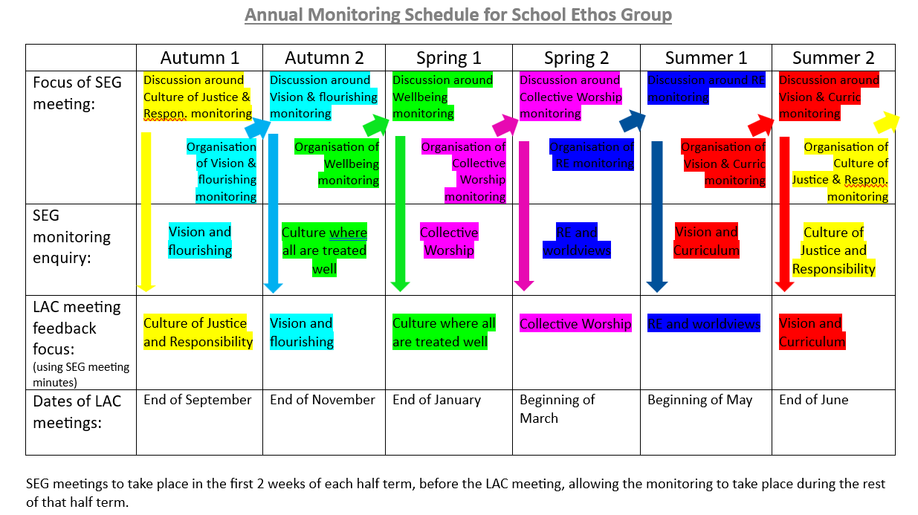
Reviews
The terms of reference and membership of LEG will be reviewed annually each year at its first meeting. Any recommendations from the governing body will be implemented.

Natalie Last
Next review September 2027

