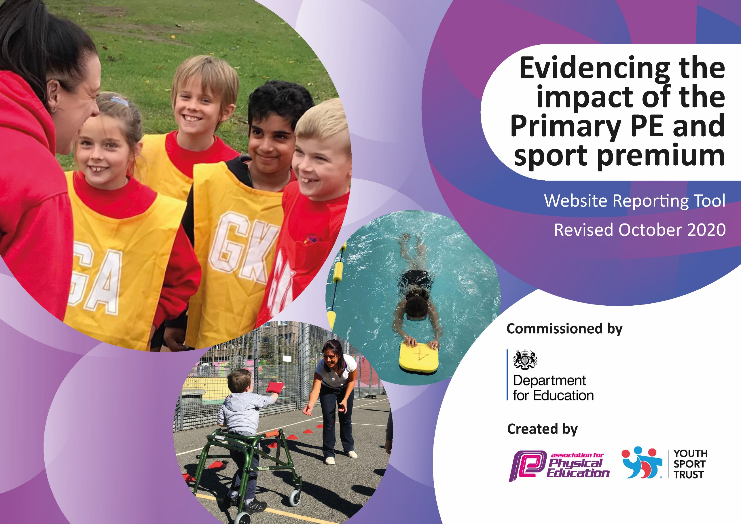
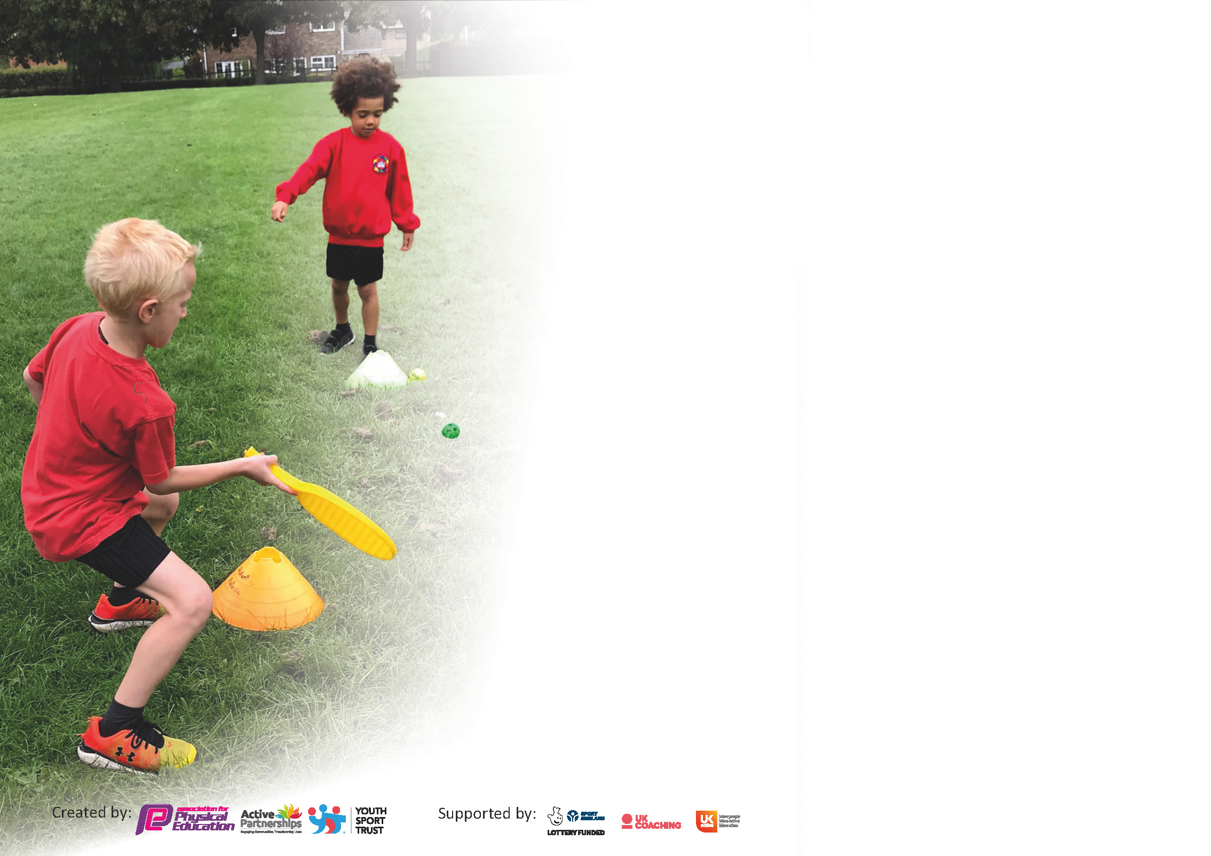

It is important that your grant is used effectively and based on school need. The Education Inspection Framework (Ofsted 2019 p64) makes clear there will be a focus on ‘whether leaders and those responsible for governors all understand their respective roles and perform these in a way that enhances the effectiveness of the school’.

Under the Quality of Education criteria (p41) inspectors consider the extent to which schools can articulate their curriculum (INTENT), construct their curriculum (IMPLEMENTATION) and demonstrate the outcomes which result (IMPACT).

To assist schools with common transferable language this template has been developed to utilise the same three headings which should make your plans easily transferable between working documents.

Schools must use the funding to make additional and sustainable improvements to the quality of Physical Education, School Sport and Physical Activity (PESSPA) they offer. This means that you should use
the Primary PE and sport premium to:

- Develop or add to the PESSPA activities that your school already offer
- Build capacity and capability within the school to ensure that improvements made now will benefit pupils joining the school in future years

Please visit gov.uk for the revised DfE guidance including the 5 key indicators across which schools should demonstrate an improvement. This document will help you to review your
provision and to report your spend. DfE encourages schools to use this template as an effective way of meeting the reporting requirements of the Primary PE and sport premium.

We recommend you start by reflecting on the impact of current provision and reviewing the previous spend.

Schools are required to publish details of how they spend this funding as well as on the impact it has on pupils’ PE and sport participation and attainment by the end of the summer term or by 31st July 2021 at the latest.

** In the case of any under-spend from 2019/20 which has been carried over this must be used and published by 31st March 2021.

We recommend regularly updating the table and publishing it on your website throughout the year. This evidences your ongoing self-evaluation of how you are using the funding to secure maximum, sustainable impact. Final copy must
be posted on your website by the end of the academic year and no later than the 31st July 2021. To see an example of how to complete the table please click HERE.
Created by: Supported by:

Please note: Although there has been considerable disruption in 2020 it is important that you publish details on your website of how you spend the funding - this is a legal requirement.
Support for review and reflection - considering the 5 key indicators from DfE, what development needs are a priority for your setting and your pupils now and why? Use the space below to reflect on previous spend and key achievements and areas for development.

N.B. In this section you should refer to any adjustments you might have made due to Covid-19 and how these will influence further improvement.
Key achievements to date until July 2020: | Areas for further improvement and baseline evidence of need:
KI1  - All students given 60 minutes of physical activity through constructive lunchtimes activities and whole-school morning movement activities.  KI2  - Trust employed PE specialise to lead subject within the school.  - Profile of PE raised across the school through a wide range of curricular opportunities and extra-curricular clubs for all students.  - Use of video analysis in line with whole school improvement plan.  KI3  - CPD has been provided for all teaching staff and has improved staff confidence of delivering a range of PE activities.  KI4  - New PE curriculum has been rolled out, which includes a greater range of sports and activities, increasing the opportunity for students.  - Wide variety of extra-curricular opportunities available for all students to widen their experiences.  - Whole-school community day to provide wider variety of activities.  KI5  Despite difficulties surrounding COVID-19 restrictions, all students in KS1 & 2 have taken part in a competitive virtual festival against other schools. | - Additional festivals for KS1, KS2 and EYFS (COVID permitting). This will allow all students in the school to take part in competitive activity (KI 5).  These festivals were planned but could not take place due to COVID-19.  - Wider opportunities for student to take part in outdoor and adventurous activities/gain experiences outside of the school in areas which aren’t covered in the PE curriculum e.g. rock climbing, sailing etc.

Did you carry forward an underspend from 2019-20 academic year into the current academic year? YES

If YES you must complete the following section
If NO, the following section is not applicable to you

If any funding from the academic year 2019/20 has been carried over you MUST complete the following section. Any carried over funding MUST be spent by 31 March 2021.

Sports Premium Carry-Over

Academic Year: September 2020 to March 2021 | Total fund carried over: £2000 | Date Updated: 30/03/2021
What Key indicator(s) are you going to focus on?  KI1, 2 and 4. |  |  |  | Total Carry Over Funding:
 |  |  |  | £2000
Intent | Implementation |  | Impact
Your school focus should be clear how you want to impact on your pupils. | Make sure your actions to achieve are linked to your intentions: | Carry over funding allocated: | Evidence of impact: How can you measure the impact on your pupils; you may have focussed on the difference that PE, SS & PA have made to pupils re-engagement with school. What has changed?: | Sustainability and suggested next steps and how does this link with the key indicators on which you are focussing this academic year?:
KI1 & KI2  KI4 - Give students a wide range of high-quality physical activities. | Central PE staffing costs  Resources purchased to allow greater breadth of activities taught within the PE curriculum. | £1500  £500 | Trust PE staff implemented a variety of online and school based learning for students during school closures. This included live morning PE lessons every day and weekly recorded lessons.  Students experience a greater number of new activities in curriculum PE and extra-curricular clubs. These activities have specialised equipment which has improved the quality of student’s learning. | Staff continuing to work for the trust and provide staff across the Link Academy Trust with resources, ideas and training in how to deliver high quality PE.  Purchased by the school and new activities have formed part of the new school PE curriculum, which is more varied than previous years.

Meeting national curriculum requirements for swimming and water safety.

N.B Complete this section to your best ability. For example, you might have practised safe self-rescue techniques on dry land.
What percentage of your current Year 6 cohort swim competently, confidently and proficiently over a distance of at least 25 metres?  N.B. Even though your pupils may swim in another year please report on their attainment on leaving primary school at the end of the summer term 2021. | %  N/A as swimming provision has been effected by COVID-19 restrictions.
What percentage of your current Year 6 cohort use a range of strokes effectively [for example, front crawl, backstroke and breaststroke]? | %  N/A as swimming provision has been effected by COVID-19 restrictions.
What percentage of your current Year 6 cohort perform safe self-rescue in different water-based situations? | %  N/A as swimming provision has been effected by COVID-19 restrictions.
Schools can choose to use the Primary PE and sport premium to provide additional provision for swimming but this must be for activity over and above the national curriculum requirements. Have you used it in this way? | No

Action Plan and Budget Tracking
Capture your intended annual spend against the 5 key indicators. Clarify the success criteria and evidence of impact that you intend to measure to evaluate for pupils today and for the future.

Academic Year: 2020/21 | Total fund allocated: £16,740 | Date Updated: 01/07/2021
Key indicator 1: The engagement of all pupils in regular physical activity – Chief Medical Officers guidelines recommend that primary school pupils undertake at least 30 minutes of physical activity a day in school |  |  |  | Percentage of total allocation:
 |  |  |  | 2%
Intent | Implementation |  | Impact
Your school focus should be clear what you want the pupils to know and be able to do and about  what they need to learn and to  consolidate through practice: | Make sure your actions to achieve are linked to your intentions: | Funding allocated: | Evidence of impact: what do pupils now know and what can they now do? What has changed?: | Sustainability and suggested next steps:
Engage all students in daily active playtimes.  Increase number of extracurricular activities available for students | Playleaders established and equipment has been purchased so students of all ages have access to a range of different physical activities during these times.  A new Sports Leaders programme has started, with KS2 students leading activities for all students during PE lessons and play times.  Extra-curricular clubs are available for students after school each day. These are led by external providers as well as class teachers.  - Football club  - Teacher led sports club  - Gymnastics club  - Multi-sports club | £300  No cost | All students know how to access and safely use play equipment. Sports leaders and play leaders have learnt how to arrange safe activities for younger students to promote physical activity.  Significantly increased the number of students engaging in extracurricular activities. | Yearly programme will continue to run into next academic year. Equipment purchased remains in school for active playtimes.  Providers agreed for future years.

Key indicator 2: The profile of PESSPA being raised across the school as a tool for whole school improvement |  |  |  | Percentage of total allocation:
 |  |  |  | 39%
Intent | Implementation |  | Impact
Your school focus should be clear what you want the pupils to know and be able to do and about  what they need to learn and to  consolidate through practice: | Make sure your actions to achieve are linked to your intentions: | Funding allocated: | Evidence of impact: what do pupils now know and what can they now do? What has changed?: | Sustainability and suggested next steps:
Specialist PE staff to raise profile of PE and school sport to drive forward improvement in the subject and whole school community.  Use PE as a driver for improvements in student learning.  Increase sense of community through participation in PE events.  Increase students excitement of PE lessons through specialist resources.  Develop PE in line with whole-school improvement plan - Give students access to greater ICT and video analysis opportunity to develop their learning. | The school has employed a specialist PE teacher.  New PE curriculum and planning rolled out to give staff the tools to improve the quality of teaching and learning through sport and physical activity.  KS1 + 2 students have participated in trust-wide virtual festivals.  Purchase of specific PE equipment for each activity included in the PE curriculum.  Purchase of ICT resources to use for PE lessons. | See KI3  No cost (provided by PE specialist – see KI3)  No cost  EYFS = £1000  KS1 + 2 = £2000  £2850 | All students have a high-quality PE lesson from a specialist teacher. Impact of PE specialist has meant that PE is a valuable part of the curriculum and there is greater enthusiasm for the subject .  Staff have access to regular CPD to improve their delivery of quality PE.  Higher quality learning is now taking place in PE. Link made to other curriculum subjects also used within PE lessons to develop wider student understanding.  Increased excitement across the school and a driving focus on togetherness and success.  Improved quality of PE lessons and amount of sport/physical activity taking place across the school.  Improved profile of PE lessons due to the access to specialist equipment.  Going forward iPads/ICT resources will be used in PE to give students greater understanding of skills and techniques, improving their learning in both PE and computer literacy. | PE teacher employed on a permanent contract to continue developing staff competence.  PE specialist contract renewed to ensure this benefit is sustained.  Additional steps: increased number of events next year post-covid-19.  Equipment stored effectively in school and will be used in future years.  Use of technology in PE will be a continual focus across the school as part of the whole-school improvement plan.

Key indicator 3: Increased confidence, knowledge and skills of all staff in teaching PE and sport |  |  |  | Percentage of total allocation:
 |  |  |  | 51%
Intent | Implementation |  | Impact
Your school focus should be clear  what you want the pupils to know  and be able to do and about  what they need to learn and to  consolidate through practice: | Make sure your actions to  achieve are linked to your  intentions: | Funding  allocated: | Evidence of impact: what do  pupils now know and what  can they now do? What has  changed?: | Sustainability and suggested  next steps:
Regular professional development for all teaching staff, promoting higher quality teaching of PE.  Online teacher training tennis course. | Employed school PE teacher to deliver regular training for staff.  Class teachers work with PE specialist to assess students and have regular feedback about their own delivery of PE.  LTA tennis course offered to all staff | £8984  No cost | All staff have received regular CPD from PE specialist. Teaching staff are now more confident delivering the wide variety of activities included within the PE curriculum.  Staff have an increased subject knowledge of tennis and are equipped with the skills to deliver high quality tennis lessons. | PE teacher employed on a permanent contract to continue developing staff competence.

Key indicator 4: Broader experience of a range of sports and activities offered to all pupils |  |  |  | Percentage of total allocation:
 |  |  |  | 7%
Intent | Implementation |  | Impact
Your school focus should be clear | Make sure your actions to | Funding | Evidence of impact: what do | Sustainability and suggested
what you want the pupils to know | achieve are linked to your | allocated: | pupils now know and what | next steps:
and be able to do and about | intentions: |  | can they now do? What has
what they need to learn and to |  |  | changed?:
consolidate through practice:
Successful second year of PE curriculum.  Develop leadership opportunities for students in KS2.  When restrictions allow, use specialist providers to offer students exciting activities.  Mental Health resource delivered to all pupils to broaden their understanding of how mental and physical health are important. | The second year of the new PE curriculum has been a success.  Set up a new Sports Leaders Programme for KS2 students.  Whole-school community day planned for the end of June. Activities: Rugby with Exeter Chiefs, Archery, street surfing, tennis, ultimate frisbee and cricket.  Order a resource which staff can deliver to all students. | No cost  £200  £700  £675 | Within the new PE curriculum, students enjoy a broader range of sports and physical activities – 20 different sports in total over the 2-year cycle.  KS2 students have successfully began the sports leaders programme, which has had an impact on younger students across the school. This has also given KS2 students their first step towards leadership for life as well as improving your interpersonal skills, both of which will help with transition into secondary school.  All students took part in a range of new and exciting experiences from specialist providers.  All students have benefitted from understanding more about mental health and ways in which they can improve this. | Curriculum embedded within school PE planning.  Yearly programme  Links made with external providers so they can offer further events like this in the future.  Resource cost planned into next years sports premium.  This key indicator has been affected by covid-19. Next year, with facilities open and trips available, students will have access to additional activities.

Key indicator 5: Increased participation in competitive sport |  |  |  | Percentage of total allocation:
 |  |  |  | 0 %
Intent | Implementation |  | Impact
Your school focus should be clear | Make sure your actions to | Funding | Evidence of impact: what do | Sustainability and suggested
what you want the pupils to know | achieve are linked to your | allocated: | pupils now know and what | next steps:
and be able to do and about | intentions: |  | can they now do? What has
what they need to learn and to |  |  | changed?:
consolidate through practice:
Offer students trust-wide competitions. | Students in KS2 have competed in virtual festivals against schools within our Academy Trust: Gymnastics, frisbee, handball and athletics. | No cost | Students have enjoyed the festivals and developed their sportsmanship and teamwork through these events. | Festival dates in place for next year.  Next steps: post-covid-19, students to hopefully attend face-to-face events with other schools.  The usual Link Academy Trust events have been impacted hugely by Covid-19 this year, but planning is in place for next year to further improve this area.

Total Allocation: 16,740
Total spent: £16,709

Signed off by
Head Teacher: | Jill Ryder
Date: | 9th July 2021
Subject Leader: | Matt Tanner
Date: | 9th July 2021
Governor:
Date:

