Landscove C of E Primary School
Landscove, Nr Ashburton, Devon. TQ13 7LY
Tel: 01803 762656 Email: adminlandscove@thelink.academy

NEWSLETTER Friday 14th May 2021
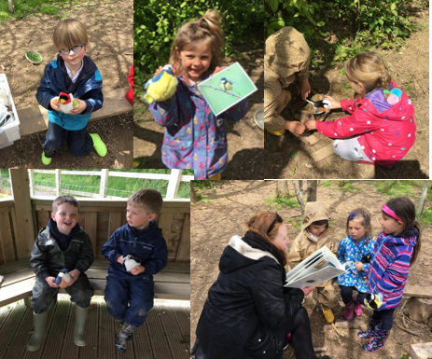
Dear Parents,
It’s been a busy week, but we’ve had a lot of fun along the way!
LANDSCOVER LEARNERS
The focus of last week's Outdoor Explorers session was to listen to and identify bird songs. We also did some work around naming birds and finding out some interesting facts about them. We used our special soft toy birds to support this learning. The children were delighted when they realised the birds could actually sing. 🎶🙂
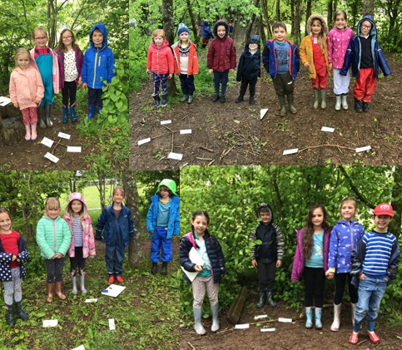
Class 2 braved the wet weather on Wednesday for their forest school session. The focus of this week’s session was based on identifying the 4 simple points on a compass. We made the 4 points out of sticks and labelled them with the correct compass direction. We then had a go at coming up with our own rhyme to remember them in our groups!

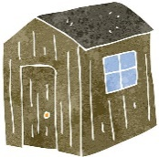
PE SHED
Huge thanks to our generous parent who is donating a PE shed to school for all our new equipment.

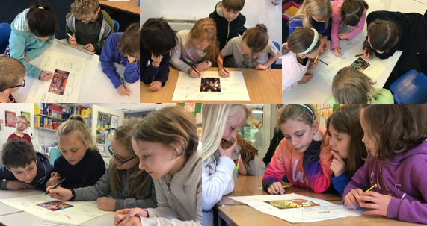

Class 3 exploring a selection of artworks depicting the arrival of the Holy Spirit.

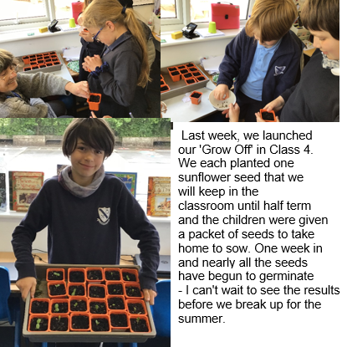
SPIRITUAL GARDEN
Thank you to everyone who has given their time to this development. If you’d like to join our merry team, please contact Mrs Neville.

NATIONAL MENTAL HEALTH AWARENESS WEEK- 10TH -16TH MAY. This year there is a ‘nature’ theme. Something to think about:
‘‘Connecting with nature is not just about the amount of time we spend outdoors; it is also about building a relationship with nature by noticing and becoming sensitive to what is around us. We use our senses to do this– such as noticing the different cloud shapes in the sky, smelling the scents of flowers and listening to the birds chirping in the trees.’’

Being 'in tune' with nature has many health benefits including:
Mental Health Foundation
Mental Health Awareness Week 2021. Hosted by the Mental Health Foundation, Mental Health Awareness Week will take place from 10-16 May 2021. This year, the theme is 'Nature'.
www.mentalhealth.org.uk
- Feeling happier
- Feeling less stressed
- Having more & better-quality sleep
- Feeling less worried /anxious
- Being more environmentally aware
- Increases self-esteem & self confidence
- Improves concentration & attention
All information taken from https://www.mentalhealth.org.uk
This website is worth a look. There is a fantastic guide for parents you can request to download. Mrs Field
STAFFING NEWS
We will be incredibly sad to say goodbye to Mrs Field at the end of the summer term. Lucy has been a cornerstone of the Landscove team and will be much missed. We do, of course, wish her every success on her next adventure.
The recruitment process is underway, so be reassured that we will be looking for someone with just the right qualities to keep our team tip-top.

ATTENDANCE AND SAFEGUARDING
Attendance:
(Our school target is 96.8%)

Whole school | 97.2%
Class 1 | 94.4%
Class 2 | 98.6%
Class 3 | 98.9%
Class 4 | 95.2%
Well done to class 3!
Our Safeguarding Lead is Jill Ryder and our Deputy Safeguarding Lead is Miss Barlow. If you are concerned about a child’s safety or wellbeing please contact the school or in non-school hours contact MASH on 0345 155 1071

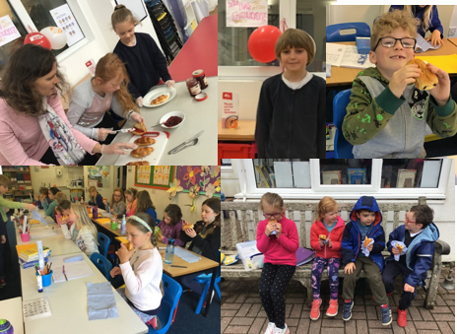
THE BIG BREKKIE
Thank you for supporting our Big Brekkie and raising money for Christian Aid. Members of the Ethos Group from class 3 did a fabulous job of serving croissants to the whole school. We had an efficient conveyor belt in operation! I think it is evident that the children really enjoyed tucking in. Mrs Neville
SCHOOL DINNERS
Please ensure all lunches are ordered 48 hours in advance – this supports our kitchen. It’s rather tricky if we have lots of requests for food on the day!
Many thanks.

FOLS – from Justina
Thank you to all those who have participated in the silent auction. Bids will be accepted until 6pm Friday 14th May. Please email fols@outlook.com.
We will be holding a mufti day Friday 28th May for £1 each towards FOLS fund raising.
FOLS are short of members! Anyone interested in joining our team please contact us for positions available.

That’s all the news for now. Have a good weekend
