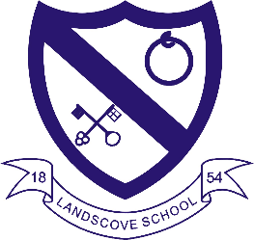
LANDSCOVE C OF E PRIMARY SCHOOL
RE & CW Lead Report for the School Ethos Group

October 6th 2021

SCHOOL ETHOS, SIAMS & RE

Global Neighbours Action Plan written and now being implemented.

14.9.21 Ethos Group seed collection for Meadow Restoration Project.
20.9.21 Nick and Pa Arding visited to share their experience of kayaking around the UK, stopping at
beaches to collect waste.
21.9.21 Landscove Harvest in a Day – Sway created to share with parents.
£30 raised for Christian Aid and generous Food Bank donations received.
22.9.21 Class three beach clean at Elberry Cove, organised by Nick and Pa.
1.10.21 Friday afternoons 2.30pm until half term - Rev Laura offering sessions in spiritual garden. Parents invited to drop in for a chat, advice or catch up.
Upcoming Events:
9.10.21 Love Your School Day planned to develop spiritual garden and have a general tidy up.
11.10.21 Arts Week – linking with Global Neighbours Action Plan
Theme: Our impact on the environment (plastic pollution and climate change).
Intended outcome: To produce a large a ‘beach tree’ to accommodate plastic beach waste ‘sea creatures’ and ‘leaves/foliage’ that make connections with climate change and future sea level rise.
Collective Worship
It has been lovely for children to get back in their gospel groups and share worship together as a whole school. Pattern of worship is as follows:
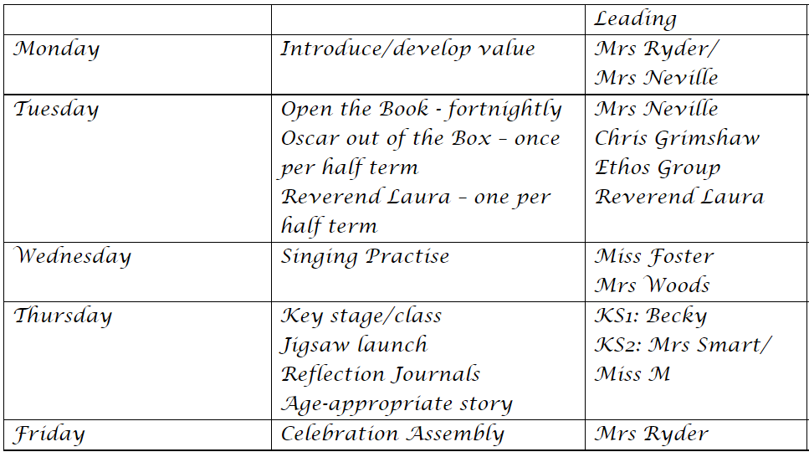
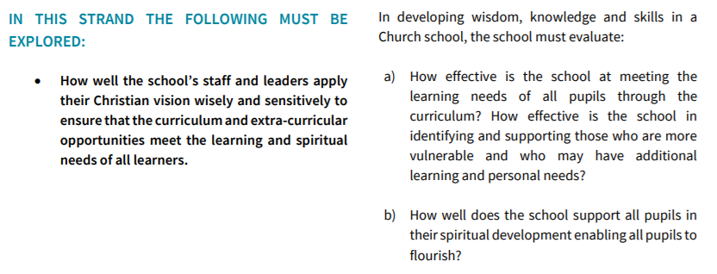
SIAMS strand 2 - Knowledge, Wisdom and Skills

Meeting academic needs
Broad and balanced curriculum now being implemented. Rolling programmes all revised and updated.
PE and one WWL session per week.
Lots of extra-curricular opportunities: clubs (Sports, Young Engineers, French) class trips (Y3/4 beach, Y5/6 Eden Project).
Good SEND provision provided within school and support available from Improvement and Inclusion Hub.
Staff CPD on Managing Anxieties – offering advice and resources to support children’s MH within our learning environments.

Meeting spiritual needs
We use the Window, Mirrors, Doors strategy developed by Liz Mills to broaden and deepen understanding about spiritual learning. AN documenting children’s responses in Sway.
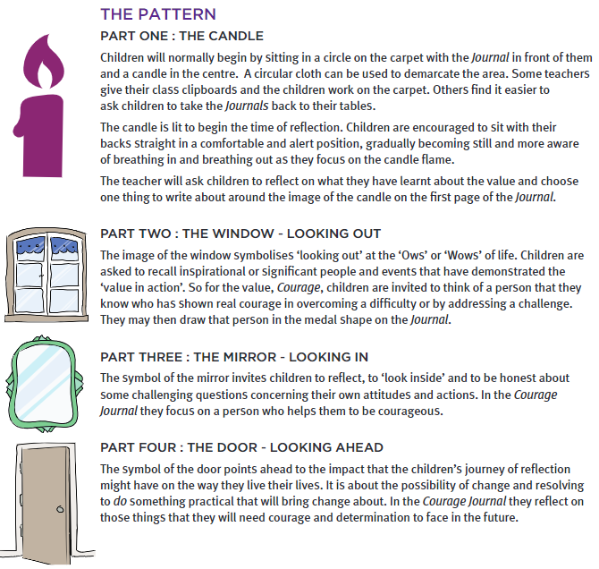

LANDSCOVE C OF E PRIMARY SCHOOL
Academy Head Report for the School Ethos Group

PUPIL NUMBERS

R 11
Y1 15
Y2 14
Y3 14
Y4 10
Y5 13
Y6 12
Total 89

CLASS ORGANISATION
- Class 1 : R (0.4 Rebecca Barons, 0.6 Jo Woods)
- Class 2: Y1 & Y2 (FT Jenny Foster)
- Class 3: Y3 & Y4 (0.5 Anna Neville, 0.5 Anne Smart)
- Class 4: Y5 & Y6 (Chloe McFadzean FT)

STAFFING UPDATES
- We have welcomed Chloe McFadzean & Rebecca Barons to team Landscove.
- We currently have 2 adverts out for TAs – a 1:1 as Annie Smith is moving on to pastures new and for Tasha Kearle’s maternity cover.

SCHOOL IMPROVEMENT PLAN & SCHOOL SELF EVALUATION:
The key priorities for school have been finalised and I have created our ASIP – which is the school improvement plan which details how we will meet our improvement targets.
LANDSCOVE C OF E PRIMARY
LINK ACADEMY TRUST
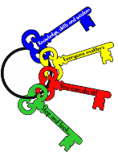
SCHOOL IMPROVEMENT PLAN: KEY PRIORITIES
2021-2022

Small Schools, Big Opportunities
Key Priority 1: WRITING:  Focus on the highest quality delivery of English teaching using forensic analysis to determine the needs of the writers & to ensure progress is rapid and sustained for all groups of learners. | 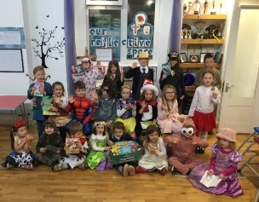
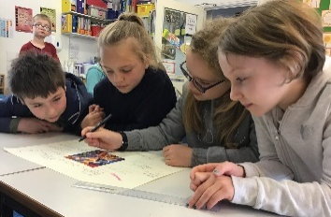 | Key Priority 2: VOCAB DEVELOPMENT - CLOSING THE VOCABULARY GAP.  Develop a robust and systematic approach to teaching & learning vocabulary - using tiered vocab – Alex Quigley & Oracy project work to guide action plan. (to impact on speaking, reading and writing)
Key Priority 3: GLOBAL CITIZENSHIP  Develop the children’s awareness of global citizenship and how they can develop an ethos of action to challenge injustice both locally and globally. Develop children’s understanding of diversity & support them to be outward facing and develop attitudes of ‘global generosity’. | 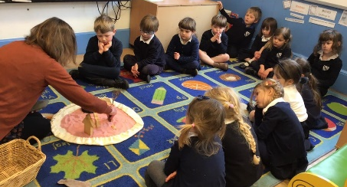
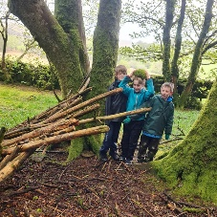 | Key Priority 4: SUBJECT LEADERSHIP:  Developing and supporting talent and passions. Develop a robust system for subject leaders to work across the two partner schools, lead, research, offer CPD, monitor, and ensure QFT in all areas.
Key Priority 5: BROAD CURRICULUM: ART AND DESIGN & DESIGN TECHNOLOGY:  following pandemic revive themed arts and STEM weeks where children can be immersed in subjects and experiences to enhance learning. Have robust system in place to ensure themed weeks meet needs/objectives/skills of the national curriculum as well as enriching and personally sustaining. | 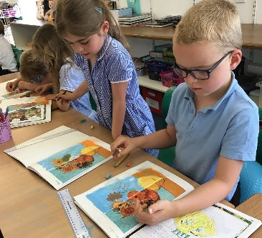
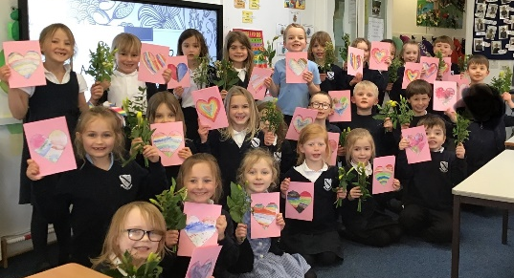 | Key Priority 6: MFL  To implement the MFL SOW to ensure it acts as a support to teachers and meets the needs of all children so that: 1. Teachers have the subject knowledge teach & to make an informed judgement on each child’s progress.  2. Children are taught MFL consistently ensuring that they know more, remember more and understand more.
www.landscove.thelink.academy
WWW.THELINK.ACADEMY

In addition to these Key Priorities as a Trust we will continue to develop the use of TEAMS as a teaching tool, for homework and as we move forward as a method of class teachers communicating with parents. This is work in progress!

OTHER INFORMATION – VISITORS - COURSES ETC
- We have established subject leadership across Broadhempston and Landscove – ensuring sharing of good practice and allowing staff to develop their interests and passions. Visits have taken place and all staff have a good knowledge of the starting point for their subjects following the disruption caused by COVID.
- We plan to hold learn, Support & Challenge days across the year where subject leads and Trust senior leaders monitor teaching and learning, complete a book scrutiny and talk to children. This helps to shape next steps in all areas monitored. We will be having a LSC day later this month
- Our Trust Inclusion Hub continues to support school. Alice Eeles is the named SENDCO supporting Landcove & Broadhempston (she holds the SENDCO award) and I am the SEND lead for the school; Chloe McFadzean is supporting this role.
- Arts week will be from 11th Oct – Anna Neville has organised a well-planned week, including a visiting artist.
- We will be holding an open evening & exhibition following our arts week on 10th November

HEALTH & SAEFTY/ SAFEGUARDING/ BEHAVIOUR/C19
- Covid19: our risk assessment is up to date and will be reviewed once new guidance is received (following downgrade from Enhanced Response Area – limiting social contact area)
- All school staff attended Level 2 safeguarding training on Tuesday 7th Sept
- Our online Every H&S system is being completed for this term

Anna Neville & Jill Ryder

