Landscove C of E Primary
Recovery Curriculum Plan September 2020
Rationale/Intent

Due to the impact of the Corona virus, schools have only been able to directly support those children of key workers. All children have been designed a formal education since the national lockdown in March. However, some children, especially the more vulnerable, have experienced loss not only to their friendships, but also to their daily routines, as well as structures and the freedom of opportunities available in school.
Throughout the pandemic Landscove has supported children through an online supported learning approach using Eschools and email. Teachers provided video links to further support and enhance the learning experience, as well as providing printed packs for families who did not have access to online provision.
For some families establishing and maintaining a routine throughout this time has been challenging and we are aware that for some of our children little or no formal learning has taken place.

We have been thinking about what September might look like, how our pupils and staff might be feeling and what the curriculum should look like at Landscove. Whilst we continue to believe that our Landscovians will be ok, we do need to listen to the advice of experts.
Whether intentional or not, our children are likely to have been exposed to adults who are feeling anxious, who may have acted in a manner different to usual or who have taken on different and contradicting roles to normal. Additionally, children will be returning to a new year group possibly within a new classroom and perhaps with a new teacher. They will be experiencing a new routine and new expectations having not had the transitional opportunities that they are usually afforded at Landscove.
To support children at this time Landscove staff have been researching the latest information on the recovery curriculum for children and will staff be focusing on five levers of support:

1. Building positive relationships – re-building friendships, safety and security in school.
2. Community – understanding what our community looks like now.
3. Curriculum – including the integration of lockdown experiences.
4. Metacognition – how we can support and re-skill learners and build confidence
5. Self-realisation – to support pupils to recognise and achieve their full potential.

In September, we need to ensure that all children are able to settle back into school and to be able to share their own authentic lived experiences and learn to come together again and reconnect emotionally in a holistic way seeing themselves once again as learners.

R e s e a r c h a n d f o u n d a t i o n s t a k e n f r o m: ‘ A R e c o v e r y Cu r r i c u l u m: L o s s a n d L i f e f o r o u r c h i l d r e n a n d s c h o o l s p o s t p a n d e mi c . ’ By Barry Carpenter, CBE, Professor of Mental Health i n Education, Oxford Brookes University, UK .
https://www.evidenceforlearning.net/recoverycurriculum/
https://thenationalcollege.co.uk/webinars/recovery-curriculum

Implementation
Support will include:
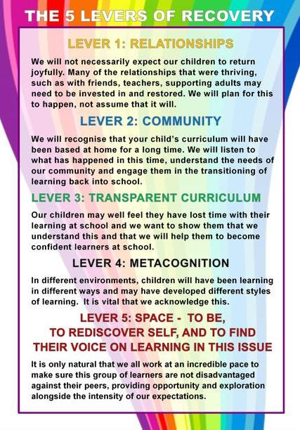
Lever 1 Relationships:
- Extensive relationships education using PSHE Jigsaw resources
- Time f or 1: 1 and small group discussions
- Guidance from Thrive practitioners & IIH on best activities to re-establish friendships
- Staff take time to notice every individual in school and make them feel noticed, safe and welcomed

Lever 2 Community:
- Sharing of lockdown experiences
- Validating and attuning of concerns and worries that children held and continue to hold
- Communication with parents and carers around the needs of individuals
- Transition plans in pl ace f or return – activities and videos from teachers
- Links with after school clubs re-established when possible

Lever 3 Transparent Curriculum:
- Adapted curriculum to meet the needs of learners on return to school. Based on low key assessments (quizzes, discussions, questions etc)
- Sharing of planning for the term to reassure children that missed learning will be covered
- Some personalised homework linked to identified gaps in learning to be provided
- Explicit teaching about mental health and wellbeing given high priority within medium term plans
- Opportunities planned for children to voice what they have missed or forgotten

Lever 4 Metacognition:
- Sharing and validating learning experiences in place though PSHE
- Re-establishing school routines through role play, creation of class rules, making expectations clear
- Extensive praise awarded around learning and social interaction

Lever 5 Space:
- Pupil voice avenues made available so that children can share views
- Priority placed on mental health and wellbeing and pupil voice within PSHE
- Engagement with physical activity and nature/outdoor learning to support physical health and wellbeing

The Curriculum
Transition topic on return to school: Curriculum during the first two weeks of term
We want to spend the first two weeks of term focusing on the wellbeing and support for all children whether or not they attended school in the summer term in one of our ‘bubbles’. We feel it is important for the children to re-connect with the school routines, rules behaviour and learning expectations as well as re-connecting as a whole school community and re-establish friendships and social engagement.
The children across the school will therefore be involved in a two-week unit of work called ‘Here we are’. This is a literacy-based unit of work/learning that has been devised specifically for a whole school to work together using a single text to support a transition curriculum as children return to school. It aims to support reading and writing for pleasure across the school.
The age-appropriate activities will provide opportunities for children to use writing for a range of purposes including
- provide a framework for children to re-engage socially with each other and their wider community,
- suggest opportunities to engage positively with the outdoor environment,
- stimulate thinking and talk about world events and the impact of these events on individuals and the wider world,
- provide a safe forum to share thoughts, concerns, ideas and personal responses,
- use art and writing to help children respond personally to experiences they have had.
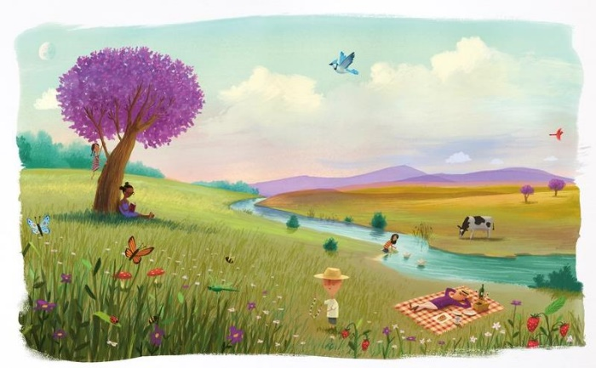

Autumn term 2020: Wider Curriculum.
Landscove’s long and medium term planning has been reviewed and revised to ensure the delivery of a high quality curriculum, which provides children with opportunities to build on prior learning and develop their knowledge and skills as they continue their educational journey.
During the Autumn term, teachers and TA’s will focus on supporting children to ‘catch-up’, having identified starting points and any gaps in learning due to the school closure. Appropriate support and targeted interventions will be available for children with SEND, by deploying TA’s and enabling specialist staff from both within and outside the school to work with children in different classes or year groups as appropriate. Teaching assistants may also be deployed to lead groups under the direction of the class teacher.
We will use our professional knowledge and expertise alongside advice from our Improvement & Inclusion Hub (IIH) and using the latest research advice from the Education Endowment Foundation. https://educationendowmentfoundation.org.uk/
- For children in our Reception Year, teachers will assess and address gaps in language, early reading and mathematics, particularly ensuring children’s acquisition of phonic knowledge and extending their vocabulary.
- For children in Key Stages 1 and 2, leaders and teachers will prioritise the identification of gaps and re-establish good progress in the essentials, such as phonics and reading, increasing vocabulary, writing and mathematics; identifying opportunities across plans so they read widely, and develop their knowledge and vocabulary. The curriculum will be adapted in the autumn tern and possibly for part of the spring term to ensure we have the opportunity to meet the needs of all our learners. It will include sciences, art, PE/sport, RE and PSHE/RHE.
We also aim to block in themed weeks to support a broader curriculum entitlement.
As we move into the spring and summer our full range of subjects and topics will be reintroduced to ensure our aspirational, broad and balanced curriculum is back in place.

- Relationships and Health education (RHE) for primary aged children, becomes compulsory from September 2020, and will be introduced into our curriculum from the Autumn term

For further information see Appendix attached below
Impact
What will the impact of our Recovery Curriculum look like?
By the time children reach the summer term they will have:
A Sense of Community:
- Children will have reconnected as a school community, recognising the important part each individual plays.
Relationships:
- Friendships and positive relationships within school will have been rebuilt and strengthened.
Re-established Routines:
- Everyone will have settled back into school life, adjusting well to necessary changes.
Respecting Space and Social Distancing:
- We will have established a ‘new normal’ in relation to proximity and personal space.
Experiencing Loss:
- Children will be supported as they struggle to understand their emotions.
- Gaps in learning will have been closed and children will be meeting their potential.

Staff: will have developed strategies for taking care of themselves / each other during this transitional period
Physical | Psychological | Emotional | Workplace
Sleep well  Eat well  Dance  Exercise  Run  Jog  Walk  Sing | Self-reflect  Read for pleasure  Say no!  Smile  Be happy in own company  Be social with friends, family & colleagues | See friends  Cry  Laugh  Praise self  Humour | Take breaks  Set limits  Peer support in place  Supervision available  Use holidays for self  Set own life/work balance  Ask / seek (support/help)

Appendix
Meeting Needs Of Learners Autumn Term 2020

Area of possible concern | Action | Person responsible | Cost | Evaluation
Global need
To plan a rigorous and robust programme of teaching, learning, intervention and ‘gap filling’ to ensure all children meet potential | To use research to aid creating appropriate planning and /or intervention programmes to meet needs  https://educationendowmentfoundation.org.uk/  Using knowledge, professional expertise and research to plan effective use of addition government funding to ensure needs met (£80 per child) | Trust AH to work together on a planned Trust level approach.  IIH  JR & All teaching staff | Research time
To maintain appropriate learning behaviours and resilielnce | Use PSHE Jigsaw to support this on weekly basis  Growth mindset to continue to be developed across the school  (Super Hero learners in EYFS) | All staff | -
Reception / EYFS
Ability of children to successfully transition from home to school having had 6 months out of nursery provision  Usual transition plans have nottaken place. Home visits will not be able to take place in September | Telephone meetings 1:1 with each family and the  Reception teachers.  Transition activity pack posted home for the  children to then bring into school in September  Introductory video on the website for all  children to be able to see the class teachers and  the classroom.  Extended Transition period in September – stay  and play sessions included and the increase in  transition time spread over the first 3 weeks in September. | LF & JW | -  Time
Understanding of gaps in  children’s communication and  language skills  Lack of time with peers could  widen the gap for some children | Speech and language link assessments to be  completed for whole cohort in in Autumn term. | LF & JW / NK | -  Time
Ability of teaching staff to  manage assessment of children | Teachers to work with EYFS Hub to ensure appropriate measure are in place for completing national baseline assessments. | LF & JW | EYFS Hub meetings
KS1 Years 1&2
Ability of children to be able to access year 1 curriculum  Specific children are not at ARE for Reception and likely to have regressed during closure. Specific  teaching of basics of RWM and phonics will need targetted teaching and support | QFT strategies to be employed  Thorough assessment of need to take place by low key methods in September  FT TA available to class to allow for targetted intervention  Some funding to be used to provide continuous provision to enable age/stage appropriate learning to take place | JF & SD  JR | -  Planning
Ability of children to be able to access year 2 curriculum  Lack of face to face teaching  since March likely to lead to  gaps and regression in learning | QFT strategies to be employed  Thorough assessment of need to take place by low key methods in September  FT TA available to class to allow for targetted intervention  Recapping Y1 learning in depth – Year 1 objectives  covered within plans as well as Y2.  writing promoted and revisiting basics for writing, talk for writing established in planning  Revisiting basics of numbers – place value, number bonds to 10, writing numbers to 100 etc | JF & SD | Planning
Gaps in phonic knowledge  Significant gaps in phonic  knowledge for all children at allability levels | Recapping session for phonics planned throughout the week  Individual phonics intervention groups planned for those in particular need  Phonics practice sent home to parents with individualised targets | JF | Planning
Regression in reading skills likely due to the closure, many  children will not have been  reading frequently | Communication with parents early in term 1 – virtual reading /curriculum meeting.  Emphasis given on home support for reading being vital  Guided reading daily  AR daily where appropriate  Reading 1:1 where required  Precision teaching where needed | JF, SD, JR(SENDCo) | Planning
Lower KS2 Years 3 & 4
Ability of children to be able to  access year 3 curriculum  Children likely to have regressed in key learning areas | QFT strategies to be employed  Thorough assessment of need to take place by low key methods in September  If accuracy of writing skills is a concern, particularly grammar use Pobble/literacy shed/talk for writing texts to inspire writing and recap explicit grammar learning  Ensure bank of resources available to support  maths learning to allow for consolidation  Informal assessments to take place using short  quizzes and formative techniques | AN, AS | Planning
Ability of children to be able to  access year 4 curriculum  Children likely to have regressed  in key learning areas | QFT strategies to be employed  Thorough assessment of need to take place by low key methods in September  Accuracy of writing skills is a concern, particularly grammar. Use Pobble/literacy shed/talk for writing texts to inspire writing and recap explicit grammar learning  Ensure bank of resources available to support maths learning to allow for consolidation  Informal assessments to take place using short quizzes and formative techniques | AN, AS | Planning
Gaps in phonic knowledge  Significant gaps in phonic  knowledge for all children at all  ability levels  Significant gaps in application of spelling rules | QFT strategies to be employed  Thorough assessment of need to take place by low key methods in September  Daily recapping session for phonics and spelling planned throughout the week  Individual phonics/spelling intervention groups planned for those in particular need  Handwriting will be linked to spelling / phonics as needed  Spelling homework will be personalised to meet need. | AN, AS | Planning
Knowledge and application of  times tables  Children will likely have  regressed in times table  knowledge | Daily use of Timestables Rockstars resources in class and at home  Importance reiterated to parents and individualised practice tasks set for homework  Regular (at least 3x weekly) practice in school  with weekly testing and rewards. | AN, AS | Planning
Upper KS2 Years 5 & 6
Academic resilience  Children likely to have reduced  academic resilience and ability to cope with mistakes | Use of PSHE resources to teach explicitly about  resilience  Practicing of mistake-making and resolving this  Reinstatement of responsibilities as soon as physically possible – e.g. Buddies, monitor jobs etc | KB | -  DFE guidance
Ability of children to be able to  access year 5 / year 6 curriculum  Children likely to have regressed in key learning areas | QFT strategies to be employed  Thorough assessment of need to take place by low key methods in September  Revise basics in english. recap explicitly: spelling and grammar that should be applied confidently  Use Pobble/literacy shed/talk for writing texts to inspire writing  Ensure bank of resources available to support maths learning to allow for consolidation  Informal assessments to take place using short  quizzes and formative techniques  Communication about SATs to be done sensitively and included in parent communication when released from government | KB HR | Planning
Knowledge and application of  times tables  Children will likely have  regressed in times table  knowledge | Daily use of Timestables Rockstars resources in class and at home  Importance reiterated to parents and individualised practice tasks set for homework  Regular (at least 3x weekly) practice in school  with weekly testing and rewards. | KB, HR | Planning
Length of time and freedom at home given around online  gaming and social media  Likely that children have had  more exposure to gaming and social media during lockdown.Parents working from home may not have been able to fully supervise this | Jigsaw resources utilised in PSHE  and ICT sessions to explicitly teach about issues  Launch of Digital Monitors to promote healthy  online habits  Use of Thinkuknow website for further resources.  Internet safety focus in Anti-bullying week  (November) | KB  School councillors to be digital monitors | Badges for monitors?? £10???  Planning

