Landscove C of E Primary School
Landscove, Nr Ashburton, Devon. TQ13 7LY
Tel: 01803 762656 Email: adminlandscove@thelink.academy

NEWSLETTER FRIDAY 23rd OCTOBERBER

Dear Parents / Carers,

Wow! Can you believe the first half term is already over?! It’s been such a busy half term and I’m sure lots of the children are ready for a break.
I would like to say a big thank you for bearing with us and supporting all the COVID procedures, it’s certainly made school feel a little different.

LIVING OUT OUR VALUES
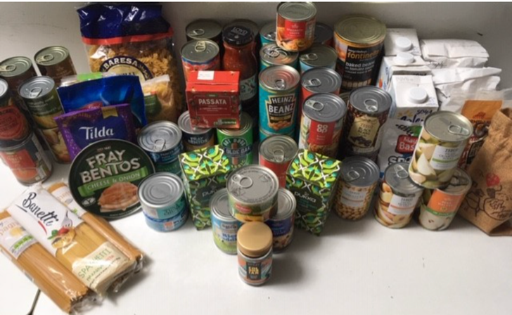
Thank you for your generous donations to our local food bank and Send a Cow. We raised a total of £92. This money will support African farming communities in growing their own food.

…. And now for the exciting launch of Landsove’s Harvest Celebrations 2020. Please visit/follow this link: https://video.link/w/vLkqb

It’s a super look at what the children have been learning; I particularly like class 1s cows!

SCHOOL ETHOS GROUP
Our school ethos committee meets half termly. The committee supports the work of the school, ensures we meet our Christian distinctiveness as a church school, helps the school to evaluate our work and acts as a local voice. There is at least one parent representative for each class as well as the FOLS representative and governor. The members of the committee are as follows:
Head | Jill Ryder
Staff representative with SIAMS/RE & collective worship lead. | Anna Neville
Community Rep | Christine Pascoe
Parish Rep | Laura McAdam (Dart Curate)
FOLS Rep | Justina Summerfield
Class 1 Rep
Class 2 Rep | Pip Cartmell (Y2) & Alexis Soul-Gray (Y1)
Class 3 Rep | Pip Cartmell (Y4), Alexis Soul-Gray(Y3) & Becca Butchart(Y4)
Class 4 Rep | Una McGovern & Becca Butchart (Y5&6)

As you can see we have a vacancy for class1. Please let me know if you are interested in joining this committee. In the event of more than one person being interested we will have a ballot. Many thanks.

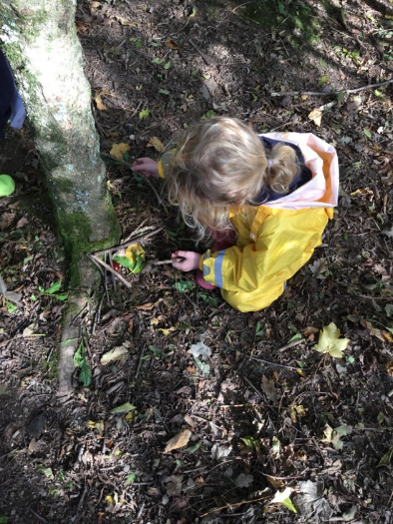
Some lovely learning experiences…
CLASS 1
Outdoor Explorers
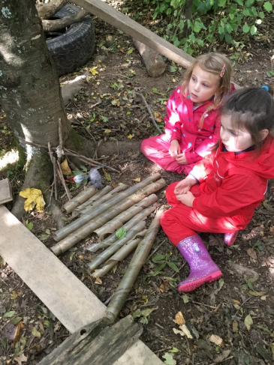
Our activities are carefully thought out to support all areas of children's learning and development: physical, creative, communication & language, personal and social and of course, 'understanding the world'. We believe that being 'in tune' with our environment is crucial to the children's development and wellbeing.
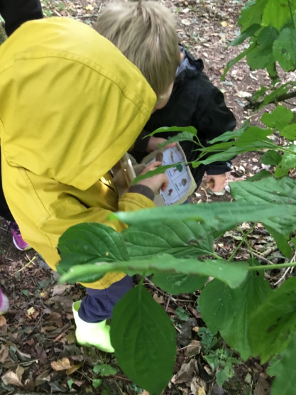
Outdoor Explorers gives children so many opportunities to 'get stuck in': to explore ways of doing things, follow their own ideas, persevere with tasks, seek out challenges, take risks and build learning resilience. All of these characteristics of effective learning are then transferable and integral to everything they do across their school week, they underpin everything! If we get their 'learning stamina' and attitude to learning right in C1 this will stand them in good stead as they go up through the school. I love watching how the children approach their tasks in these sessions, watching them develop and progress is such a huge privilege.
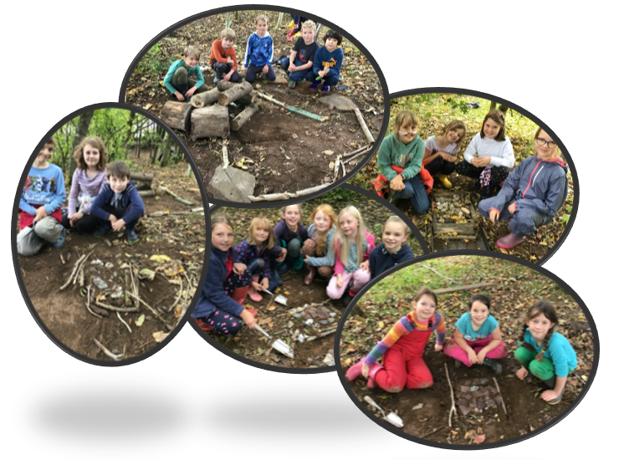
Lucy Field.

CLASS 3 Building Roman roads at forest school!

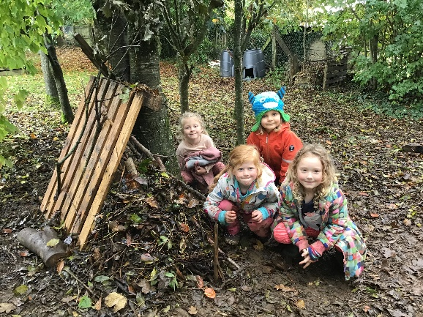

Den building
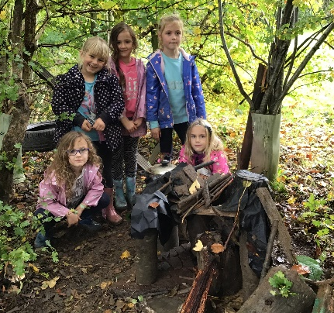
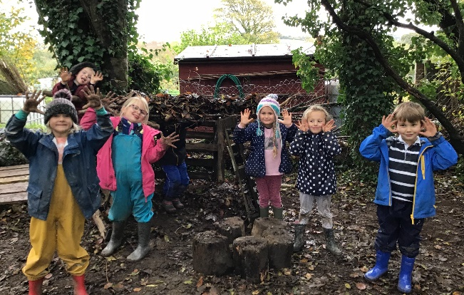
Exploring healthy balanced diets

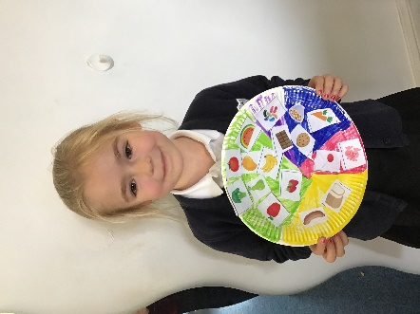
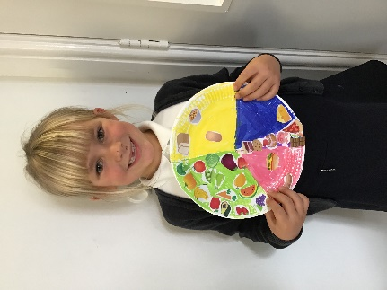
Class 4 enjoying a game of Human noughts and crosses - speed, tactics and teamwork is the name of the game!
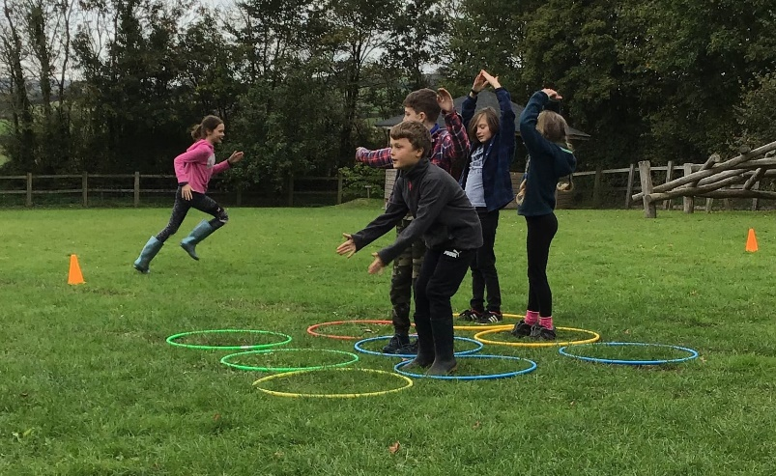

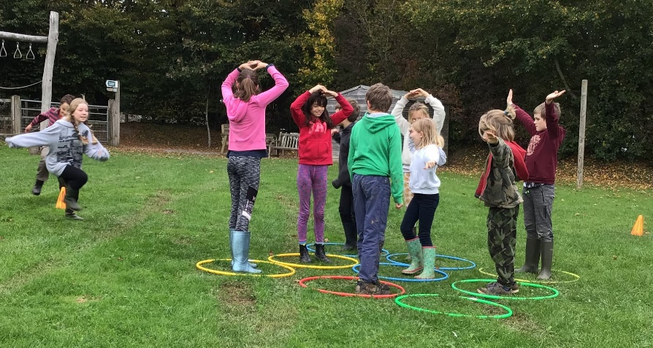

SPORTS CLUBS NEXT ½ TERM
Mondays: Premier Sports Dodgeball Y3-6
Wednesdays: SSW Football
Thursdays: Multi Sports Y1&2

SAFEGUARDING & ATTENDANCE
Attendance:  (Our school target is 96.8%) |  | Number of sessions missed per class: (session = a whole morning or afternoon)
Whole school | 97.8%
Class 1 | 95% | 14
Class 2 | 98.9% | 6
Class 3 | 99.8% | 1
Class 4 | 96% | 20
Well done to class 3!

The Designated Safeguarding Lead for Landscove is Mrs Jill Ryder and the Deputy DSLs are Ms Karen Barlow and Mrs Anna Neville. If you have any concerns please contact school or you can directly access MASH on 0345 155 1071

We are thrilled to be above target on our attendance!

Music lessons available after half term

We also have Mr Massey teaching trumpet: (07854 676889) and Lucy Wiessler teaching violin: lucywiessler@gmail.com

FOLS NEWS From Justina
Big thank you to everyone who contributed to the bags for schools collection. We raised £204 which is one of our best collections yet!
We are very happy to let everyone know that Nick Cartmell has secured a significant grant for playground improvements... Thank you Nick for all your hard work on this project!
Please look out for the raffle tickets for the Christmas raffle. They will come out in bags after half term and are well worth a ticket with a laptop as first prize!

Well this half term has certainly flown by. I wish everyone a lovely half term - Happy holidays!

Link Academy Trust – Registered Office Address
Landscove School, Landscove, Ashburton, Newton Abbot, Devon.TQ13 7LY
Tel:- 01803 762113 Email:- admin@thelink.academy

