Landscove C of E Primary School
Landscove, Nr Ashburton, Devon. TQ13 7LY
Tel: 01803 762656 Email: adminlandscove@thelink.academy

NEWSLETTER Friday 30th April 2021
Dear Parents,
It has been lovely to welcome all the children back and what wonderful weather we have been blessed with, apart from the chilly wind!! Please read on to find out about things that are happening this term.
SPORT UPDATE:
As we follow the Government's roadmap, more opportunities for whole school events will become possible. Mr Tanner is planning a Community Sport Day on 1st July (more information to follow nearer the time) and our Sports Day is planned for later this term (date TBC with Mr Tanner). We sincerely hope that we will be able to welcome parents to both events, but we will follow whatever the guidelines suggest. We will keep you informed as these things become clearer.
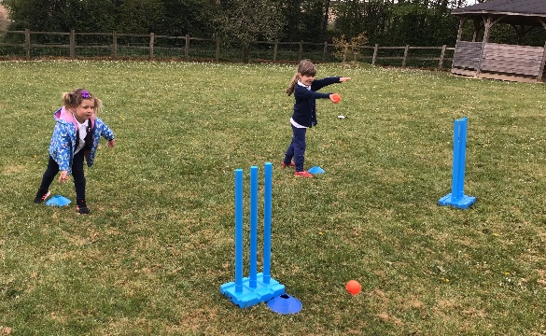
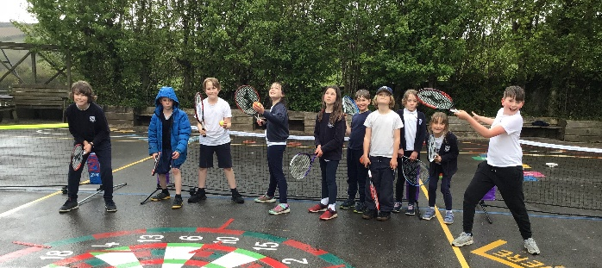
Although we are currently unable to arrange residential visits due to Government guidelines, Miss Barlow has managed to arrange a fantastic two day experience at Pixies Holt towards the end of May, which will allow the Years 5&6 to be challenged with a range of activities from mountain biking to climbing. Letters to parents about this have gone out this week.

ECO request
We have been contacted by Air Quality Management Resource Centre (AQMRC)
UWE, Bristol requesting our participation in an important national survey (in conjunction with the University of the West of England, Bristol) to address air pollution at schools. The data collected from this survey will inform the development of strategies to reduce child exposure to harmful air pollution.
The questionnaire is entirely anonymous, and no personal or identifiable information will be requested or recorded at any point.
If you are interested and would like to take part the link below will take you to the questionnaire, which should take no more than a few minutes to complete.
https://uwe.eu.qualtrics.com/jfe/form/SV_9ZD2i6fXjKPNCFD

SCHOOL UNIFORM
A reminder about school uniform. The wearing of school uniform is actively encouraged, fostering an identity with and pride in the school.
School Logo Jumpers, sweatshirts, cardigans, fleece jackets and PE shirts are available from https://myclothing.com/landscove-church-of-englandprimary-school/12863.school but not all logo items are essential.
Children are asked to wear:
- Navy sweatshirt, cardigan or fleece. (Bearing the school logo is useful for when we take trips as the logo helps to easily identify us.)
- Blue skirt or pinafore
- Blue/black/grey trousers/shorts
- White or Blue Polo Top / shirt with collars not round neck
- White socks, navy tights or blue leggings worn under a skirt as tights
- Sensible and smart black or blue shoes. Trainers of this colour are also suitable, but a second pair must be available for sport/PE.
- Summer wear with blue check
- Sun hats should be worn in the Summer
PE
- Joggers are acceptable for PE.
- White round necked t shirts
- Blue shorts
- PE trainers
This list is not exhaustive but represents the main items, which can be found in most high street supermarkets. It’s also worth noting that Justina (FOLS) has second hand uniform available. We appreciate your support with following our uniform policy.

MENTAL HEALTH & WELLBEING
Emotional Literacy
A central theme in the Jigsaw Materials we are using in our PSHE curriculum is developing children’s emotional literacy. This includes the following strands: *self-awareness, *social skills, *empathy, *motivation & *managing feelings. Together with educators, parents have a huge part to play in supporting their child’s emotional literacy. This is not an advert for ‘Bridge the Gap’- but the website is worth a look! There are some fun & interactive emotional literacy activities in the free resources section.
Mrs Field

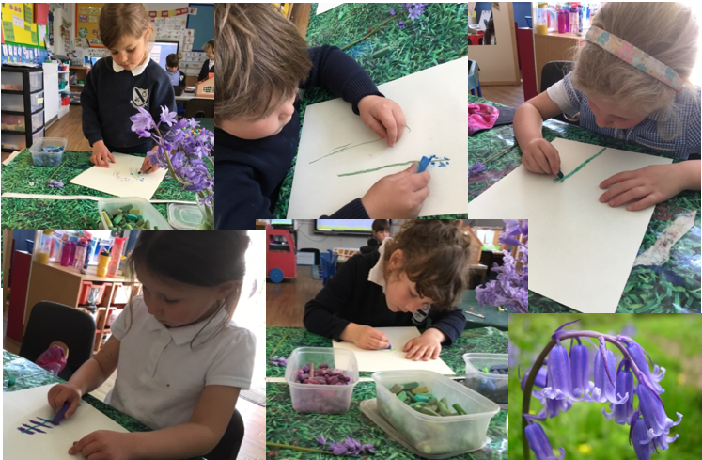
LANDSCOVER LEARNERS

Wow! Look at this stunning artwork the children in Class 1 did last week. They used watercolours & pastels to create these fantastic observational pictures of bluebells. A great way to kick off our New Life/Growing topic.
Class 2 planted sunflower seeds in WWL this week. The sunflower planting packs were kindly donated by Morrisons Totnes. We had to make a hole in the soil to pop the seeds in and give them a little bit of water. For the rest of the Summer term, we are going to look after them and watch them grow!
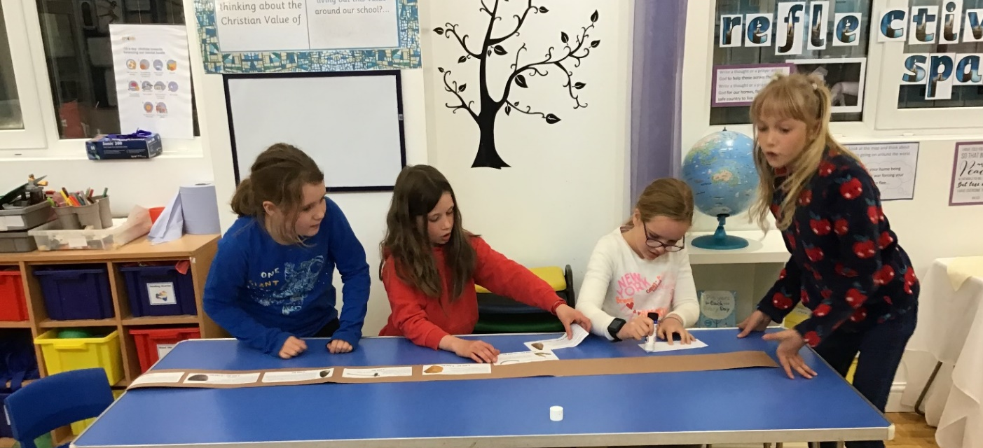
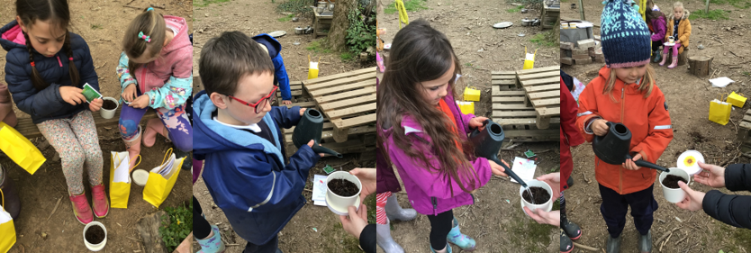
Super timeline creations in class 3
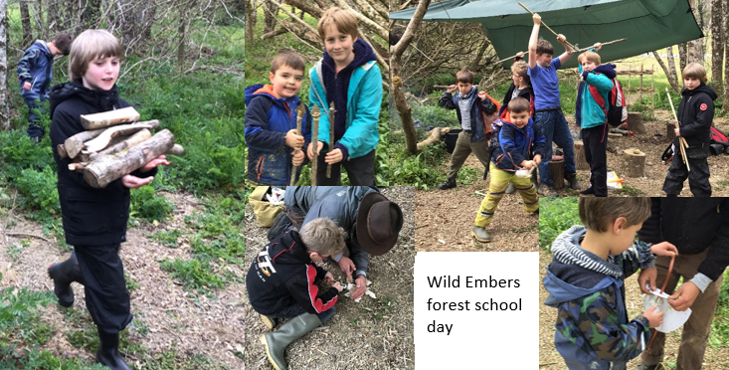
ETHOS/RE/Collective Worship
Core Christian Values
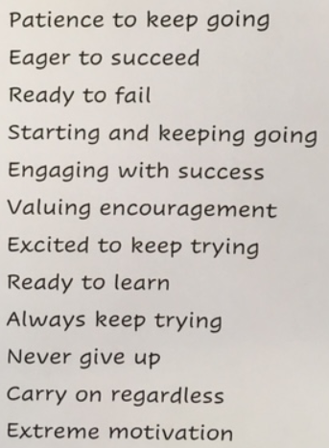
We started off Collective Worship this term by remembering the life of Prince Philip, the Duke of Edinburgh. The children could recognise how well he fulfilled his responsibilities and was deeply respected by many people across our country and further afield.
Exploring the value of perseverance has evoked some very thoughtful responses.
Class four composed this incredible acrostic poem, which encapsulates all the skills and qualities that are required to achieve the warm glow of success.
Christian Aid Big Brekkie
On Wednesday 12th May, we will be supporting The Christian Aid charity by serving up a ‘Big Brekkie.’ Please look out for further information in the next newsletter.
Spiritual Garden update
So far, we have volunteers to paint the rear wall of class three, build a gate, carry out work on the water feature and help with general digging etc. Thank you very much to these people. Your support is invaluable in moving this project forward! Please contact me if you are able to provide any materials or join us by offering help.
Anna Neville

SUNNY WEATHER
With the better weather promised can I remind you to apply sunscreen to your children before school. Please ensure sunhats and water bottles are in school each day. We will do our best to remind children to reapply sun cream at lunch time.

ATTENDANCE AND SAFEGUARDING
Attendance:
(Our school target is 96.8%)

Whole school | 99.26%
Class 1 | 100%
Class 2 | 98.61%
Class 3 | 99.47%
Class 4 | 99.44%
Well done to class 1!
Our Safeguarding Lead is Jill Ryder and our Deputy Safeguarding Lead is Miss Barlow. If you are concerned about a child’s safety or wellbeing please contact the school or in non-school hours contact MASH on 0345 155 1071

That’s all the news for now.
Have a good weekend and enjoy Bank Holiday Monday!

