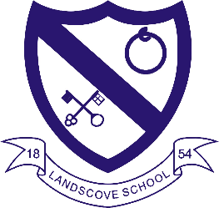
LANDSCOVE C OF E PRIMARY SCHOOL
RE & CW Lead Report for the School Ethos Group

2nd February 2022

SCHOOL ETHOS, SIAMS & RE

Communities and Living Well Together
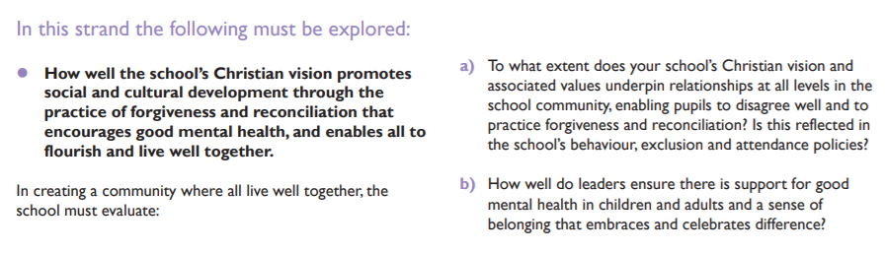
Excellent
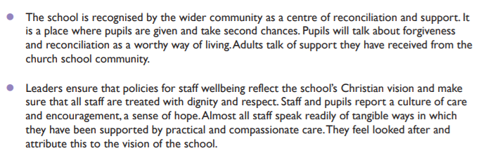

Our Vision
Landscove will use...

The keys to unlock the very best of us!
Matthew 7:7 “Ask, and it will be given to you; seek, and you will find; knock, and it will be opened to you.”
We are a school that is built on success stories; some big, some small, some public but most private. The message is simply that we want all the children to feel the warm glow of success and be motivated individuals who are constantly striving to do exceptional things.
We aim to provide an education enriched by our Christian traditions; Wisdom, Hope, Community and Dignity. Our learners will be given opportunities to become independent, collaborative, creative learners who have the confidence to seek wisdom and nurture a love of learning. Our small school provides big opportunities to broaden learners’ horizons and prepare them for the fullness of life, through hope, aspiration and our core Christian values. We focus on relationships and learning to live well in a wider community that can flourish together. Central to children’s learning is respecting the worth, dignity and preciousness of each person in a safe and inclusive environment within the sight and love of God.

Forgiveness is one of our Core Christian Values. It is evident through CW and our Understanding Christianity RE units that children recognise the importance of seeking forgiveness, saying (and being) sorry and offering forgiveness to others.
Staff worked in an incredibly supportive environment.

Collective Worship
The values of hope and perseverance. Prayer space – children are writing their personal challenges on football templates and moving to the goal when they have achieved them.
Chris Grimshaw has provided recordings of Open the Book.

24.1.22/25.1.22 AN observed FaB lessons in Class 1 and Class 2.
26.1.22 AN led joint staff meeting on Global Neighbours. We are working through our action plan meeting the Bronze criteria and in some areas Silver and Gold. Could members please provide feedback on Arts Week and Exhibition?
Did children successfully convey a message about plastic pollution/climate change? How has it impacted on you?
March 22 AN currently organising a visit to Exeter Mosque for year 3&4 children from Landscove and Broadhempston.
Late Spring Grand Opening of Spiritual Garden. Liaising with FOLS to complete work. Can any members support with this?
Summer Collate all evidence and apply for Global Neighbours Award.

LANDSCOVE C OF E PRIMARY SCHOOL
Academy Head Report for the School Ethos Group

PUPIL NUMBERS

R 11
Y1 17
Y2 13
Y3 14
Y4 10
Y5 14
Y6 12
Total 91

CLASS ORGANISATION
- Class 1 : R (0.4 Rebecca Barons, 0.6 Jo Woods)
- Class 2: Y1 & Y2 (FT Jenny Foster)
- Class 3: Y3 & Y4 (0.5 Anna Neville, 0.5 Anne Smart)
- Class 4: Y5 & Y6 (Chloe McFadzean FT)

STAFFING UPDATES
- This term Ms Jasmine Capaldi has joined class 2 for a teaching practice block.

SCHOOL IMPROVEMENT PLAN & SCHOOL SELF EVALUATION:
Staff meetings this half term are concentrating on the following key priorities:
ASIP link | Key themes of INSET
KP1, KP7(B), QE3(L) | SM: Maths update KB,  Key Priority: Phonics, JW, writing plan JW.
LM1  KP1 | Writing: Conferencing for accelerated progress: Lizzie Lethbridge leading  SG OMG KCSIE update to revisit
LM1  KP 3 | SM: Global neighbours update Sue & Anna  RE: Use of planning & assessment -Anna
LM1  QE3(L) | MATHS learning walk feedback & next steps from KB  Science update & feedback from book scrutiny & observations in own schools (AS & JP)

OTHER INFORMATION – VISITORS - COURSES ETC
- Sadly Christmas performances in church were ‘in house’ only and we still remain vigilant regarding covid cases and infection control
- Prospective parent show rounds have been taking place and our projected numbers are looking promising.
- Class 3 have been to Torquay museum trip – children have been full of enthusiasm and share information freely!
- IIH is supporting children and families
- Team around the Family (TAF) meeting continue to run.
- EP referrals continue to take place.

HEALTH & SAEFTY/ SAFEGUARDING/ BEHAVIOUR/C19
- COVID has begun to show itself in school. We continue to be guided by Public Health and all covid absences are reported on the DFE & Devon County portals. Staff are getting home learning onto TEAMS once we have been informed of an absence. It is in place by the end of the day we are informed.
- Mrs Monroe and Mrs Drew have completed their two-day paediatric first aid training and lead first aid across the school. Miss Raymont, Miss West & Mrs Redmayne completed
Safeguarding training this half term is based on:
- NPD we had a SG quiz – what have you remembered from last term & what do we need to revisit?
- Brook Tool: Sexualised behaviours traffic light tool: Information & scenarios are used
- Green behaviours reflect safe and healthy sexual development.
- Amber behaviours have the potential to be outside of safe and healthy behaviour. They may need to be shared with safeguarding officers.
- Red behaviours are outside of safe and healthy behaviour. Red behaviours indicate a need for immediate intervention and action.
- Keeping children safe in education -one minute guide to revisit key changes
KCSIE is a document outlining what staff in school should look out for in relation to Safeguarding.
It notes the different types of abuse. Staff are expected to read Part One every year.
ADDITIONS for this year are –Peer-on-Peer Abuse, Remote Learning, Allegations against staff & Sexual Violence & Harassment
- Safer Internet day & Mental health week coming up next week.
Anna Neville & Jill Ryder

