Landscove C of E Primary School
Landscove, Nr Ashburton, Devon. TQ13 7LY
Tel: 01803 762656 Email: adminlandscove@thelink.academy

NEWSLETTER Thursday 11th November 2021
Dear Parents,
OFF WE GO AGAIN!
The Autumn half term was a great break for the staff and we are all back in school feeling excited about what lies ahead. We aim to have a few settled weeks before the acting rehearsals begin and the requirements of Christmas engulf us all. It looks like we are going to have a busy half term and the FOLS are going to be particularly busy with the Christmas Fair.

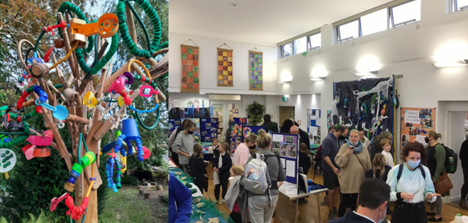
ARTS EXHIBITION & OPEN EVENING
Huge thanks to FOLS for supporting us to work with a local artist and give the children a memorable experience. It was great to get this event back on our calendar and see so many people in school. Thank you to everyone who joined us for our exhibition ~ there was some fantastic work on display and the children were very proud to show off their work. I hope you were as proud of your children as we are! Please see the collage at the end of this letter for more pictures.
LANDSCOVE LEARNERS
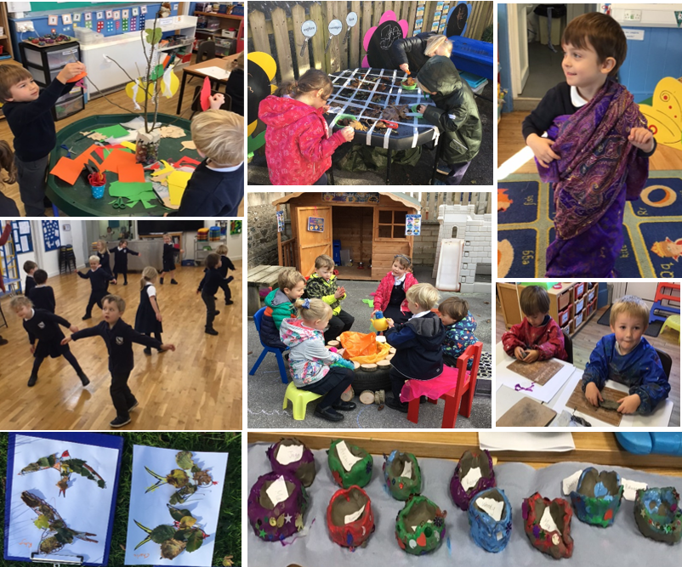
Autumn has come to Class One! The Reception children have started their new topic “Colour and Change” and as part of this learning they’ve been enjoying stories about Autumn, they’ve been singing and dancing to Autumn songs and they’ve been learning about migrating birds in their Outdoor Explorers sessions. In their Faith and Beliefs (FaB) learning the children were introduced to the Hindu celebration of Diwali and the children created their own firework pictures and clay Diva lamps. What a busy and colourful start to the half-term it has been in Class One!

Class 2 got stuck into a science experiment on Friday. The children were faced with Ted's problem - Ted couldn't play outside when it was wet, he needed an umbrella. But which material would be the most suitable for this job? They tested 4 materials in their groups - tin foil, paper, felt and plastic - and had to decide as a group which was the most waterproof, strong and long-lasting. Most groups agreed that the plastic would be best!
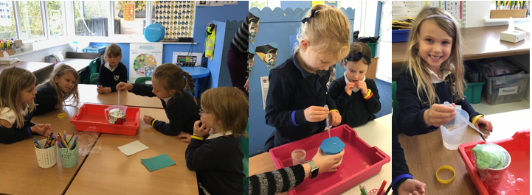
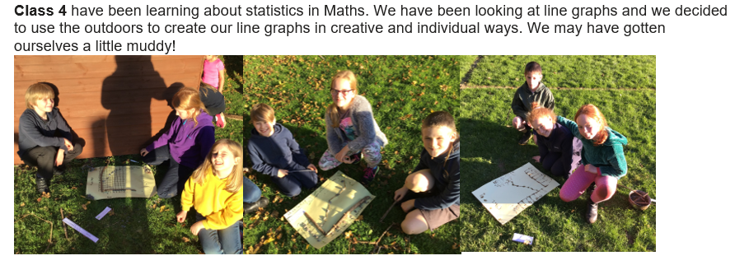
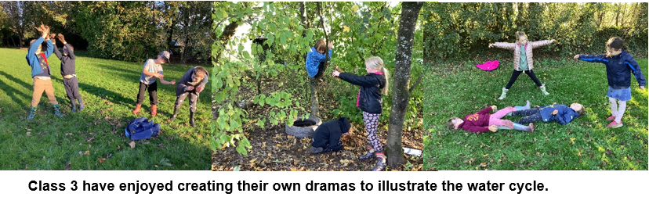
FOLS ~ Bags2School
Massive thanks to everyone for your contributions to the recent bag2school collection. A fantastic £120 was raised for FOLS. Thank you!
Advance notice - the next collection will be Friday 29th April 2022.

ETHOS & VALUESWe were delighted to welcome Chris Grimshaw from the Open the Book team back into school. He enlisted the help of some volunteers from class three to act out ‘Ruth Finds a Home.’
This bible story teaches us about the importance of showing compassion and links beautifully with courageous advocacy. Spotting injustice is one thing, taking action against it is another.

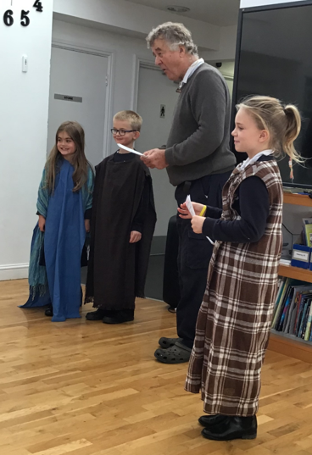
CHILDREN IN NEED ~ FRIDAY 19TH NOVEMBER
The School Council have been busy meeting and organising ready for Children in Need day next Friday:
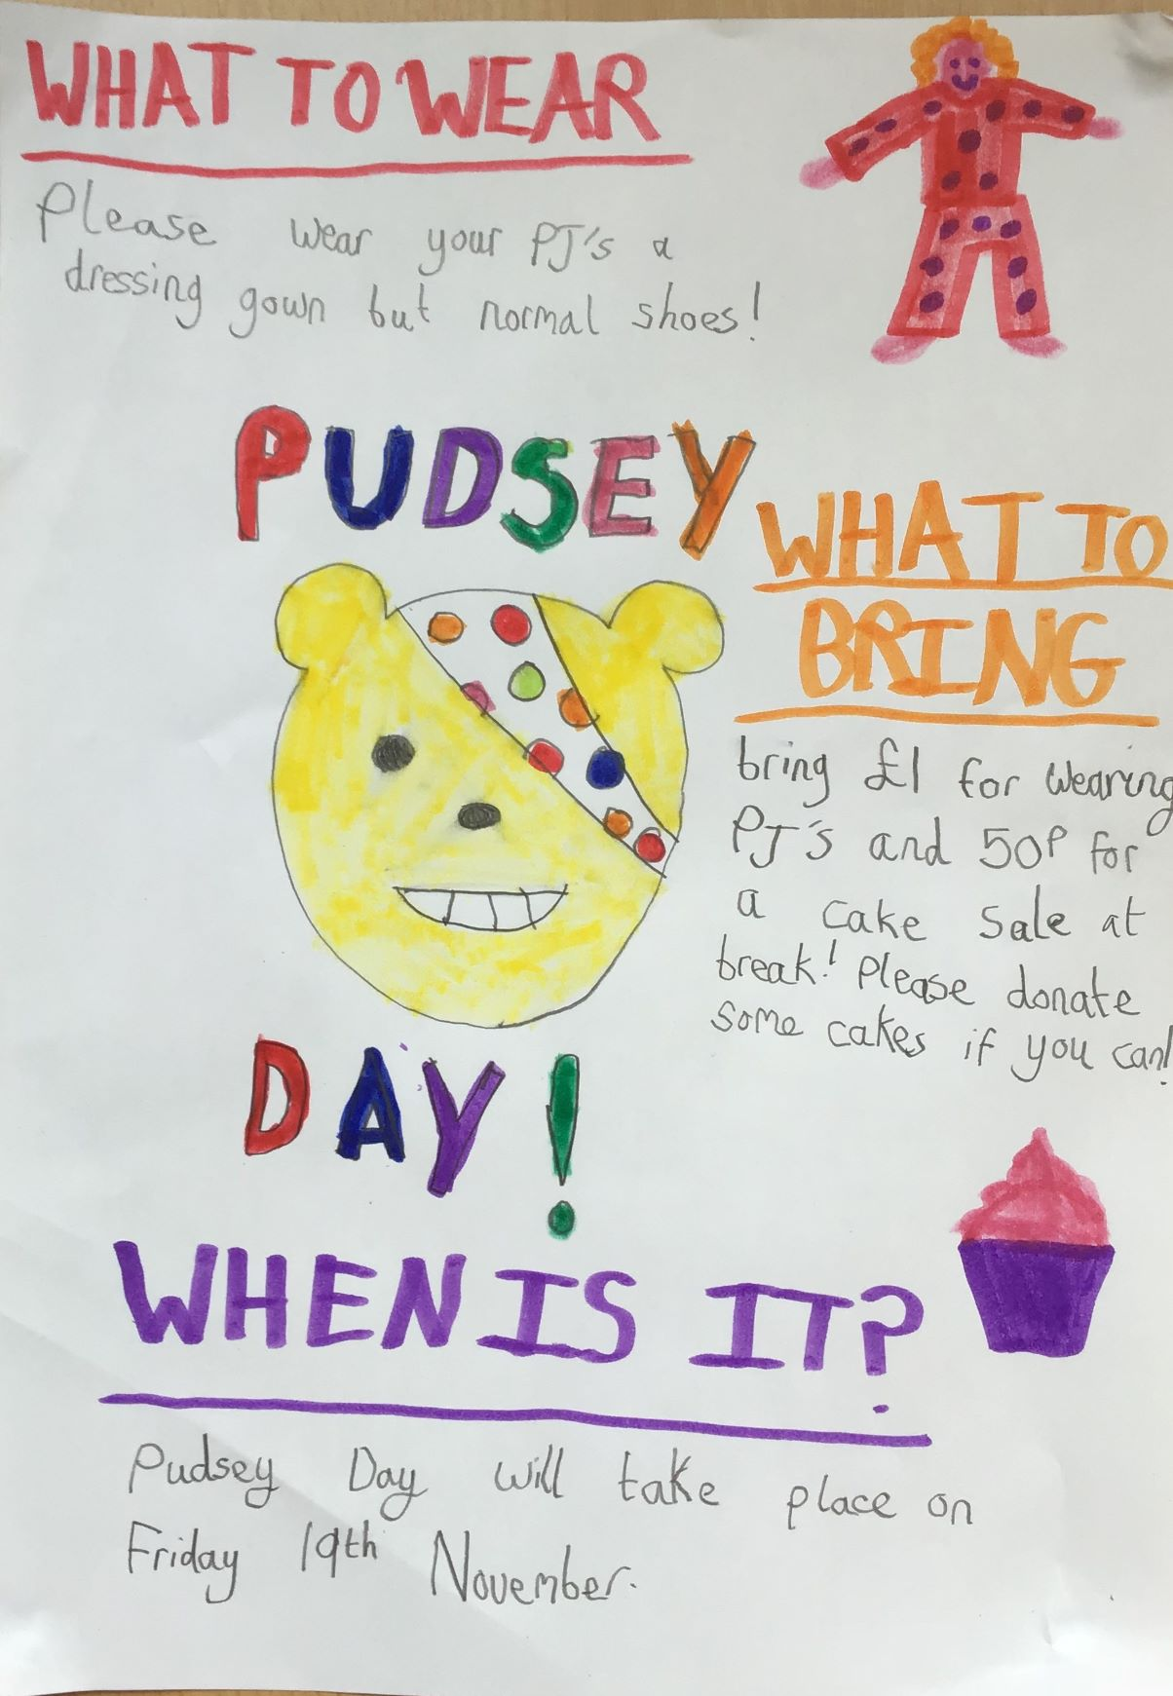
Please can cash donations for cakes and mufti be brought into classes with children in the morning.
Any donations of cake for the sale can be taken to the school office.
Many thanks, Miss Foster and the School Council.

SAFEGUARDING & ATTENDANCE
Please be aware that we are continuing to monitor attendance and will be letting you know if your child is below our attendance target. I am well aware there are many illnesses going around at the moment but I do want to keep everyone informed of current data in this area.
Attendance:
(Our school target is 97%)

Whole school | 94.6 %
Class 1 | 86.9%
Class 2 | 97.6%
Class 3 | 96.5%
Class 4 | 92.6%
Well done to class 2!

REMINDER:
COATS ~ as the winter weather sets in, can we please remind parents that all
children need to have a waterproof coat in school. We aim to get the children in the fresh air if at all possible.

COMING UP ~ DATES FOR YOUR DIARY(so far!)
17th November | Sandya Dave, Cultural Champion, visiting KS2
19th November | Children in Need Mufti day
24th November | Class 2 - Trip to Bygones Torquay
3rd December | FOLS Christmas fair
8th December | 2 pm KS1 Nativity Play in the Church  6pm KS2 Performance 2, for Class 3 parents and families
9th December | 6pm KS2 Performance 2, for Class 4 parents and families
15th December | Pupil & Staff Christmas Dinner
17th December | 1pm Carol Service St Matthew’s  2pm break up for Christmas

Well, it’s already shaping up to be a fun packed, full half term. Hard work? Yes, for sure. Worth it? Absolutely!
Have a restful weekend.

