Landscove C of E Primary School
Landscove, Nr Ashburton, Devon. TQ13 7LY
Tel: 01803 762656 Email: adminlandscove@thelink.academy
NEWSLETTER 1st APRIL 2021
Dear Parents and Carers,
Well, we’ve arrived at the end of term already! Can we really be this far through the year? It’s been a busy couple of weeks~ but we’ve had a lot of fun along the way!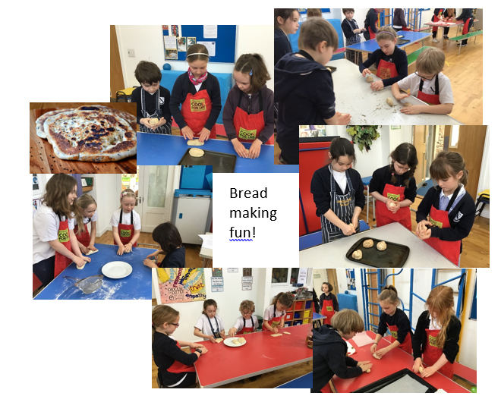
COVID UPDATES
To support the NHS Test and Trace process, the DFE have asked that staff are available for the first 6 days of the Easter holiday to fulfil necessary contact tracing responsibilities. This means that for contact tracing purposes up to and including Wednesday 7 April you will be able to report a positive test result for your child or family to school. To support this the Trust have set up a COVID email address for reporting results. Please report any positive test results using the following email: Covid.notification@thelink.academy There is no expectation for school to be on-call after this point.
Thank you for being so supportive of our C19 restrictions, I do understand that children want to play on the field but we are following DFE guidelines and doing our bit to remember the rule of 6 and all social distancing expectations that the government would like us to follow. This is not a new rule at school and has been part of all risk assessments and communication of these. Hopefully it won’t be for too much longer!
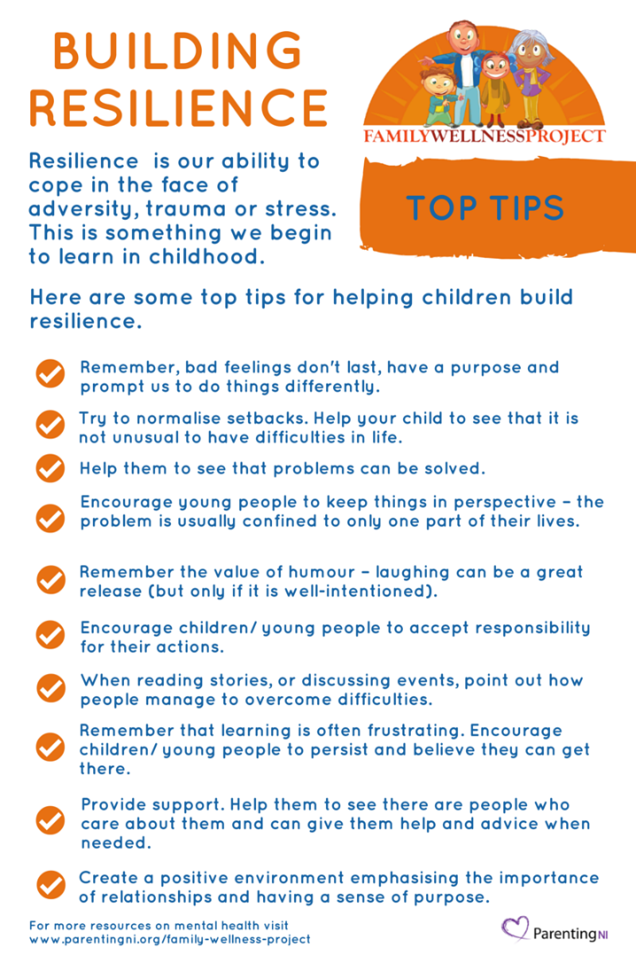
WELLBEING
Emotional Resilience
Although perhaps an over-used term at the moment, I think it is worth thinking about ‘emotional resilience’. Essentially, it means to be able to ‘bounce back’ from disappointment or tough times & cope with life’s uncertainties. As key adults in children’s lives there are many things we can do to support and develop children’s emotional resilience. If children can develop their levels of resilience, this has a huge impact on their learning, development and attitude to life generally! I came across the poster below and thought it might be useful to share. Lucy Field
ATTENDANCE AND SAFEGUARDING
Attendance:
(Our school target is 96.8%)

Whole school | 98.1 %
Class 1 | 97.2%
Class 2 | 98.6%
Class 3 | 97.3%
Class 4 | 98.9%
Well done to class 4
I would like to remind everyone that in line with DFE guidance, we will rigorously monitor attendance now we are back to full time schooling. If you are ever uncertain if you should send your child to school please call the office and we will advise you.
We would request that parents are punctual as late starts mean children miss the beginning of lessons. Late starts and early finish requests are not authorised, and are recorded and shared at County level with the school’s EWO who monitors our attendance data. Please, where possible try to make appointments out of school hours. Many thanks for your support with this.
FaB & COLLECTIVE WORSHIP
A huge congratulations to the courtesy cup winners, who were spotted living out our core Christian values of responsibility and perseverance. They were awarded the cup during whole school live Teams Assemblies, enabling everyone to share their wonderful achievements.

Easter…A Time to Wonder- Reflective Storytelling
A sense of awe and wonder was certainly evident on the children’s faces as they listened to the Easter story being retold with the aid of objects representing key figures and symbols. Having time to pause and reflect, helped developed a deeper understanding of the sequence of events and their significance to Christians. Class three had a long discussion about ‘Why Christians call the day Jesus Died Good Friday,’ culminating their unit on Salvation.
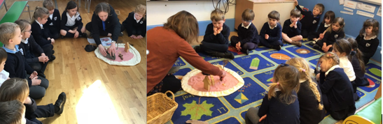

Spreading Easter Joy in our Local Community
Beautiful cards, handmade by the children, have been delivered to members of our local community and the residents of St Andrews and Redmount Residential Homes.
Easter Service
Reverend Tom’s Easter Service has been uploaded to Teams and our Facebook page. We hope you enjoy watching this together.
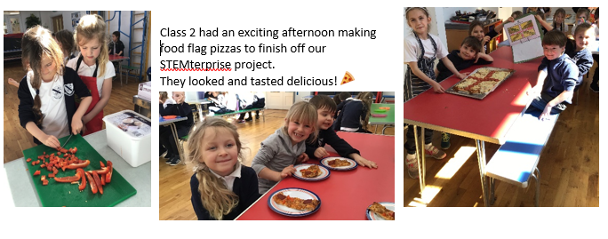
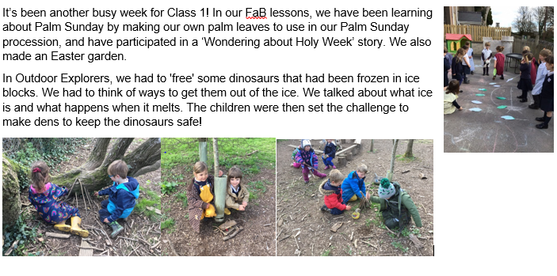
Anna Neville

SCHOOL DINNERS
The summer menu is now up on ParentPay. Please remember to order your child’s dinners 48 hours in advance; and if you’re feeling super organised, why not order for the whole term?!
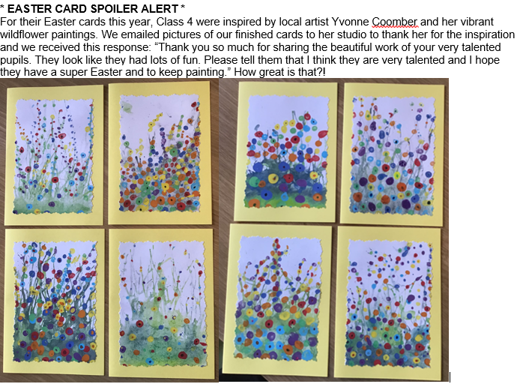
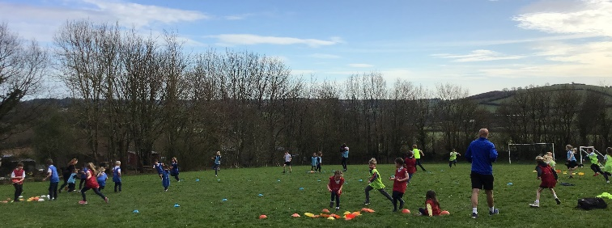
SPORTS
This short half term has seen lots of energy going into our 3 after school sports clubs for children throughout the school: Premier Sports gymnastics on Mondays, SSW football on Wednesdays &
Mr Tanner's multi sports on Thursdays
Look out for details of the next clubs coming after Easter!
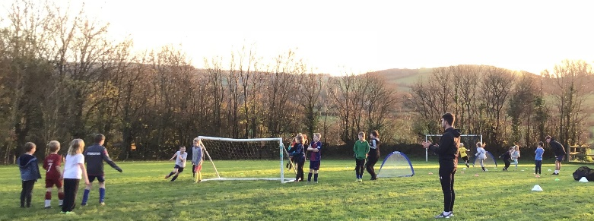

That’s all the news for now. I hope everyone has a restful and happy Easter Holiday. See you on Tuesday 20th April when we will begin another fun filled term of adventures!
