LANDSCOVE C OF E PRIMARY SCHOOL
RE & CW Lead Report for the School Ethos Group

30th March 2022

SCHOOL ETHOS, SIAMS & RE

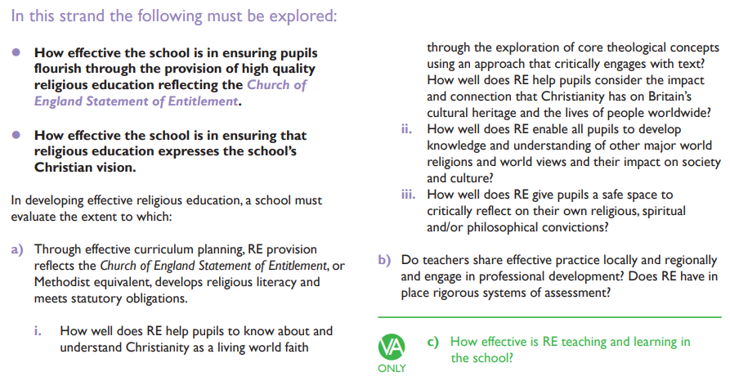
Our Vision
Our small school provides big opportunities to broaden learners’ horizons and prepare them for the fullness of life, through hope, aspiration and our core Christian values. We focus on relationships and learning to live well in a wider community that can flourish together. Central to children’s learning is respecting the worth, dignity and preciousness of each person in a safe and inclusive environment within the sight and love of God.

- Understanding Christianity Approach
Creation – Fall – People of God - Incarnation – Gospel – Salvation – Kingdom of God
The core concepts of Christianity are explored in a progressive way, using an enquiry approach that engages with biblical text and helps develop theological and religious literacy.
ii) Other major world religions and world views – please see Rolling Programme
iii) Do pupils have a safe space? Questions raised and discussed during a recent KS2 lesson:
- Why is that only Muslim women have to wear hijabs?
- If God is Jesus’ father, who is Joseph?
- How do you decide which religion to follow?
- Can you follow more than one religion?
Also consolidated through PSHE lessons.
Starting in the summer term, we will be exploring spirituality within Gospel groups during CW.
Self – Others – World and Beauty - Beyond

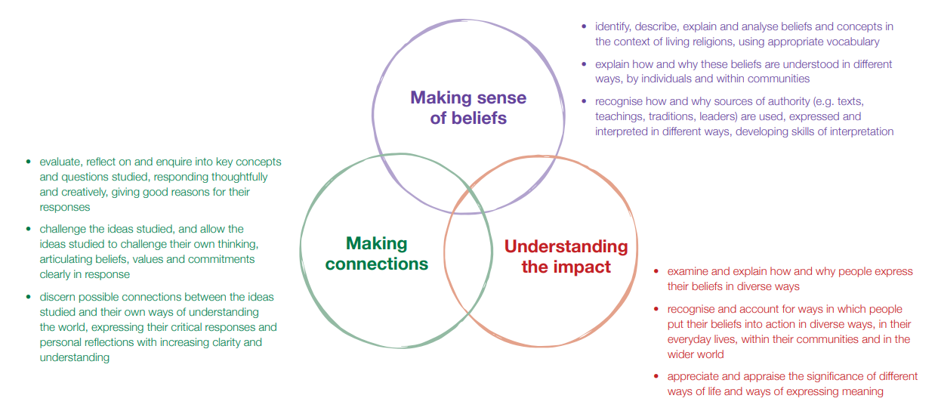
The three elements in the teaching and learning approach of The Devon Agreed Syllabus

- Rigorous systems of assessment – Elicitation Tasks at the start of each unit, on going assessment throughout (informing next lesson) and end of unit assessment. AN checks assessments and refers to these during book scrutiny. Teachers also encouraged to record verbal responses in class Sway/scrapbooks.
Professional Development – AH attends Trust Hub and LITRE meetings. Trust RE Lead keeps us up to date with latest developments.

Global Neighbours
3.3.22 Class 4 attended Fairtrade Conference.
10.3.22 Key Stage age appropriate CW on current crisis in Ukraine.
18.3.22 Class 3 planted trees on field following on from COP26.

Spiritual Garden
- Work on mosaics underway.
- All raised beds weeded and planted during Science Week.
- AN liaising with Art student regarding 3D project for year 6 post SATs.

14.3.22 Class 3 visit to Exeter Mosque
15.3.22 Will Watson from Riverford launched Science Week
16.3.22 AN led joint Landscove and Broadhempston Staff Meeting. Focus on Developing Spirituality, CW and Worldviews.
25.4.22 Mothering Friday.
5.4.22 Easter in a Day.
6.4.22 Easter Service for children in St. Matthews.

LANDSCOVE C OF E PRIMARY SCHOOL
Academy Head Report for the School Ethos Group

PUPIL NUMBERS

R 11
Y1 17
Y2 13
Y3 14
Y4 10
Y5 14
Y6 12
Total 91

CLASS ORGANISATION
- Class 1 : R (0.4 Rebecca Barons, 0.6 Jo Woods)
- Class 2: Y1 & Y2 (FT Jenny Foster)
- Class 3: Y3 & Y4 (0.5 Anna Neville, 0.5 Anne Smart)
- Class 4: Y5 & Y6 (Chloe McFadzean FT)

STAFFING UPDATES
Nothing to report

SCHOOL IMPROVEMENT PLAN & SCHOOL SELF EVALUATION:
Staff meetings this term have/are concentrating on the following key priorities:
- Curriculum plans for all subjects
- Global Neighbours project
- Conferencing – a forensic approach to accelerated progress
- Science – incl science week planning
- RE & world views – incl spirituality (awe and wonder)
- Oracy project
- Cross school moderation
- Disadvantaged pupils and the impact of COVID
In the summer term I will begin to think about key priorities for the coming year – these will be linked to Trust wide priorities as well as school priorities.

OTHER INFORMATION – VISITORS - COURSES ETC
- IIH is supporting children and families
- Team around the Family (TAF) meeting continue to run.
- EP referrals continue to take place.
- Subject leads have continued to work across the two schools supporting and developing their subjects and leading improvements.
- Karen Barlow and Jo Woods have completed Learning walks across both school for English and maths. These learning walks give us next steps and keep practice moving forward.
- We had a music specialist working within KS2 this half term. Mr Kip Pratt joined us -teaching
class 3 how to play glockenspiels and class 4 the ukulele. The children have been enthusiastic and enjoyed performing to the other classes. This was arranged through our Music in Education Grant & is part of our commitment to WCET (Whole class ensemble teaching).
- Forest School days have been a real success – the children have been immersed in whole days with trained forest school leaders. We will aim to do this as well as use our own woodland area – this will be blocked according to our curriculum plans.
- Sport has had a high priority with Matt Tanner organising some super Trust wide events including Volley ball mini tournament, Hand ball, Football & Cross Country
- Class 4, Y5 and Oak Class joined together to attend the Fairtrade conference at KEVICCs
- Parent’s evening took place in person – which was so much nicer for all!

HEALTH & SAEFTY/ SAFEGUARDING/ BEHAVIOUR/C19
- Covid19: our risk assessment will be updated to the latest guidance, but most restrictions are coming to an end
- Trust advice is that from the Summer term we will be able to hold school events and welcome parents to these (Yipee!)
- Attendance monitors have taken place and letters sent as required. This is always a thorny issue with parents but is a legal requirement that we are held accountable for. This is both a national and county wide agenda.
- We have a H&S review coming up which is a 3hour audit of systems we have in place.

Safeguarding training this half term is based on:
- Ramadan - What is it celebrated & How? What could be the potential issues for schools?
- Suicide ideation –the abstract thought of ending your life or believing that other people may be better off without you. Looking at how to have difficult conversations
- ASF - The Adolescent Safety Framework is Devon’s response to concerns regarding contextual safeguarding and the impact on children and young people’s safety outside of their family home from exploitation risk.

Anna Neville & Jill Ryder

