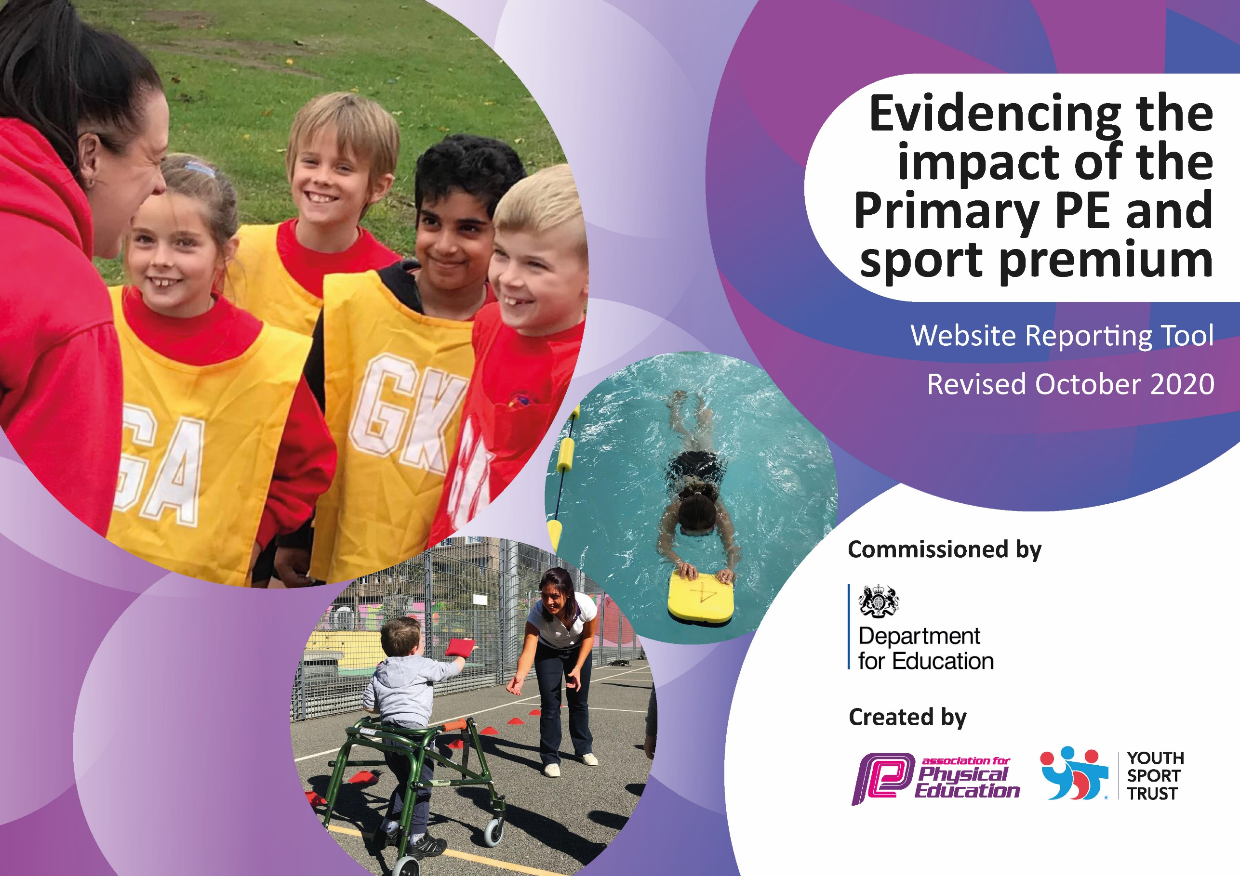
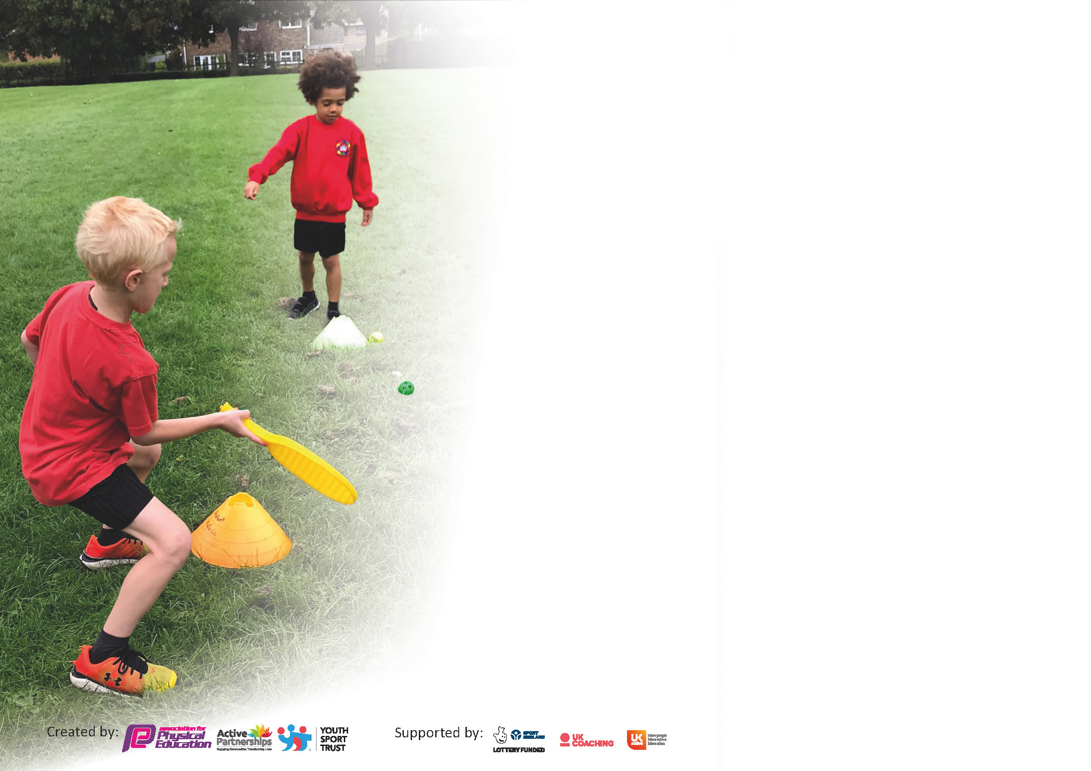

It is important that your grant is used effectively and based on school need. The Education Inspection Framework (Ofsted 2019 p64) makes clear there will be a focus on ‘whether leaders and those responsible for governors all understand their respective roles and perform these in a way that enhances the effectiveness of the school’.

Under the Quality of Education criteria (p41) inspectors consider the extent to which schools can articulate their curriculum (INTENT), construct their curriculum (IMPLEMENTATION) and demonstrate the outcomes which result (IMPACT).

To assist schools with common transferable language this template has been developed to utilise the same three headings which should make your plans easily transferable between working documents.

Schools must use the funding to make additional and sustainable improvements to the quality of Physical Education, School Sport and Physical Activity (PESSPA) they offer. This means that you should use
the Primary PE and sport premium to:

- Develop or add to the PESSPA activities that your school already offer
- Build capacity and capability within the school to ensure that improvements made now will benefit pupils joining the school in future years

Please visit gov.uk for the revised DfE guidance including the 5 key indicators across which schools should demonstrate an improvement. This document will help you to review your
provision and to report your spend. DfE encourages schools to use this template as an effective way of meeting the reporting requirements of the Primary PE and sport premium.

We recommend you start by reflecting on the impact of current provision and reviewing the previous spend.

Schools are required to publish details of how they spend this funding as well as on the impact it has on pupils’ PE and sport participation and attainment by the end of the summer term or by 31st July 2021 at the latest.

** In the case of any under-spend from 2019/20 which has been carried over this must be used and published by 31st March 2021.

We recommend regularly updating the table and publishing it on your website throughout the year. This evidences your ongoing self-evaluation of how you are using the funding to secure maximum, sustainable impact. Final copy must
be posted on your website by the end of the academic year and no later than the 31st July 2021. To see an example of how to complete the table please click HERE.
Created by: Supported by:

Please note: Although there has been considerable disruption in 2020 it is important that you publish details on your website of how you spend the funding - this is a legal requirement.
Support for review and reflection - considering the 5 key indicators from DfE, what development needs are a priority for your setting and your pupils now and why? Use the space below to reflect on previous spend and key achievements and areas for development.

N.B. In this section you should refer to any adjustments you might have made due to Covid-19 and how these will influence further improvement.
Key achievements to date until July 2021: | Areas for further improvement and baseline evidence of need:
KI1  - All students given 60 minutes of physical activity through constructive lunchtimes activities and whole-school morning movement activities.  KI2  - Trust employed PE specialise to lead subject within the school.  - Profile of PE raised across the school through a wide range of curricular opportunities and extra-curricular clubs for all students.  KI3  - CPD has been provided for all teaching staff and has improved staff confidence of delivering a range of PE activities.  KI4  - New PE curriculum has been rolled out, which includes a greater range of sports and activities, increasing the opportunity for students.  - Wide variety of extra-curricular opportunities available for all students to widen their experiences.  - Whole-school community day to provide wider variety of activities.  KI5  Despite difficulties surrounding COVID-19 restrictions, all students in KS1 & 2 have taken part in a competitive virtual festival against other schools. | - Additional festivals for KS1, KS2 and EYFS (COVID permitting). This will allow all students in the school to take part in competitive activity (KI 5).  - Wider opportunities for student to take part in outdoor and adventurous activities/gain experiences outside of the school in areas which aren’t covered in the PE curriculum e.g. rock climbing, sailing etc.  - Greater personalised CPD for teaching staff to further develop confidence teaching a wide range of PE activities.

Planned spending 2021-22

Action Plan and Budget Tracking
Capture your intended annual spend against the 5 key indicators. Clarify the success criteria and evidence of impact that you intend to measure to evaluate for pupils today and for the future.

Academic Year: 2020/21 | Total fund allocated: £16,740 | Date Updated: 10/10/2021
Key indicator 1: The engagement of all pupils in regular physical activity – Chief Medical Officers guidelines recommend that primary school pupils undertake at least 30 minutes of physical activity a day in school |  |  |  | Percentage of total allocation:
 |  |  |  | 3%
Intent | Implementation |  | Impact
Your school focus should be clear what you want the pupils to know and be able to do and about  what they need to learn and to  consolidate through practice: | Make sure your actions to achieve are linked to your intentions: | Funding allocated: | Evidence of impact: what do pupils now know and what can they now do? What has changed?: | Sustainability and suggested next steps:
Engage all students in daily active playtimes.  All students participate in the Golden Mile each day for additional physical activity.  Increase number of extracurricular activities available for students | Equipment has been purchased so students of all ages have access to a range of different physical activities during these times.  A new Sports Leaders programme has started, with KS2 students leading activities for all students during PE lessons and play times.  Premier Sport have set up the Golden Mile programme which tracks students running distances over the school year. Classed participate each day to increase their distance and subsequently their physical activity.  Extra-curricular clubs are available for students after school each day. These are led by external providers as well as class teachers/PE teacher. | £250  No cost  No cost

Key indicator 2: The profile of PESSPA being raised across the school as a tool for whole school improvement |  |  |  | Percentage of total allocation:
 |  |  |  | 38%
Intent | Implementation |  | Impact
Your school focus should be clear what you want the pupils to know and be able to do and about  what they need to learn and to  consolidate through practice: | Make sure your actions to achieve are linked to your intentions: | Funding allocated: | Evidence of impact: what do pupils now know and what can they now do? What has changed?: | Sustainability and suggested next steps:
Specialist PE staff to raise profile of PE and school sport to drive forward improvement in the subject and whole school community.  Use PE as a driver for improvements in student learning.  Increase students’ excitement of PE lessons through specialist resources. | The school has employed a specialist PE teacher.  New PE curriculum and planning rolled out to give staff the tools to improve the quality of teaching and learning through sport and physical activity.  Purchase of specific PE equipment/resources for each activity included in the PE curriculum. | See KI3  No cost (provided by PE specialist – see KI3)  EYFS, KS1 & KS2 = £1000

Key indicator 3: Increased confidence, knowledge and skills of all staff in teaching PE and sport |  |  |  | Percentage of total allocation:
 |  |  |  | 51%
Intent | Implementation |  | Impact
Your school focus should be clear  what you want the pupils to know  and be able to do and about  what they need to learn and to  consolidate through practice: | Make sure your actions to  achieve are linked to your  intentions: | Funding  allocated: | Evidence of impact: what do  pupils now know and what  can they now do? What has  changed?: | Sustainability and suggested  next steps:
Regular professional development for all teaching staff, promoting higher quality teaching of PE.  Regular afterschool CPD support for less confident staff, NQT’s. This will be made available for schools to come together to share expertise. | Employed school PE teacher to deliver regular training for staff to develop confidence in a wide range of activities. Detailed and personalised CPD programme in place for all class teachers.  Class teachers work with PE specialist to assess students and have regular feedback about their own delivery of PE.  Working group set up to regularly communicate and share best practice. | £9025  No cost

Key indicator 4: Broader experience of a range of sports and activities offered to all pupils |  |  |  | Percentage of total allocation:
 |  |  |  | 7%
Intent | Implementation |  | Impact
Your school focus should be clear | Make sure your actions to | Funding | Evidence of impact: what do | Sustainability and suggested
what you want the pupils to know | achieve are linked to your | allocated: | pupils now know and what | next steps:
and be able to do and about | intentions: |  | can they now do? What has
what they need to learn and to |  |  | changed?:
consolidate through practice:
Develop leadership opportunities for students in KS2.  All students to take part in outdoor/adventurous activities.  Improve water confidence and safety for students in ks2  Use specialist providers to offer students exciting activities.  Additional swimming support for students not meeting Yr 6 criteria. | Set up a new Sports Leaders Programme for KS2 students.  School to fund trips for all students in KS1 & KS2.  Surf life saving training for all KS2 students  Whole-school community day planned for the summer term. This will include a range of different activities.  6-week block of additional lessons given by swimming staff for year 6’s needing support. | £250  KS1 = £1000  KS2 = £1000  £500  £800  £500

Key indicator 5: Increased participation in competitive sport |  |  |  | Percentage of total allocation:
 |  |  |  | 0 %
Intent | Implementation |  | Impact
Your school focus should be clear | Make sure your actions to | Funding | Evidence of impact: what do | Sustainability and suggested
what you want the pupils to know | achieve are linked to your | allocated: | pupils now know and what | next steps:
and be able to do and about | intentions: |  | can they now do? What has
what they need to learn and to |  |  | changed?:
consolidate through practice:
Offer students trust-wide competitions.  Fixtures for schools to compete against others on a regular basis | All students to have the opportunity to represent their school in the 2021-22 academic year.  Link Academy league to be set up. | Facility hire = £300  Transport = £2000  No cost | .

Total sports grant: 16,740
Total projected spend: 16,625

