Landscove Long Term Curriculum Map 2021-2023
 | Autumn |  | Spring |  | Summer
Reception | 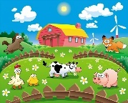The Farm | Colour and Change | Space | 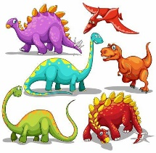Dinosaurs | Year A  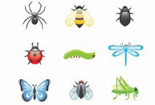Minibeasts | 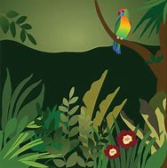The Jungle
 |  |  |  |  | Year B  New Life | The Sea
Hook or visit | Rare Breeds Farm Trip/Farm visit |  | Journey around Earth (Google Earth) | Visitor – someone who helps us | Stover Country Park | Beach Trip
Year 1&2  A | Amazing me! |  | 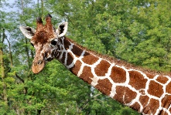  Africa |  | Roots, shoots and moon boots
Hook or visit | Visitor – someone who helps us |  | Paignton Zoo trip |  | Space day
Year 1&2  B | Toy Story |  | Fire Fire! |  | Under the Sea  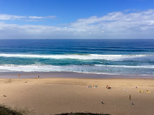
Hook or visit | Bygones museum visit |  | Great Fire of London themed forest school day |  | Beach trip
Year 3 & 4  A | 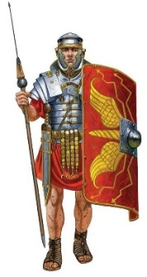What did the Romans do for us? |  | 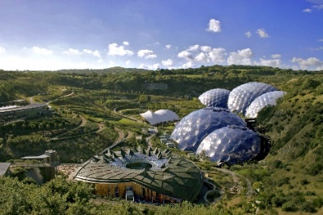People, Plants and Possibilities |  | 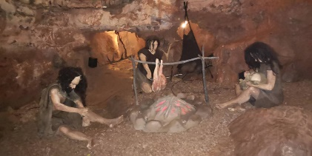  Journeys – Back to the Future
Hook or visit | Roman Soldier |  | Eden Project Visit |  | Kents Cavern Visit
Year 3 & 4  B | 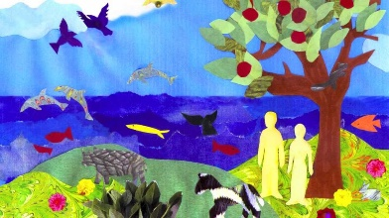  Settlers, Shakers, Noise, Creator |  | 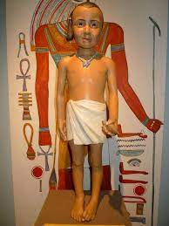  People, Plants and Possibilities |  | Fun at the Fair
Hook or visit | Cross curricular themed forest school day |  | Visit to Exeter Mosque  Torquay Museum Visit |  | Outdoor Activity Day
Year 5 & 6  A | Fighting Fit and Flying High |  | Discover Dartmoor  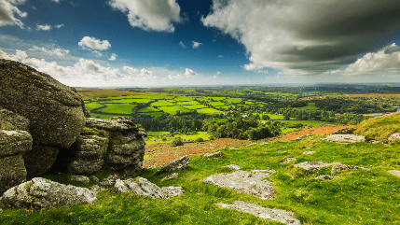 |  | Greece Lightning  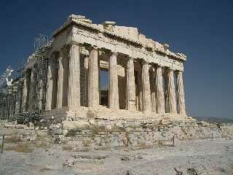
Hook or visit | Visitor |  | Dartmoor Visit |  | Greek Day
Year 5 & 6  B | Darwin, Dynasties and Dragons |  | Rule Britannia |  | Volcanic Voyagers
Hook or visit | Jurassic Coast fossil hunt |  | Fairtrade conference and Topic-Themed Forest School Day |  | Vikings Day

