Landscove C of E Primary School
Landscove, Nr Ashburton, Devon. TQ13 7LY
Tel: 01803 762656 Email: adminlandscove@thelink.academy

NEWSLETTER Thursday 27th January 2022
Dear Parents,
Well – it’s been a busy time over the last two weeks with all the classes working hard as the term hits full speed. I have the pleasure of having children come to me to show off their work and it is always a joy to see the effort and progress they make – my gold stickers guarantee a smile!

LANDSCOVE LEARNERS

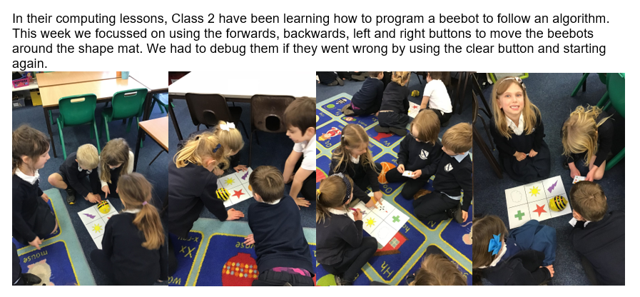
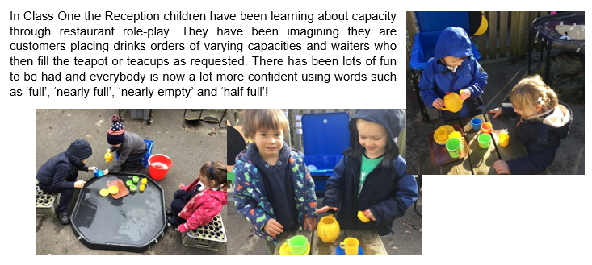

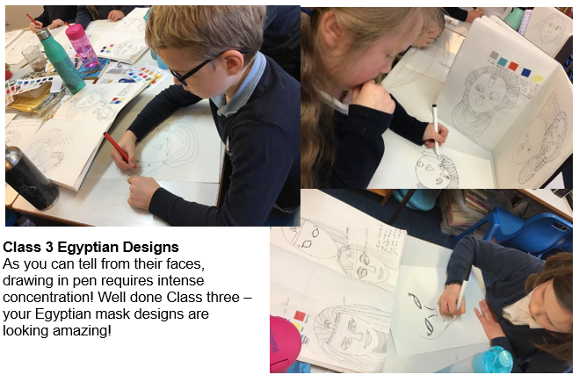
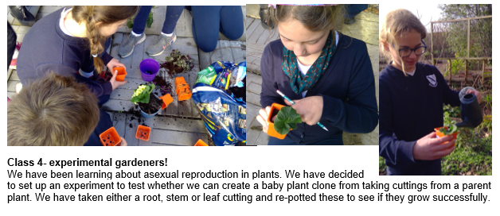

SAFEGUARDING & ATTENDANCE
What Parents Need to Know About Age-Inappropriate Content
“Inappropriate” means different things to different people. What’s acceptable for one age group, for example, may be unsuitable for a slightly younger audience. Online, young people can chance upon inappropriate content in various way – from pop-up ads to TikTok videos. The increasingly young age at which children become active in the digital world heightens the risk of them innocently running into something that they find upsetting or frightening. Trusted adults need to be able to help children be aware of what to do if they’re exposed to age-inappropriate content. Follow the link below to find a guide with some top tips on a number of potential risks such as social media, gaming and adverts.
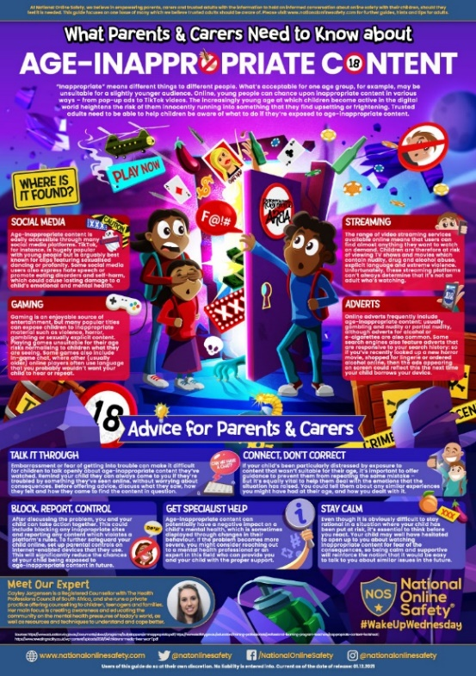
https://nationalonlinesafety.com/guides/age-inappropriate-content
Attendance:
(Our school target is 96.8%)

Whole school | 95.1%
Class 1 | 97.7%
Class 2 | 93.3%
Class 3 | 98.1%
Class 4 | 93.3%
Well done to class 3!

Internet safety day is coming up on 8th February. Miss Barlow has prepared assembly and learning material for the children at both Broadhempston & Landscove. Parent packs will also be available during this week and will be sent to you all to enable you to support your children at home.

FOLS UPDATE
Events for the term.
Friday 4th Feb- Mufti day- £1 per child
Tuesday 1st March- pancake day- 50p per pancake
Friday 1st April- mufti day- £1 per child
Weather permitting Friday 1st April- second hand uniform sale on the field after school.
Second-hand uniform.
FOLS has a large collection of second hand uniform. Suzy Parker- mum of Darcy class 2 is now running this. Please catch her in the playground or contact her on 07813738194 for any requests.
We will be looking to hold a sale on the school field once the weather gets better.
Bags 4 School
The next collection is booked for Friday 29th April. We can store any bags that people already have. Please just let us know.
This will be Valda’s last collection. After 3 years we wish to thank Valda for her hard work keeping this up and running. If anyone feels they could take this over from Valda please let me know!
100 Club
Whilst numbers are lower, we are still running and wish to thank everyone who plays this monthly. If anyone wishes to have more information or join please email me. I am also looking for someone to take over the running of this. If anyone feels they may be able to, please email me to discuss further.
As always please feel free to catch me in the playground or email fols@outlook.com with any fund raising ideas or if you could volunteer to join the team!
Many Thanks
Justina and FOLS team

ETHOS, VISION & VALUES
Through the values explored in Collective Worship as well as their learning across the curriculum, the children are developing their awareness of global citizenship. Last week, we experienced quiet moments of reflection, then shared our hopes for the world. Responses included: more sustainable farming, less plastic pollution and everyone playing a part in slowing down climate change. Key Stage Two children were able to discuss the importance of accepting each other’s differences and spreading kindness.
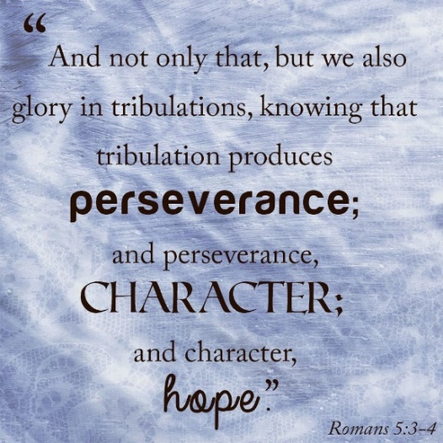
We are now focusing on perseverance. Children are often told by teachers ‘you can do it!’ Encouragement, self-belief and determination contribute to many successes.
January Courtesy Cup Winners
Well done to Olly Lewis and Tobias Norman for living out Landscove’s Values.
Another pupil living out our values is Ophelia in class 4. Ophelia is doing a sponsored hair cut to donate her hair to the little princess cancer charity. If you would like to support her please follow the link below. Well done Ophelia!
https://www.justgiving.com/fundraising/OpheliaLilleySoul-Gray1?experiments=donate_now_track_click&successType=StaticDonateButtonClick
COMING UP
MENTAL HEALTH WEEK: February 7th-13th Dress to express yourself
More news will follow from Miss M, but we will be having a day where we will encourage the children to dress to express!

That’s all the news for now. Many thanks to you all for your continued support.

